Starviewer 2.0
User guide

Table of contents
1. Starviewer 6
2. Contact us 7
3. Electronic instructions for use 8
4. Safety information (warnings) 9
4.1. Residual risks 10
4.2. Side-effects 11
4.3. Known issues 11
5. Intended purpose 12
5.1. Intended use 12
5.2. Intended users 12
5.3. Indications and contra-indications 12
5.4. Expected clinical benefits 12
5.5. Performance characteristics 13
6. Special operating instructions 14
7. Device lifetime 15
8. Technical requirements 16
8.1. Specifications 16
8.1.1. Generic specifications 16
8.1.2. Observations 16
8.1.3. General recommendations and things to take into account 17
8.2. Tested setups 17
9. Study management 19
9.1. Searching for and retrieving studies 19
9.1.1. Local database 19
9.1.2. PACS servers 22
9.1.2.1. Operation List 24
9.1.3. DICOMDIR 25
9.1.4. Access from RIS 26
9.2. Exportation of studies 27
9.2.1. Anonymisation of studies 29
9.2.2. Recording to CD or DVD 29
9.2.3. Recording to hard disk or USB flash drive 30
10. Image visualisation: 2D viewer 32
11. Basic visualization 34
11.1. Navigation and image layout 34
11.1.1. Opening studies 34
11.1.1.1. Hanging protocols 34
11.1.1.2. Automatic layout 34
11.1.1.3. Criteria for the selection of the layout mechanism 35
11.1.2. Comparison of studies 35
11.1.3. Related studies 36
11.1.4. Manipulation of the layout and content of viewers 40
11.1.4.1. Layout manipulation tools 40
11.1.4.2. Tools to select the content of the viewer 46
11.1.5. Viewer enlargement 47
11.2. Image manipulation tools 50
11.2.1. Scrolling and phase change 50
11.2.2. Zoom 51
11.2.3. Magnify 52
11.2.4. Panning 53
11.2.5. Windowing (WW/WL) 54
11.2.6. Selection of default windows (VOI LUT) 55
11.2.7. User defined windows 57
11.2.8. Selection of colour functions (CLUT) 59
11.2.9. Window or colour inversion 60
11.2.10. Horizontal and vertical flip 60
11.2.11. Rotation 61
11.2.12. Restore to initial state 62
11.2.13. Information layers management 63
11.2.13.1. Textual information 63
11.2.13.2. Overlays 64
11.2.13.3. Shutters 65
11.2.14. Screenshot 66
11.2.15. Exporting DICOM images 66
11.3. Measurement and drawing tools 71
11.3.1. Distance 71
11.3.2. TA-GT 72
11.3.3. Angle 73
11.3.4. Cobb angle 74
11.3.5. Regions of interest (ROI) 75
11.3.5.1. Elliptical ROI 76
11.3.5.2. Polyline ROI 77
11.3.5.3. Magical ROI 78
11.3.6. Circle 79
11.3.7. Arrow 80
11.3.8. Erase 81
11.3.9. Considerations on geometric measurements 82
11.3.9.1. Units and types of measurements 82
11.3.9.2. Measurements in pixels 83
11.3.9.3. Measurements in millimetres 83
› Physical measurements 83
› Measurements in projection radiography images 83
11.3.9.4. Priority of measurements 85
11.3.9.5. Measurements verbosity 85
11.3.9.6. Accuracy and precision 86
12. Advanced visualization 88
12.1. Reconstructions 88
12.1.1. Change reconstruction in all viewers 88
12.2. Thick slab 89
12.3. Reference lines 91
12.4. 3D cursor 92
12.5. Cine 94
12.6. Voxel information 94
12.7. DICOM information 95
12.8. Manual synchronisation 97
12.8.1. For each viewer 97
12.8.2. For all viewers 98
12.9. Automatic synchronisation 98
12.10. Propagation 99
12.11. Fusion 101
12.11.1. Fusion layout 103
12.11.2. Fusion balance 105
12.12. Standardised Uptake Value (SUV) 106
12.12.1. Formulae 107
12.12.1.1. SUV 107
12.12.1.2. Decay correction factor 107
12.12.1.3. Lean body mass 108
12.12.1.4. Body surface area 108
12.12.2. Required data 109
12.12.2.1. Manufacturer exclusive attributes 109
12.13. MPR 2D viewer 109
12.14. 3D viewer 111
12.15. Clipping planes 112
12.16. 3D rotation 115
12.17. External applications 116
12.18. PDF 117
13. Diagnosis tests 118
14. DICOM Print 120
14.1. Selection of images to print 121
14.2. Add a printer 121
15. Menus 124
15.1. File 124
15.2. Visualisation 125
15.3. Tools 125
15.4. Window 126
15.4.1. Move to screen 126
15.4.2. Maximise to multiple screens 126
15.4.3. Move to previous screen 127
15.4.4. Move to next screen 127
15.5. Help 128
16. Configurations 130
16.1. 2D viewer 130
16.2. 2D viewer layout 132
16.3. 2D viewer annotations 134
16.4. PACS 135
16.4.1. PACS servers 136
16.4.2. Local configuration 137
16.5. Local database 138
16.6. RIS listener 140
16.7. DICOMDIR 140
16.8. External application 141
16.9. Magnification 144
17. Keyboard shortcuts 145
17.1. Main shortcuts 145
17.2. Other shortcuts 145
18. Glossary 147

Starviewer
Starviewer is a DICOM viewer that integrates image visualisation and evaluation tools for the diagnosis of medical images, reconstruction techniques, 3D navigation tools and image fusion support. It adds functional modules and it can be integrated into hospital information systems such as PACS and RIS servers.
Starviewer is made by:
Institut de Diagnòstic per la Imatge
Parc Sanitari Pere Virgili
Carrer d’Esteve Terrades, 30
Edifici Mestral 2a planta
08023 Barcelona, Catalunya
https://idiweb.gencat.cat
idi@idi.gencat.cat
Tel. +34 93 259 41 75
Fax +34 93 259 41 85

Contact us
For any doubt or suggestion, please send an email to support@starviewer.udg.edu.

Electronic instructions for use
You can print these instructions for use using the print function of your PDF viewer. However, you can request a hard copy at support@starviewer.udg.edu.
New, current and old versions of the instructions can be downloaded at https://starviewer.org/eifu. We recommend accessing the instructions via the Help menu to ensure you visualise the correct ones.

Safety information (warnings)
Read this user guide.
You must read this user guide before using Starviewer for diagnostic purposes.
Starviewer is designed for trained professional radiologists.
Starviewer is a medical imaging viewer designed to be used by a trained professional radiologist when used for diagnostic purposes.
Do not rely solely on Starviewer to make critical decisions.
Medical imaging devices are not bug free, and the images and data that are presented arise from a complex chain of devices, each one adding risks. Whenever you make a critical decision for a patient, you should consider supporting it with additional information from other sources in order to minimise as much as possible a scenario where a software bug that is unnoticed and shows plausible data to the user ends up underpinning a critical decision for the patient that may lead to death or irreversible damage.
Contact support if you observe suspicious results or any issue.
If you are using Starviewer and you observe strange results that you suspect may be wrong, you should contact the support team at support@starviewer.udg.edu to report the potential problem as soon as possible. You should also try to open he same study with an alternative software, if possible, to check whether the same result is obtained. If you detect an error in the program or some usability issue or suggestion you can also report it to the same address.
Report serious incidents to IDI and the competent authority.
If there is a serious incident in relation with the use of Starviewer you should report it to IDI (preferably through the support address support@starviewer.udg.edu) and the competent authority of your member state of the European Union.
Do not rely solely on Starviewer in emergency situations.
If you need high availability in order to respond in emergency situations, you shall have a contingency plan in order to continue diagnosing in the event that some parts of the chain of devices fail. This can include the acquisition devices, the network, or the visualisation workstations.
In the specific case of Starviewer, the contingency measures could range from the ability to diagnose from the acquisition devices’ workstations to being able to transfer studies to USB drives in case of network or PACS failure. Unlike centralised or cloud visualisation solutions, Starviewer is a decentralised software where each visualisation workstation is independent from each other.
Calibrate your displays to ensure a correct visualisation.
The correct visualisation of medical images requires taking measures in order to ensure that what is displayed is consistent with what the human user perceives. You shall calibrate your displays, ensure their operation, use medical displays, do periodic checks, etc.
Use diagnosis monitors with the hardware and drivers indicated or recommended by their manufacturer.
Medical displays certified for diagnosis, especially grayscale ones, are usually designed to be used in combination with a specific graphics card and drivers supplied by the same vendor. If alternative graphics cards or drivers are used, visualisation errors may be encountered, such as incorrect conversions to grayscale.
Do not use the hardware above its specified limits.
Starviewer is a software that runs on a general purpose computer hardware. You shall ensure that the hardware operates within the parameters specified by the manufacturer regarding vibration, altitude, environmental radio interference, temperature, humidity, radioactivity, etc.
Image quality may temporarily degrade during interaction.
For the sake of performance and interactivity, image quality may be temporarily degraded during some interactions. Starviewer restores the maximum quality when the interaction ends.

Residual risks
Wrong measurements or calculations.
As indicated above, medical devices are not bug free, and the images and data that are presented arise from a complex chain of devices, each one adding risks. The risk of displaying a wrong measurement or calculation is small but not null. Possible causes are program error, data error or hardware error. Follow the previous safety indications to minimise this risk.
Images wrongly ordered.
DICOM images usually do not have a defined order in their series. Starviewer sorts them following a set of criteria that we have been able to verify that work in all tested cases, including situations never observed in real series. Notwithstanding, possibilities are infinite and an inconceivable image set could end up being wrongly sorted. If you find such an error please contact the support team at support@starviewer.udg.edu.
Cyber attack.
All software is prone to receive cyber attacks that can compromise its security and that of its environment. These attacks are usually executed through the software’s input channels. In the case of Starviewer, the input channels are the user interface (keyboard and mouse), command line, disk (reading studies) and network (PACS connection and checking for updates in the Starviewer web server). The attack surface is small compared with viewer that depend on a permanent network connection, but nevertheless it must be taken into account that the risk is not null. There is also the possibility that an evil agent infects the system with a spyware like the ones used by the Kingdom of Spain, but this escapes Starviewer’s control scope.
Errors due to external causes.
In addition to attacks, Starviewer could fail due to external causes like errors in data or hardware problems (defective RAM, insufficient power supply, etc.). Follow the previous security indications and use hardware with the recommended specifications to minimise this risk.

Side-effects
Starviewer cannot produce any side-effect on patients and does not have any known side-effect on users.

Known issues
This version of Starviewer does not have any known issue.

Intended purpose

Intended use
Starviewer is a medical software platform intended to provide support for diagnosis and clinical decision from medical images by healthcare professionals. It is an application for the visualisation and processing of medical images stored in DICOM (Digital Imaging and Communications in Medicine) format.

Intended users
Starviewer primary intended users are: (i) Radiologists or specialized medical doctors who interpret and diagnose medical images, such as X-rays, CT scans, MRIs, and ultrasound. They use DICOM viewers as essential tools to review, analyse, and interpret medical images, make clinical assessments, and issue diagnostic reports; (ii) Clinical physicians and specialists including cardiologists, orthopaedic surgeons, neurologists, and oncologists, among others, that use Starviewer to review relevant medical images within their respective fields. (iii) Medical imaging technologists or radiologic technologists responsible for acquiring medical images using imaging equipment, such as X-ray machines, CT scanners, and MRI machines that can use the device to review the images they have acquired to ensure quality and completeness. (iv) Nuclear medicine technologists that work with imaging techniques involving the use of radioactive materials. They can use the device to review images from nuclear medicine studies, such as positron emission tomography (PET) and single-photon emission computed tomography (SPECT) scans; (v) Surgeons that may use the device to review preoperative images for surgical planning and guidance, particularly for procedures requiring precise anatomical knowledge.
In addition, other healthcare professionals involved in patient care, such as nurses, nurse practitioners, and physician assistants, may use the device to gain insights from medical images relevant to their roles. In all the cases, to use the device it is required to follow its indications for use.

Indications and contra-indications
Starviewer is recommended in any kind of disease or injury that can be diagnosed from DICOM format medical images.
It does not have a special intended patient population or medical conditions to be diagnosed and uses medical images from general electromedical and radiology equipment.
It is indicated for general use and no patient selection criteria are established.
There are no contra-indications.

Expected clinical benefits
The expected clinical benefits that derive from the use of Starviewer are:
- Accurate diagnosis and treatment by providing tools that enable healthcare professionals to accurately interpret and analyse medical images, leading to precise diagnoses, effective treatment planning and disease progression monitoring.
- Efficient workflow by reducing the time required for image analysis and interpretation, thus benefiting both patients and healthcare providers.
- Improved patient care by facilitating timely identification of medical conditions from medical images, resulting in quicker interventions and better patient outcomes.

Performance characteristics
High-speed image processing: Starviewer’s ability to rapidly process and render medical images, such as X-rays or MRIs, allows healthcare professionals to efficiently analyse and interpret images, leading to quicker diagnoses and more timely patient care.

Special operating instructions
It is assumed that users have some basic experience using computer programs and know how to use a mouse and keyboard.
No special training is required but can be requested by contacting the manufacturer.
Fully reading this user guide and following it allows to use the device safely and effectively.

Device lifetime
Although Starviewer, as a purely software medical device, is not subject to physical degradation, it is required by the auditing notified body to set a limited arbitrary lifetime.
The lifetime is set at 3 years since the date of manufacture. This is the minimum time span during which a released Starviewer version will be supported. This time will be extended if there is not any new release during that time.

Technical requirements

Specifications
Next we detail the minimum and recommended hardware requirements to work with Starviewer.

Generic specifications
CPU | Minimum: x86_64 mid range or high end CPU  Recommended: x86_64 high end CPU with 8 or more cores
RAM | Minimum: 4 GiB  Recommended: 16 GiB or more with ECC
Graphics card | Minimum: OpenGL 3.2 and 1 GiB of RAM  Recommended: OpenGL 4.6 and 4 GiB of RAM or more
Storage | Minimum: HDD with 5 GiB of free space or more (the more the better) to download studies (Starviewer itself uses about 172 MiB)  Recommended: HDD or SSD with as much free space as possible and ECC
Network card | Gigabit Ethernet
Optical drive | Only needed if the user needs to read or burn optical discs.
Operating system | Windows 7 64-bit  Windows 10 64-bit  Ubuntu 20.04 LTS 64-bit
Software | PDF viewer (needed for the instructions for use and to open encapsulated PDFs)

Observations
These specifications are generic. This does not mean that Starviewer cannot work with other setups. It will greatly depend on the type and quantity of studies desired to handle and open at the same time. In case of doubt with a specific setup please contact the Starviewer team.
- CPU: We recommend a mid rage or high end CPU to obtain a pleasant user experience. Starviewer can run on any x86_64 CPU but if it is not powerful enough some features may perform sluggishly. Starviewer can take advantage from several CPU cores to speed up certain tasks.
- RAM: The specified quantities should in principle allow to open any type of study, but the more RAM the better, it will allow to open more studies or other programs at the same time. One cannot have “too much” RAM.
- Graphics card: Starviewer needs a card and drivers that support at least OpenGL 3.2 (specification published in 2009), otherwise it cannot work. The recommended video RAM quantities are to perform 3D rendering; if you only need 2D rendering you could do with less RAM.
- Storage: The drive speed has a big impact in the user experience when downloading and opening large studies. The minimum required should be a magnetic hard disk drive at 7200 rpm and connected via SATA 2.0, but for new workstations we recommend a NVMe SSD if the budget allows it. On the other hand, the more capacity the drive has the more studies can be downloaded by users before some of them have to be deleted to regain space. As with RAM, one cannot have “too much” storage space. A RAID system or similar that detects and recovers from errors can be useful too.
- Network card: Starviewer can work with speeds lower than the indicated but study download speed from PACS may be crippled.
- Operating system: The indicated operating systems are supported by us under the CE certification.

General recommendations and things to take into account
We recommend to acquire PCs designed or intended as visualisation workstations.
Some specialised monitors may only work with proprietary graphics cards from the same vendor. You must make sure that they meet the minimum requirement of OpenGL 3.2.
You must ensure that the workstation has a power supply unit adequate for its graphics card and also a case with enough ventilation.
If the CPU has an integrated GPU you must make sure that the monitors are connected to the discrete graphics card as integrated GPUs usually have low performance. In some cases you may need to disable the integrated GPU in the BIOS to get the proper function, but it usually it should not be necessary.
If the setup has 2 diagnostic monitors and a normal one with two different graphics cards (for example some Barco setups), then the diagnostic monitors must be connected to the most powerful graphics card.
You must ensure that there is not any type of lossy compression in the image sent to the monitors (see DSC).

Tested setups
CPU | 2x Intel Xeon E5-2620 v4 CPU @2.10GHz (8 cores / 16 threads per CPU)
RAM | 4x16GiB DDR4 ECC
Graphics card | AMD FirePro W7100 (8 GB GDDR5)
Storage | SSD Kingston 480 GB SATA 6 Gbps  HDD WD 3 TB @7200rpm (x2 in RAID 1)
Operating system | Windows 10 64-bit 1607 Enterprise 2016 LTSB

CPU | Intel Core 2 Quad Q9550 @2.83GHz Cache L2 2x6Mb (4 cores)
RAM | 4x2GiB DDR2
Graphics card | Nvidia Geforce 8800 GT (512MB GDDR3)
Storage | 2xHDD 320GB SATA
Operating system | Windows 7 64-bit SP1 Professional

CPU | AMD Ryzen 7 Pro 2700U @2.20GHz (4 cores / 8 threads)
RAM | 2x16GiB DDR4
Graphics card | AMD Raven Ridge
Storage | SSD Samsung 970 EVO 2 TB NVMe
Operating system | Ubuntu 20.04 LTS 64-bit

CPU | AMD Ryzen 9 5950X @3.40GHz (16 cores / 32 threads)
RAM | 2x16GiB DDR4-3200 ECC
Graphics card | AMD Radeon RX 570 (4 GiB GDDR5)
Storage | SSD WD_BLACK 1TB SN850 NVMe PCIe 4.0  HDD Toshiba X300 6 TB @7200rpm (x2 in RAID 1)
Operating system | Fedora Linux 36 (Workstation Edition) 64-bit

Study management

Searching for and retrieving studies
The application allows users to search for studies from three different sources:
- Local database: It allows users to search for retrieved or imported studies on the computer.
Menu: File > Local database studies…
Shortcut: Ctrl+L
- PACS servers: It allows users to search for studies from one or more PACS.
Menu: File > PACS…
Shortcut: Ctrl+P
- DICOMDIR: It allows users to search for studies that are stored in a DICOMDIR on the computer or any other device (USB, CD, DVD).
Menu: File > Open DICOMDIR…
Shortcut: Ctrl+D
From the same window that appears when searching in any of the three options, users can search in any of the other options by simply selecting the tab corresponding to the place where they want to search for the studies.

Local database
In order to search for studies in the local database, it can be accessed in two different ways:
- From menu File > Local database studies…
- With the shortcut Ctrl+L
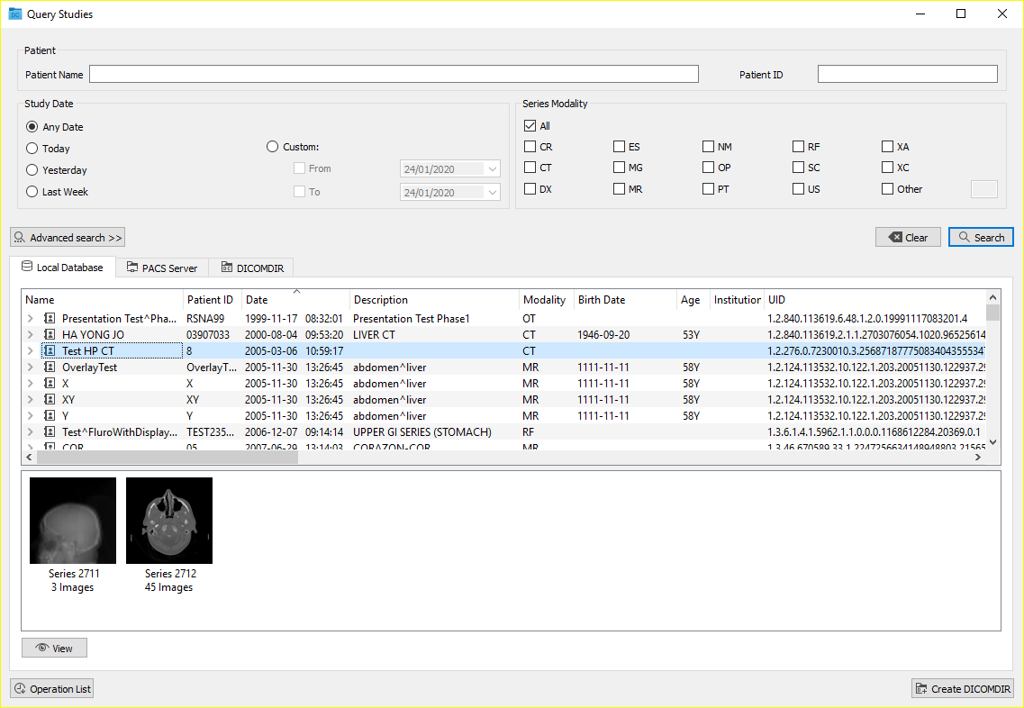
The following window appears:
This tab shows the studies that are stored in the computer where users are working, and that have been retrieved from a PACS of from a DICOMDIR.
In order to search in the local database different filters can be applied such as: patient name, patient ID, date of the study, and modality.
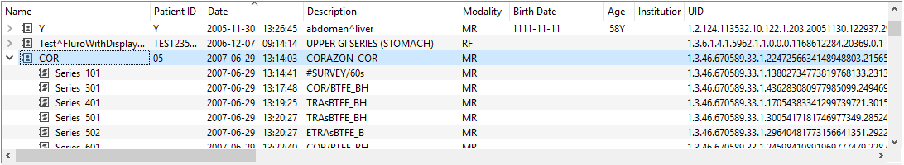
Studies are displayed in the form of a list, where they can be selected and, using the arrow on the left of the folder, users can expand the information about the series they contain. The studies can be sorted by any of the attributes shown in the list by clicking on the title of the corresponding column. The sorting option is saved according to the last configuration applied.
To perform a multiple selection of studies, the Ctrl key must be held down while performing the selection of the list. If there is more than one selected study, the operations carried out will affect all the selected studies.
By selecting one or more studies, different operations are allowed:
- View: It opens the selected studies, organising the viewers and the series automatically with an automatic layout or a hanging protocol. This operation can also be performed by using the keyboard with the Ctrl+V keys, by right-clicking  on the study, or by double-clicking  on any series of the study.
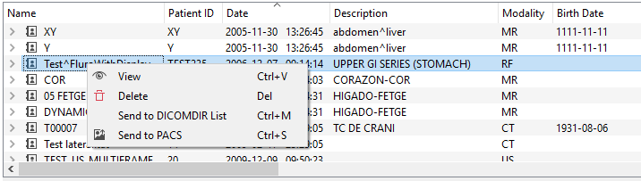
By right-clicking  on a study or a series, different actions can also be performed:
- View: It performs the same operation as the View button: it visualises the selected studies, organising the viewers and the series automatically with an automatic layout or a hanging protocol.
- Delete: It deletes the selected studies or series from the list of the locally stored studies. This operation can also be performed by selecting the study or series and pressing the  key.
- Send to DICOMDIR List: It exports the files (the data) of the study to DICOMDIR format in order to record it on a USB, CD, DVD, hard disk… To do so, it is first necessary to send all the desired studies to the DICOMDIR list by using this functionality, and then export them together (see section 9.2 Exportation of studies). This operation can also be performed by selecting the study and pressing the Ctrl+M keys.
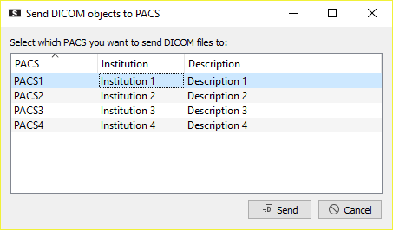
- Send to PACS: It sends the selected studies or series to the selected PACS. This operation can also be performed by pressing the Ctrl+S keys. A dialogue box with the configured PACS appears from which the PACS where the selected elements will be sent can be chosen. Once the PACS have been selected, the submission is confirmed with the Send button. If the PACS does not appear in the list, a new PACS can be configured (see section 16.4 PACS).

PACS servers
In order to search for studies in one or several PACS servers, they can be accessed in two different ways:
- From menu File > PACS…
- With the shortcut Ctrl+P
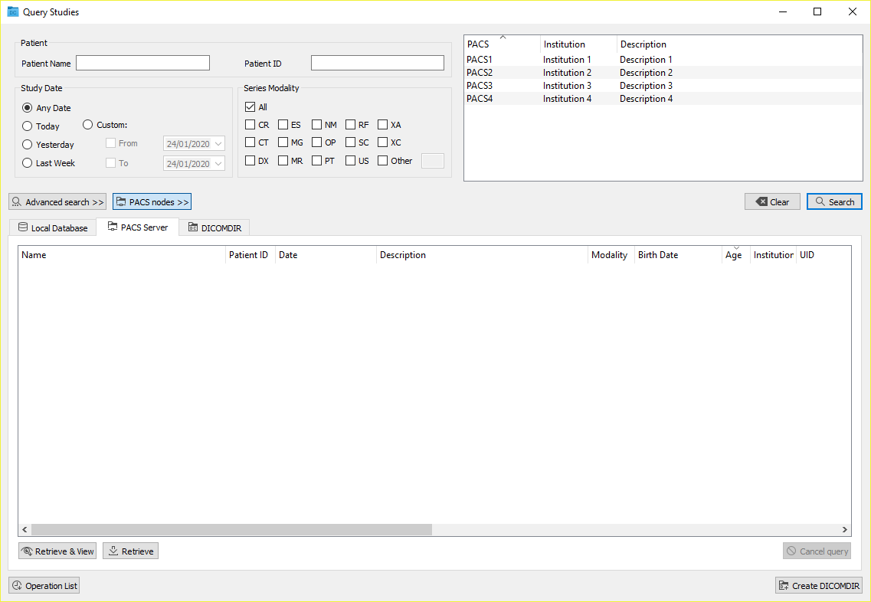
The following window appears:
From the PACS Server tab, users can search for patient studies that are stored in the configured PACS list. To configure new PACS, see section 16.4 PACS.
Queries are carried out in all the PACS selected in the upper-right list, which can be displayed and hidden using the PACS nodes >> button. The first time the window is opened, the selected PACS are those configured as default PACS. A PACS can be selected or unselected by clicking it in the list, and multiple PACS can be selected.
Different filters can be applied to perform the query such as: patient name, patient ID, date of the study, and modality of the series. By selecting the Advanced search >> button, users can apply other criteria such as: patient birth date, study time, study UID, study modality, series UID, SOP Instance UID…
Once the parameters have been specified, the query can be performed by clicking the Search button, and then all the results that match the chosen options are displayed. The query can be cancelled before it ends by using the Cancel query button.
Once the query results are received, different actions can be performed when selecting one or more studies, series or files:
- Retrieve & View: It retrieves the selected elements, stores them in the local database, and visualises them automatically. This operation can also be performed directly by right-clicking  on the study that has to be visualised and selecting the Retrieve & View option, or by using the Ctrl+V keys.
- Retrieve: It retrieves the selected elements and stores them in the local database. This operation can also be performed directly by right-clicking  on the study that has to be visualised and selecting the Retrieve option, or by using the Ctrl+R keys, or double-clicking  on the element.
The status of the different studies, series or files that have been requested for retrieval can be checked by clicking the Operation List button.

Operation List
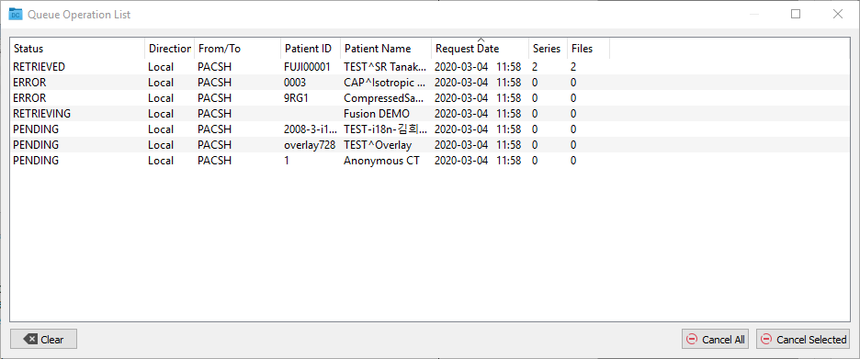
The status of all the studies that have been requested for retrieval or submission during the current Starviewer session can be checked by clicking the Operation List button of the PACS window. This action opens the following window:
The different statuses are:
- Retrieved: The study has already been retrieved and it can be found in the local database, where it is ready to be visualised.
- Retrieving: The study is being retrieved.
- Pending: The study is on the waiting list, waiting to be retrieved (studies are retrieved one by one).
- Error: There has been an error while retrieving the study.
- Sent: The study has been sent to the PACS.
- Sending: The study is being sent to the PACS.
- Cancelling: The retrieval or the submission of the study is being cancelled.
- Cancelled: The retrieval or the submission of the study has been cancelled.
There are also different operations available to perform with the elements of the list:
- Cancel All: It cancels all the pending operations and the ones that are being executed.
- Cancel Selected: It only cancels the selected operations that are pending or in progress.
- Clear: Removes from the list all the operations that have already finished (retrieved, sent, cancelled or error status).

DICOMDIR
In order to search for studies in a hard disk, USB or optical disc, we have the functionality of opening a DICOMDIR. It can be accesses in two different ways:
- From menu File > Open DICOMDIR…
- With the shortcut Ctrl+D
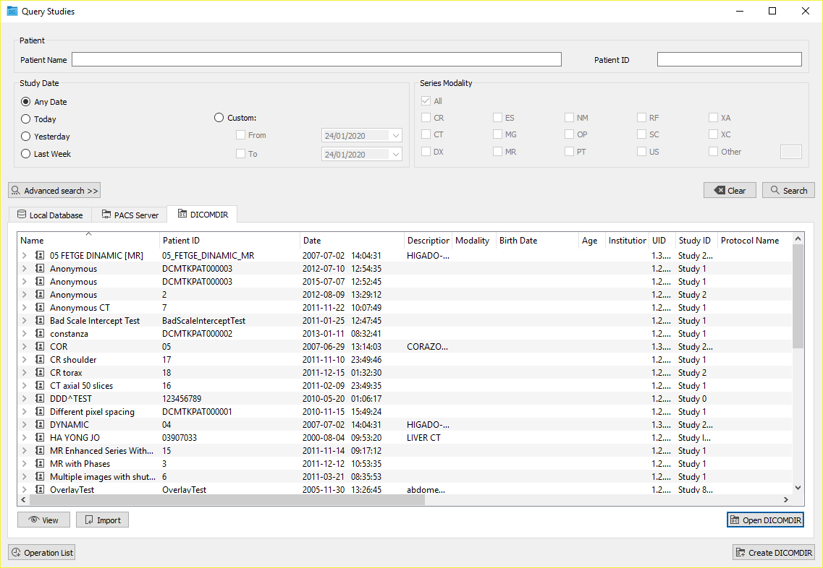
A dialogue box is shown that allows users to choose the DICOMDIR file from the hard disk, USB or optical disc and open it. Once opened, the DICOMDIR tab is shown with all the studies that it contains, as in the following image:
One or more elements of the list can be selected and different actions can be performed:
- View: Visualises the selected elements. This operation can also be performed directly by right-clicking  and selecting the View option, or by pressing the Ctrl+V keys.
- Import: It copies the selected elements to the local database. This operation can also be performed directly by right-clicking  and selecting the Import option, or by pressing the Ctrl+R keys.

Access from RIS
Starviewer can be integrated into a RIS, so that users can choose the study they want to visualise from the RIS without the need for doing the search manually.
The connection between Starviewer and the RIS must be well configured. Section 16.6 RIS listener contains information about how to configure this connection.
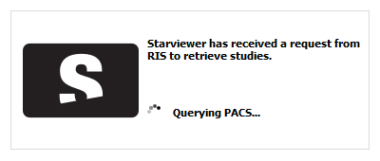
To open a study from the RIS, users have to select the button of the study in the RIS. After that, the Starviewer application starts (if it was not previously opened) and a notification is shown that indicates that the search for the studies that have been requested from the RIS has begun.
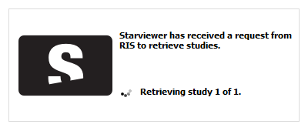
If the study is found in the PACS, it is automatically retrieved and visualised. While retrieving, the notification is updated to report progress.
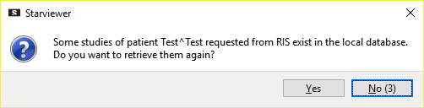
If the study is already in the local database, users are asked whether they want to retrieve them again.
If users reply in the affirmative, the study is retrieved again by updating the copy located in the local database, and then the study is opened. Otherwise, if users reply in the negative, or they remain silent for some seconds, Starviewer automatically visualises the study of the local database without retrieving it again.
If the study is not found, the same notification is used to inform users.

Exportation of studies
Starviewer allows the exportation of data from one or more studies to DICOMDIR format. This functionality is accessible from the local database window, which can be accessed either from menu File > Local Database Studies… or with the shortcut Ctrl+L.
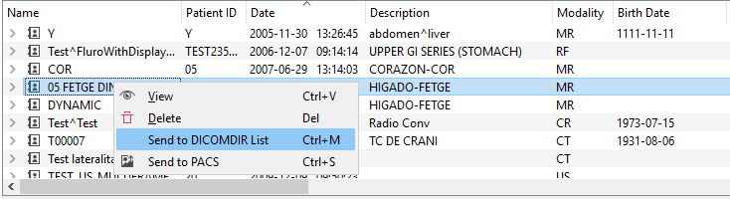
In order to export studies, it is first necessary to select one or more studies (by holding down the Ctrl key, non-consecutive studies can be selected) from the list, and then right-click  on one of the selected studies and choose the Send to DICOMDIR List option in the contextual menu, or use the shortcut Ctrl+M.
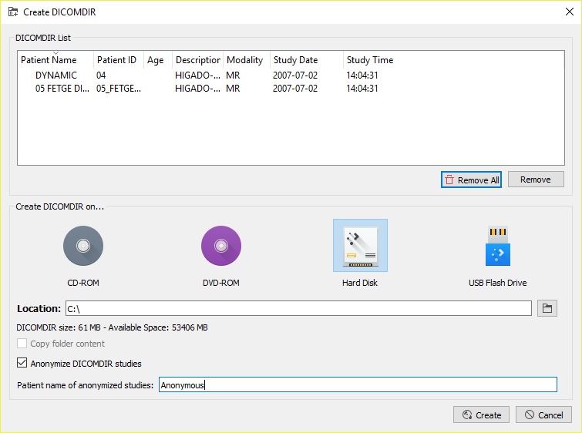
Later, by clicking the Create DICOMDIR button, the following window appears:
This window allows us to select where we want to create the DICOMDIR:
- CD/DVD
- Hard disk or USB flash drive
Optionally, the application allows us to add the whole content of a specific folder into the exported data, such as a viewer that allows the visualisation of the images, or additional information to the study (in any format, e.g. reports). This directory must be previously configured following the instructions in section 16.7 DICOMDIR.

Anonymisation of studies
This option allows the deletion of personal data from the exported studies to convert them into anonymous studies. To anonymise the data, the Anonymize DICOMDIR studies option has to be selected, and a new name for the patient (maximum 64 characters) has to be chosen. This name will be applied to all the patients being exported at that time and it can be left blank. It is recommended to anonymise the studies if they have to be sent outside the hospital.

Recording to CD or DVD
It is first necessary to follow the steps described in section 9.2 Exportation of studies.
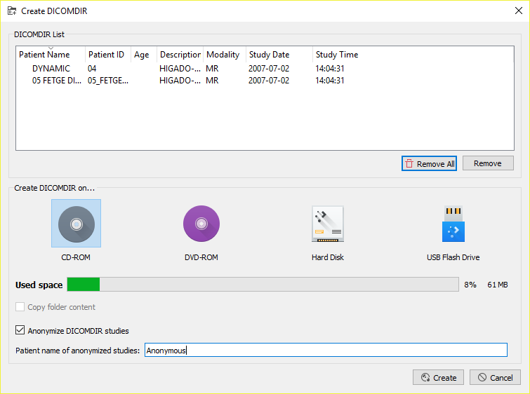
Once we see the list of studies in the recording queue, we have to choose the corresponding option (CD-ROM o DVD-ROM) and click the Create button.
The program that has been configured to create the CD or the DVD (whose configuration can be found in the DICOMDIR configuration panel) automatically opens and the disc is burned.

Recording to hard disk or USB flash drive
It is first necessary to follow the steps described in section 9.2 Exportation of studies.
Once we see the list of studies in the recording queue, we have to choose the corresponding option (Hard disk o USB Flash Drive) and then click the 🗀 button to choose the location where the DICOMDIR will be created. Finally, the Create button has to be clicked to create the DICOMDIR.

Image visualisation: 2D viewer
The 2D viewer is the module that allows us to visualise the images from the studies of practically every kind of image modality such as CT, MR, MG, RF, CR, and US, amongst others. It allows us to perform a wide range of basic and advanced actions on the loaded images. A summary of the most outstanding functions is shown below.
Visualisation management
- Choosing the visualisation mode in a custom way (number of opened studies, placement of images...)
- Visualising the list of related studies that the patient has
Basic manipulation
- Images movement in spatial and temporal dimension
- Zoom, magnify
- Image rotation
- Horizontal and vertical image flip
- Windowing
- Invert image colours
- Restore a viewer to its initial state
- Hide patient information from the viewer
- Save a screenshot in image format (.jpg, .png, .bmp, .tiff)
- Send images to a PACS
Measurement and drawing tools
- Distance, TA-GT
- Angle, Cobb angle
- Regions of interest (ROI) to compute areas and statistical data: elliptical, polyline, magical
- Circle (to find the centre of a circular area)
- Arrow
- Erasing performed measurements
Advanced functions
- Orthogonal reconstructions: axial, sagittal, coronal
- Thick slab (MIP, MinIP, average)
- Reference lines
- 3D cursor
- Visualising images as video
- Checking the information of a voxel
- DICOM information
- Automatic and manual synchronisation
- Propagation of zoom, window, orientation, panning…
- Fusion of PET-CT and SPECT-CT images
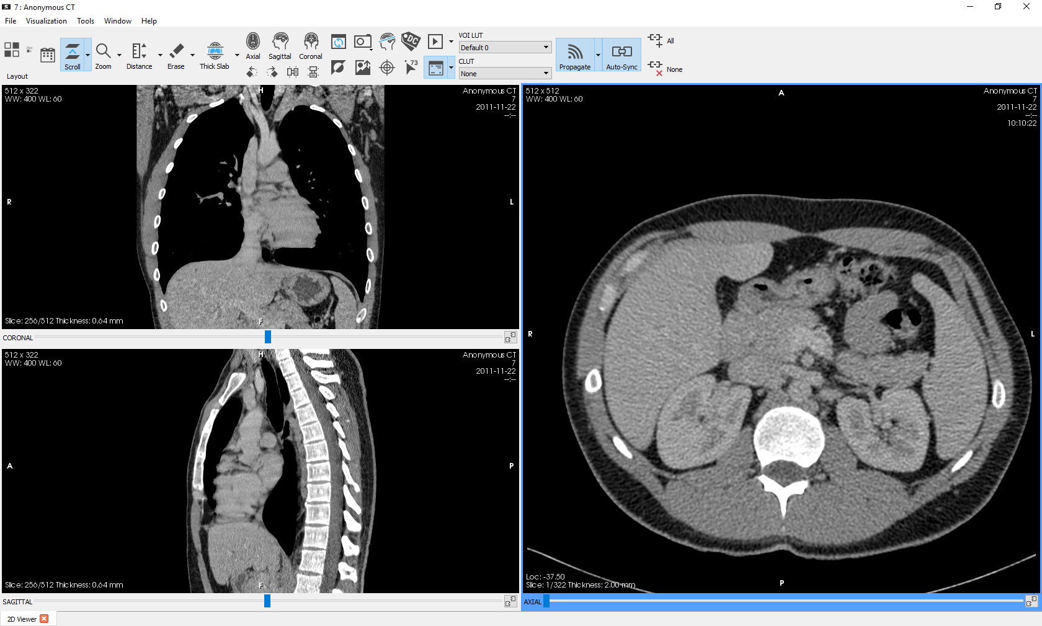
To learn more about each function, please check 11 Basic visualization and 12 Advanced visualization chapters.

Basic visualization

Navigation and image layout

Opening studies
When a study is opened, Starviewer is responsible for automatically distributing its content in a set of viewers. This is carried out using two alternative mechanisms, the hanging protocols and the automatic layout, which are explained below.

Hanging protocols
The hanging protocols are templates that allow defining a layout of viewers where the content of each viewer is given by a set of restrictions and conditions with which the series and the images of the opened studies must comply.
This allows performing custom automatic layouts of almost any study. The most typical example is that of mammographies, where hanging protocols allow the creation of several templates to show the different projections with the desired layout, such as the comparison of craniocaudal, oblique or even prior mammographies. The same is applicable to any image protocol.

Automatic layout
With this mechanism, a regular viewer layout is created so that the maximum amount of series or images can be placed, and it is automatically filled with the series or images of the opened study.
Series are always sorted by series number, and images by position within the series, but there are other layout parameters that are configurable for each image modality:
- Distributing by series or by images
- Main layout direction (from left to right or from top to bottom)
- Maximum number of viewers (between 2 and 48)
- Excluding or not CT locators, MR surveys or attenuation correction CT series (B08s)
Starviewer provides a default configuration for each modality according to the following criteria:
- For plain X-ray images (CR, DX, ES, MG, OP, RF, US, XC) the distribution is done by images; for the rest of modalities (CT, MR, NM, PT, SC, XA, etc.) the distribution is done by series
- Main direction from left to right
- As many viewers as needed (48)
- Locators and attenuation correction series (B08s) are excluded in CT, and surveys are excluded in MR
These parameters can be modified in the configuration window of the 2D viewers layout.

Criteria for the selection of the layout mechanism
Starviewer allows configuring, in the 2D viewers layout configuration options for each modality, whether a hanging protocol has to be applied when a study is opened, if any is applicable, or an automatic layout, regardless of whether there are applicable hanging protocols or not. By default, priority is given to hanging protocols in the CR, CT, MG, MR and US modalities.
For each loaded study, Starviewer checks the internal library of hanging protocols and, according to the study properties, filters those that are applicable according to the restrictions defined in each hanging protocol. If there is a hanging protocol preference and several of them are applicable, the winner is chosen according to the following criteria:
- The one with the highest priority (defined in the hanging protocol)
- The one that shows more different series or images (the same series or image can be in more than one viewer)
- The one with the most non-empty viewers
- The one with the fewest viewers in total
Regardless of the applied layout mechanism, users can apply at any moment a regular layout or one of the applicable hanging protocols by using the viewers layout tool.
If a study with multiple modalities is loaded, the best hanging protocol is applied from those modalities that have the hanging protocol option as a preference. If no hanging protocols are applicable or no modality prioritises the hanging protocols, an automatic layout is applied by combining the automatic layout preferences of each modality with the following criteria:
- If distribution is by series in some cases and by images in others, by series is applied
- If the main direction is different, left to right is applied
- The maximum number of viewers is the minimum of the set of configurations to be combined
- All the excluding criteria included in each configuration are applied

Comparison of studies
Function
It allows the visualisation of two studies of the same patient at the same time to compare them. The most recent study is considered as the current one, and the oldest study as the prior one.
Shortcut
F10 (only for mammographies and chest CR)
Mode de operation
The comparison mode is enabled by selecting a prior study in the related studies tool, and it is disabled by unselecting the prior study in the same tool. Alternatively, if the current study is a mammography or a chest CR, the comparison mode can be enabled and disabled with the F10 shortcut. In this case, the most recent prior study of the same type (mammography or chest CR) is automatically selected, and if none exists, the comparison mode is not enabled.
When the comparison mode is enabled or when the current or prior study is changed while it is enabled, the application first looks for an existing combined hanging protocol (that is, that combines images from two studies at the same time) that is applicable to both selected studies, and it is applied if found. If no applicable combined hanging protocol is found, then the Starviewer window is divided in two halves where by default the left half corresponds to the current study and the right half to the prior one; for each study, a regular layout or an individual hanging protocol is applied in accordance with the criteria explained in section 11.1.1.3 Criteria for the selection of the layout mechanism. The division in two halves can be configured as explained in section 16.2 2D viewer layout.
Viewer where it is applied
All of them; when the comparison mode is enabled, the layout of the whole window changes.

Related studies

Function
It shows the list of related studies of the current patient that are in the local database, in the PACS selected by default, and in the PACS where the study comes from, and allows changing the current and prior studies.
Mode of operation
When clicking  the button, the list of related studies that have been found appears. From this list, the displayed study can be changed and the comparison with a prior study can be enabled or disabled. The selection buttons of the Current and Prior columns allow changing, respectively, the current and prior studies that are displayed at every moment. Only a more recent study than the selected prior one can be chosen as the current study, and only an older study than the selected current one can be chosen as the prior one; in any other case the selection button does not appear.
To change the current study, click  on the selection button corresponding to the new study in the Current column. To add or change a prior study to compare, click  on the selection button corresponding to the new study in the Prior column. When a study is selected as current or prior, if it is not in memory, it is automatically retrieved from the PACS or it is loaded from the local database. To disable the comparison and view only the current study, click on the checked selection button of the Prior column. To load a study from the list to memory without viewing it, click  the 👁 button of the desired study.
The list is sorted by study date in descending order (from newest to oldest). The order can be changed by clicking on the desired column (Name, Modality, Description…).
The search for related studies is performed in the local database, in the PACS selected by default, and in the PACS where the study comes from (see section 16.4 PACS). All the studies that have the same patient ID are considered to be related studies. It is possible to change the configuration by including also the studies with the same patient name, but in this case it is necessary to contact the Starviewer administrator in order to enable this option.
The studies from the list may be in different states:
- Selected as current or prior: selection button checked in the Current or Prior column (🔘)
- Available to be selected as current or prior: selection button unchecked in the Current or Prior column (⭘)
- Not available to be selected as current or prior: no selection button in the Current or Prior column ( )
- In memory: ✔ in the third column
- Retrieving or pending retrieval: 🕘 in the third column
- Retrieval error: ⦸ in the third column
- Available to be retrieved from the PACS or loaded from the database: no icon in the third column
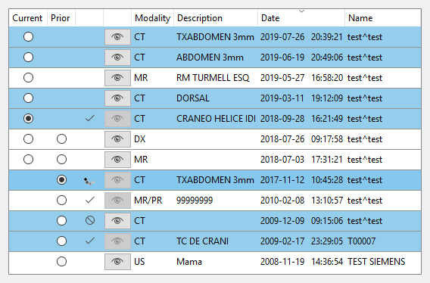
The studies with the same modality as the study being displayed are highlighted.
Viewer where it is applied
Once the selected current or prior study has been retrieved, it is automatically loaded. If only one study is visualised, without a prior one, the new images layout and placement of viewers is decided as explained in section 11.1.1.3 Criteria for the selection of the layout mechanism. If two studies are displayed, current and prior, the criteria explained in section 11.1.2 Comparison of studies are followed.
Example
We open a study, click on the related studies icon, and a list of found cases appears.
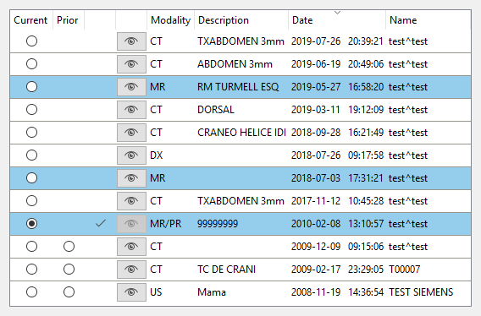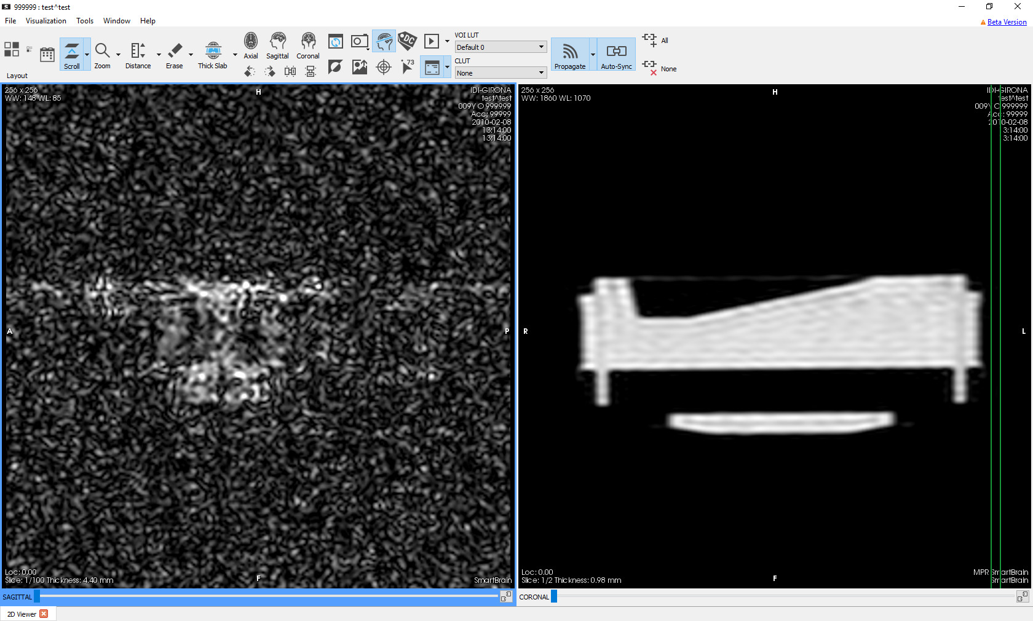
We select another study as the current one by clicking its selection button in the Current column. Once opened, the viewer layout predetermined by the new study is applied.
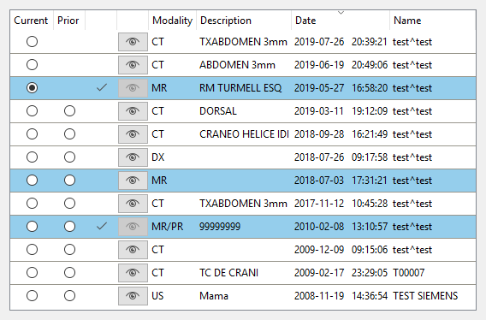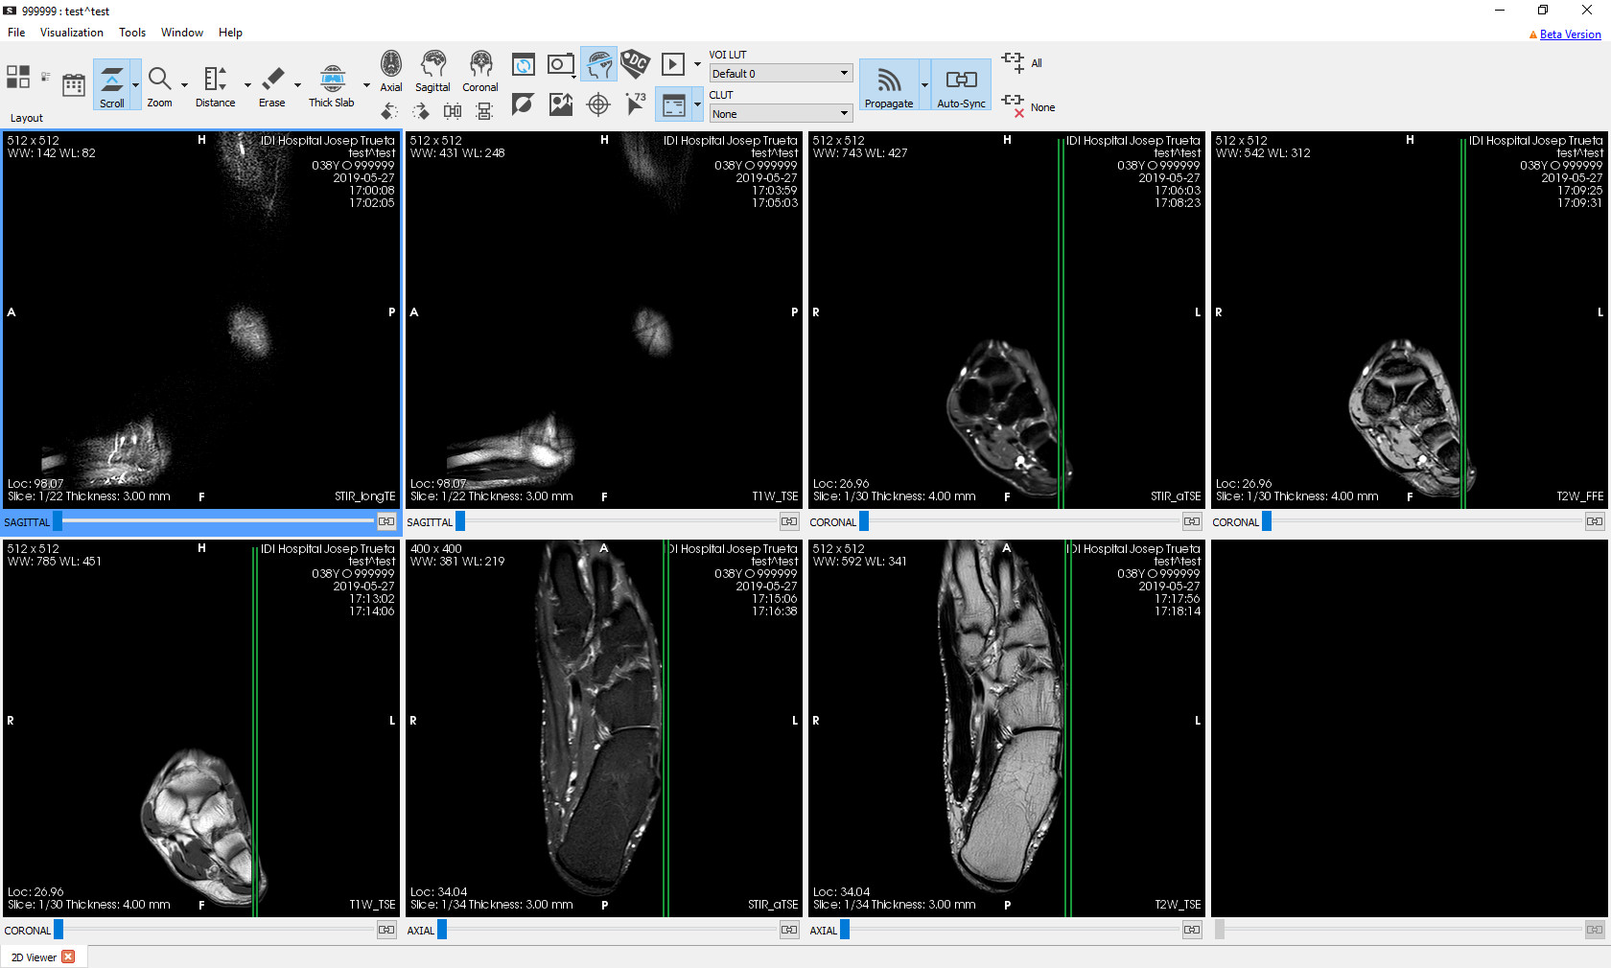

We select a prior study to compare by clicking on its selection button in the Prior column. Once opened, a layout combining both studies is applied.
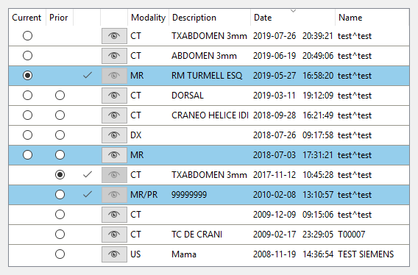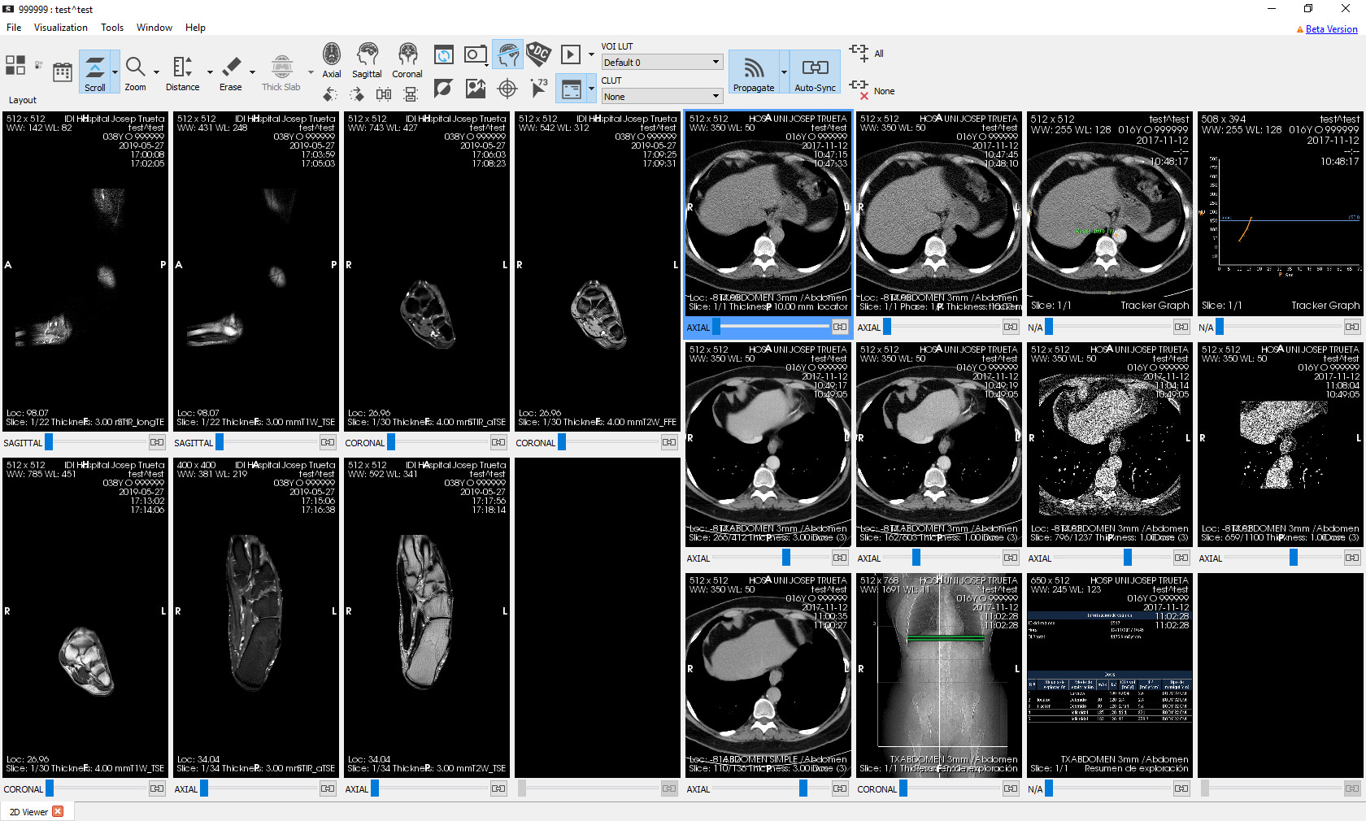
If no related studies of the patient are found, only the opened study is displayed in the list.
If no other related studies appear, it does not mean there are none. They may be found in a PACS that is not configured to search for by default.

Manipulation of the layout and content of viewers
Once the studies have been loaded, we have some tools to modify the applied layout and adjust both the viewers’ content and layout. These tools are explained below.

Layout manipulation tools

Function
It creates a viewers layout in accordance with the chosen specification. Two types of layout can be chosen:
- Custom regular layouts: it allows selecting the number of rows and columns to generate a regular grid of viewers; viewers are filled following the automatic layout criteria.
- Hanging protocols layouts: if the study has applicable hanging protocols, it allows choosing the one to be applied.
Shortcuts
F11 and F12 (to explore the different hanging protocols)
Mode of operation
Mouse:
- Custom regular layouts: click  on the button, move the mouse over the dynamic grid of squares that appears, and click  again on the square corresponding to the desired size.
- Hanging protocols layouts: click  on the button and select one of the available hanging protocols with another click . Hanging protocols are divided into three groups: hanging protocols for the current study, hanging protocols for the prior study, and combined hanging protocols. The last two groups are only displayed if the comparison mode is enabled.
Keyboard: with the F11 and F12 keys, the previous and next hanging protocol, respectively, can be applied within the same group and following the order in which they appear in the menu.
Viewer where it is applied
When only one study is displayed, all viewers are affected; the whole current layout is replaced by the selected one. When two studies are compared, and a combined hanging protocol is applied or one was already applied, all viewers are also affected. When two studies are compared, no hanging protocol was applied, and a regular layout or a hanging protocol is applied for a single study, then only half of the window corresponding to the study in question is affected.
Example of a custom regular layout
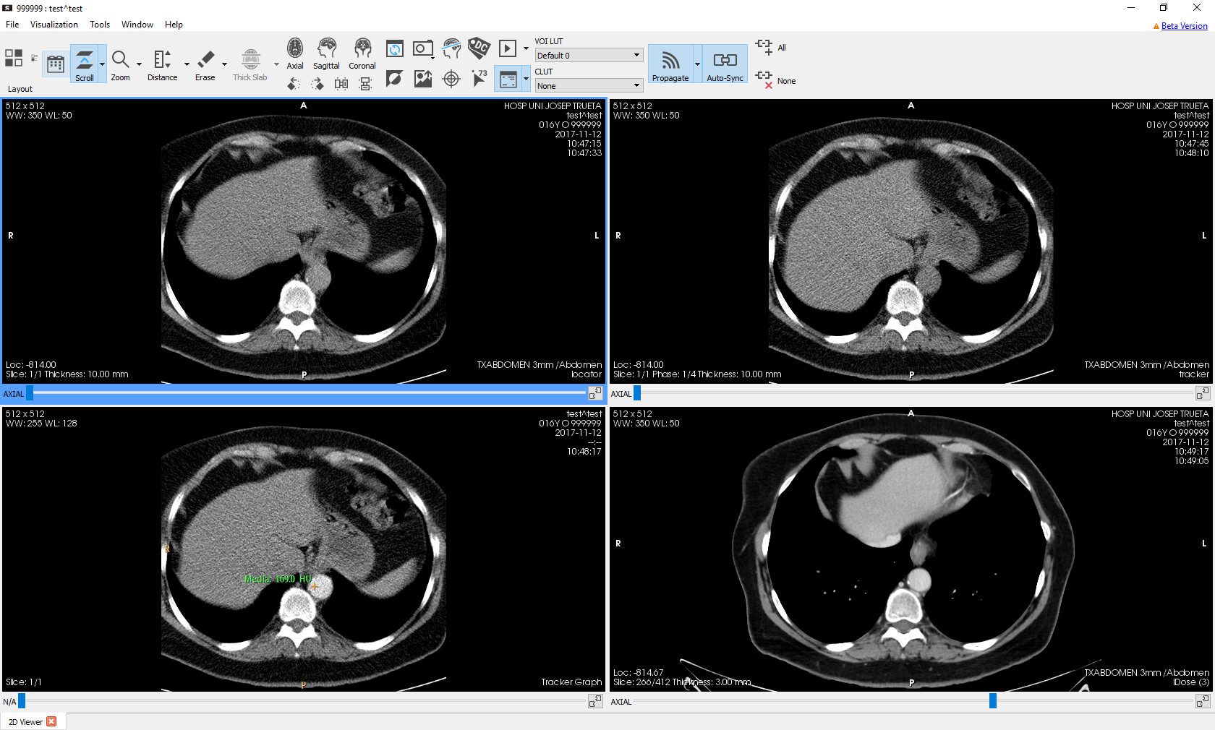
- Initial viewers’ layout:

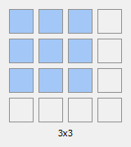
- Selection of a different layout; for example, a 3×3 layout:
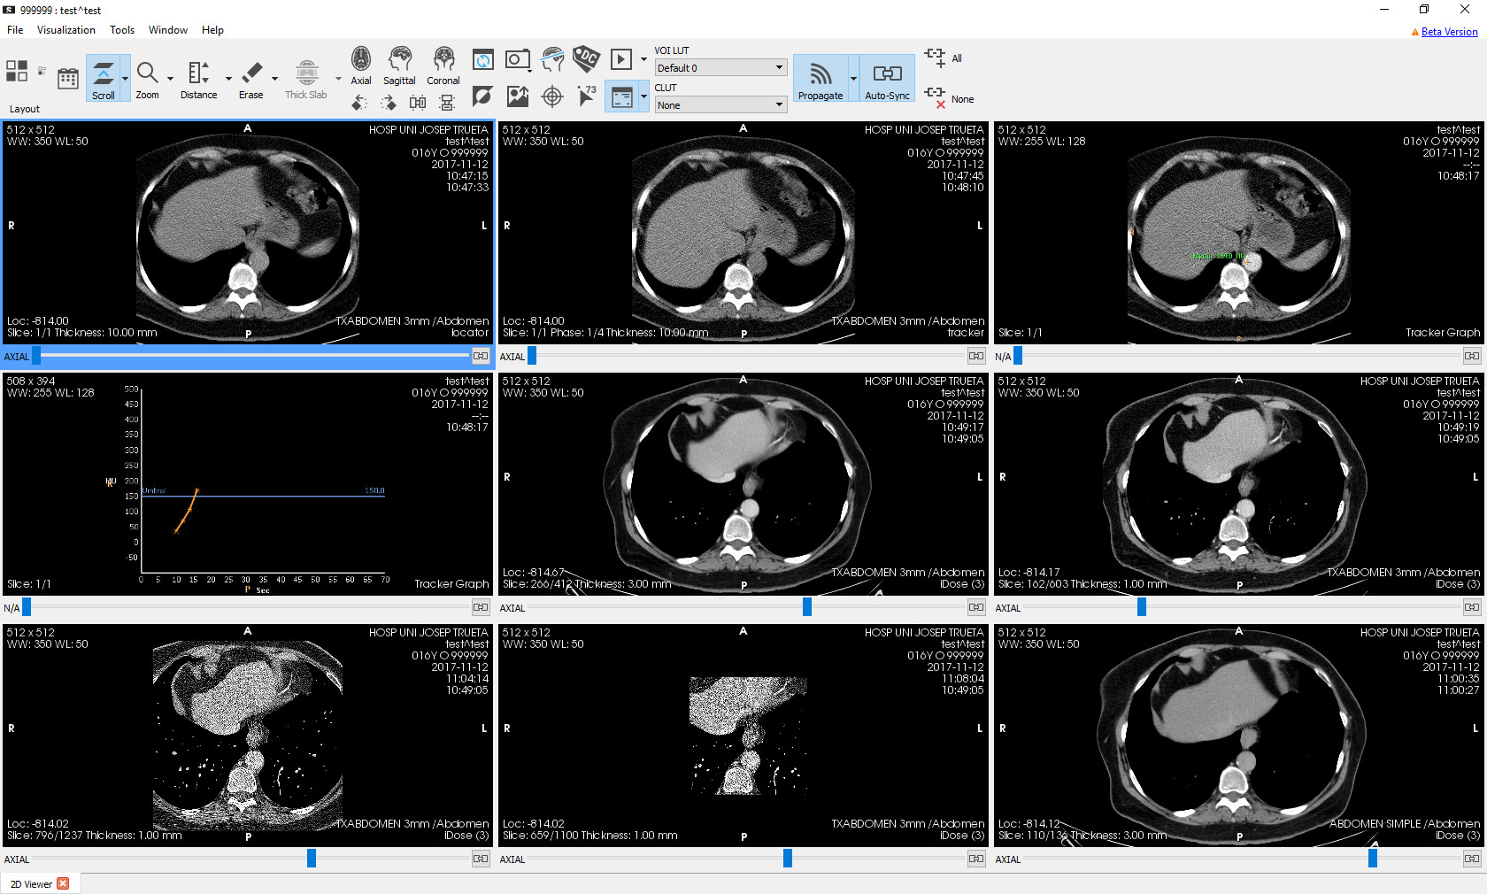
- Result obtained:

Example of a layout with hanging protocols
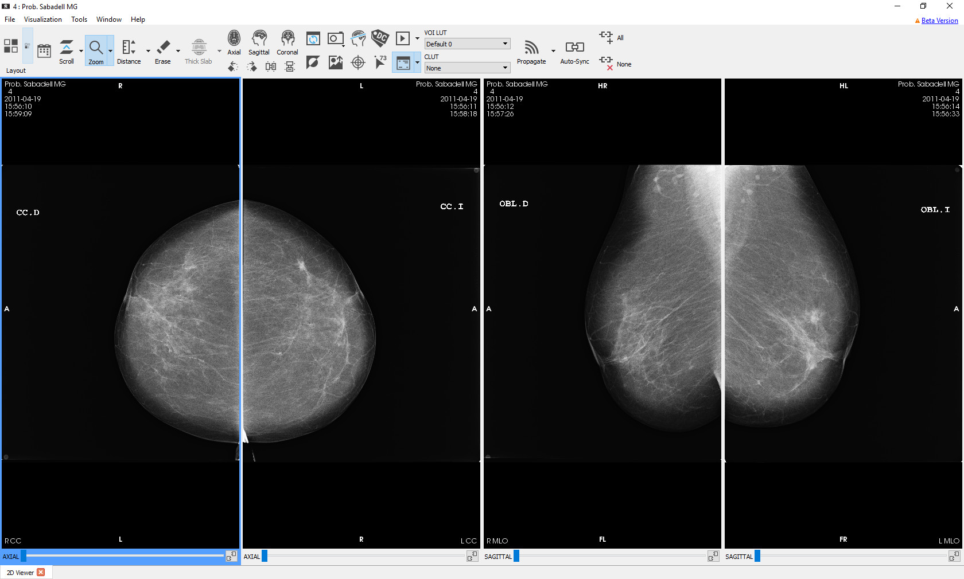
- Initial viewers’ layout:

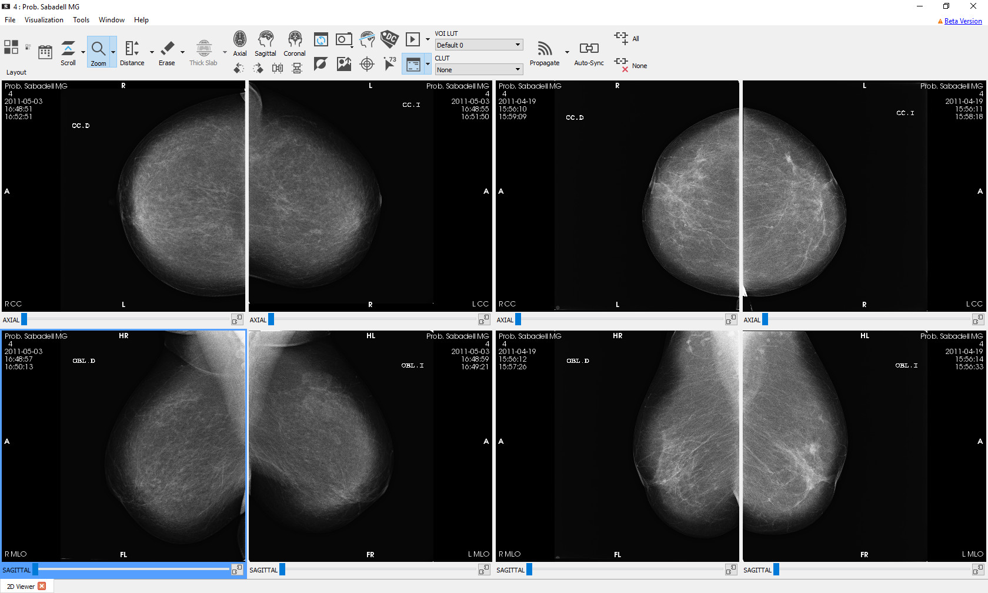
- Enabling the comparison with a prior study: a combined hanging protocol is applied by default, in this case Mammo Prev:
- Selection of another combined hanging protocol; for example, MLO-L Prev:

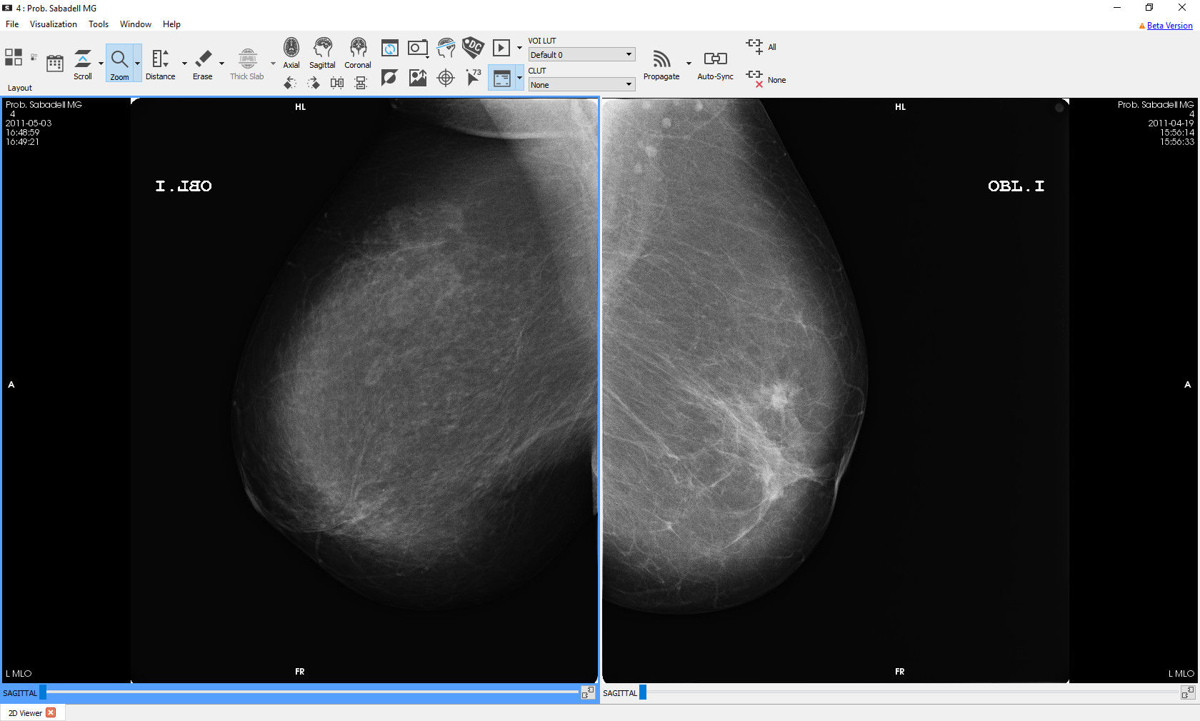
- Result obtained:
- Selection of an individual hanging protocol for the current study; for example, Dretes:
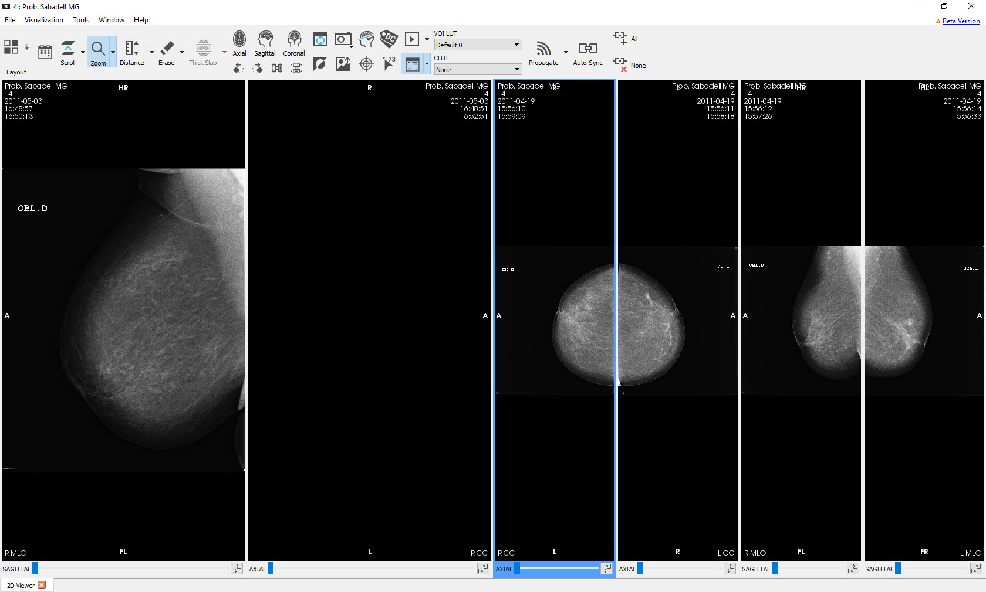
- Result obtained: the selected hanging protocol is applied to the current study, and the default one, in this case CC MLO, is applied to the prior one:

Tools to select the content of the viewer
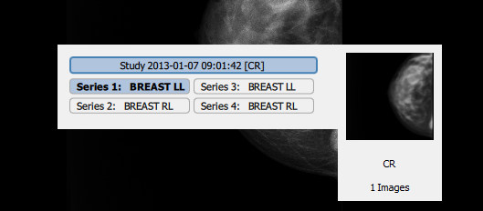
In order to change the series displayed by a viewer, right-click  inside a viewer, and then select by clicking  on one of the series from the menu that appears. The element shown in bold indicates the series that is currently displayed in the selected viewer.
If another study from the same patient is loaded, either from a PACS, from local studies, or from the related studies tool, its series automatically appear in the list of available series. Series are displayed grouped by study and sorted by series number, with studies sorted from newest to oldest.
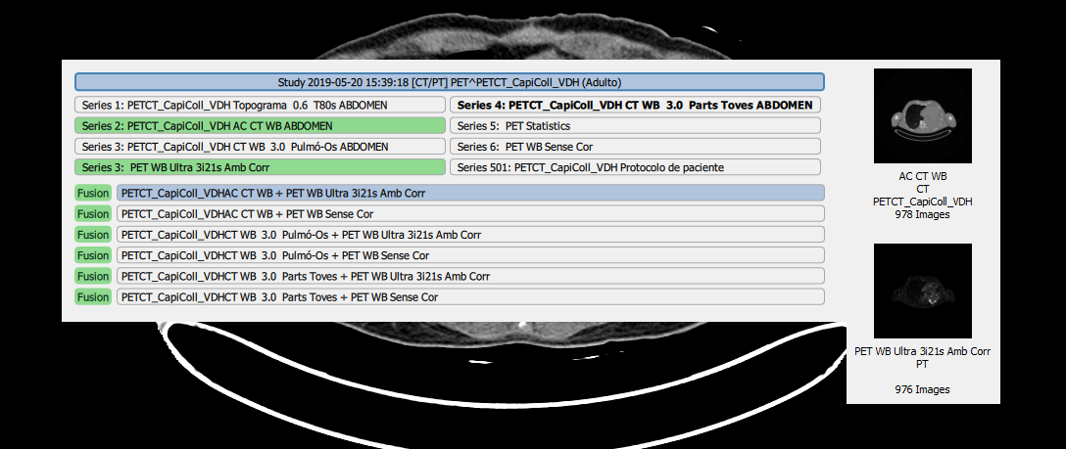
If there are series that can be merged, the possible supported fusion combinations appear after the individual series, flagged with the Fusion label. When the mouse hovers over a fusion element, the series it combines are highlighted in green. To know more about the conditions under which fusion options appear, see section 12.11 Fusion.
Apart from the series menu, it is also possible to change the series with the keyboard under certain circumstances. If one is in the last image of a series and presses the + key, Starviewer moves to the first image of the subsequent series. Similarly, if one is in the first image of a series and presses the - key, Starviewer moves to the last image of the previous series. This navigation is circular and includes all loaded patient studies: if one is in the last image of the last series of the last study and presses +, it will end up in the first image of the first series of the first study. For more information about images movement, see section 11.2.1 Scrolling and phase change.

Viewer enlargement
A viewer can be temporarily enlarged to visualise the image in greater detail. By double-clicking  on a viewer, it is enlarged to fill the whole window or solely one half, depending on whether the main window of Starviewer is on a single screen or two, respectively. By double-clicking  again on an enlarged viewer, it returns to its normal size.
This functionality is always available except when the distance, TA-GT, angle, Cobb angle, polyline ROI, magical ROI and arrow measurement tools are enabled.

Example
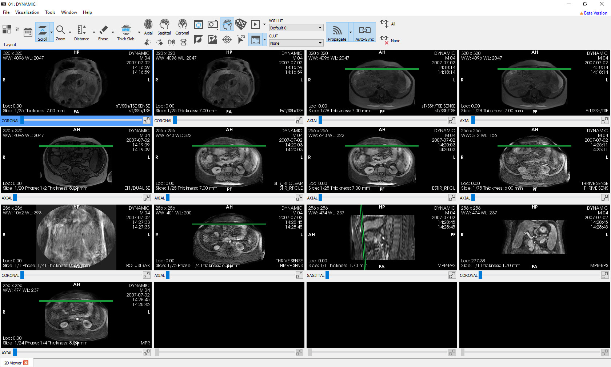
- Viewers’ normal layout:

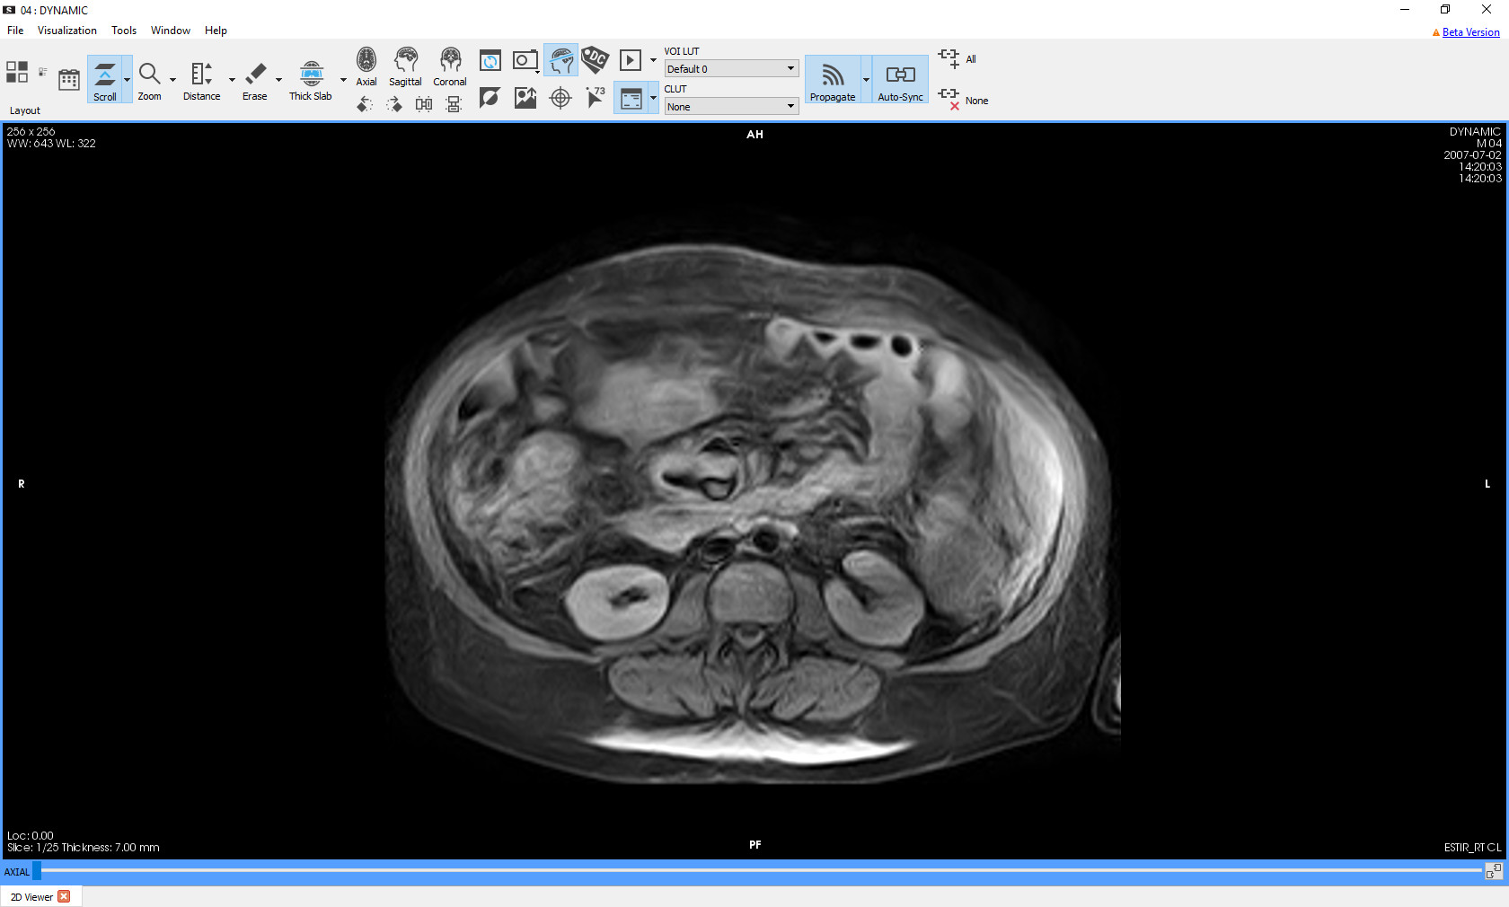
- Double click on one of the viewers:
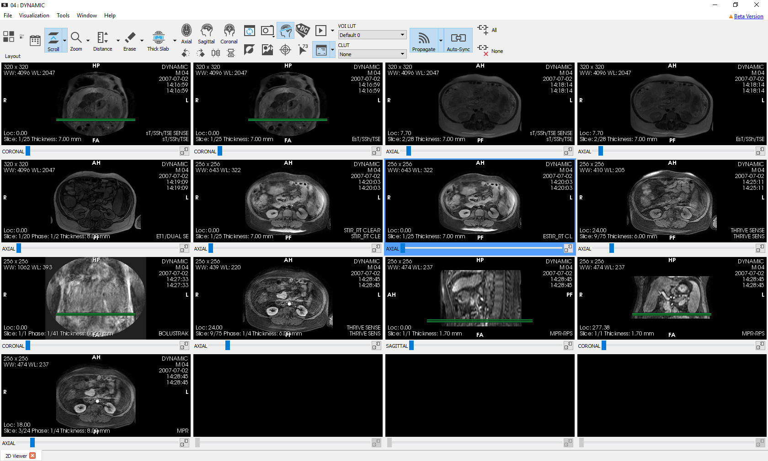
- Double click on the viewer:

Image manipulation tools

Scrolling and phase change

Function
It changes the image of the different slices that form the displayed patient’s series. In dynamic models, where there is more than one image for each slice, it also allows changing the phase. The slice and phase number being displayed is indicated below each viewer on the left side, as well as the total number of slices and phases contained in the series.
This tool can be configured so that scrolling and phase change are cyclical, mouse can be infinitely moved, and wheel scrolling goes through all the series. See how to do this in section 16.1 2D viewer.
Shortcut
S
Mode of operation
With the mouse: slices and phases are changed when moving the mouse within a viewer while holding down the left button . In series with slices and phases, the vertical axis changes the slice and the horizontal one the phase; when there are only slices, both axes change the slice; and when there are only phases, both axes change the phase.
Slices and phases can also be changed by spinning the mouse wheel . In this case, there are two modes: scrolling and phase change. Modes can be switched by clicking with the wheel ; the alternative mode can also be used temporarily while holding down the Ctrl key on the keyboard. In series with slices and phases, the initial mode is scrolling; in series that only have slices or only have phases, the mode is always scrolling or phase change, respectively. The functionality of the wheel is always kept even if another tool is enabled.
With the keyboard:
Function | Keys
Next or previous image | ↑ ↓
Next or previous phase | → ←
Next or previous image going through all the series | + -
First or last image | Home End

From the interface: below each viewer there is a slider that allows changing the slice.
Viewer where it is applied
The viewer over which the mouse is moved while the left button is held down or the mouse wheel is spun, or the active viewer while the keys are pressed.
Examples
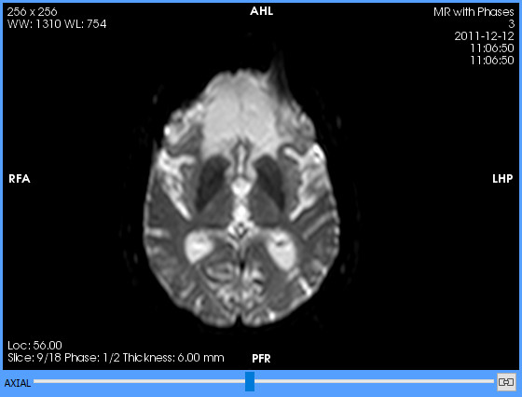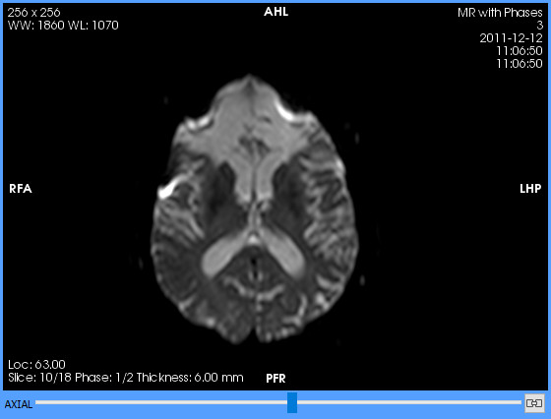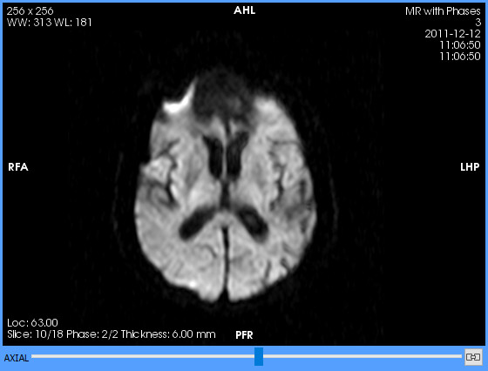Figure 1: Left: initial slice and phase. Centre: scrolling. Right: phase change.

Zoom

Function
Increases or reduces image size.
Shortcut
Z
Mode of operation
Drag the mouse up or down within a 2D viewer while holding down the left mouse button . Zoom is centred at the point that has been first clicked .
Viewer where it is applied
The viewer where the dragging has started.
Example
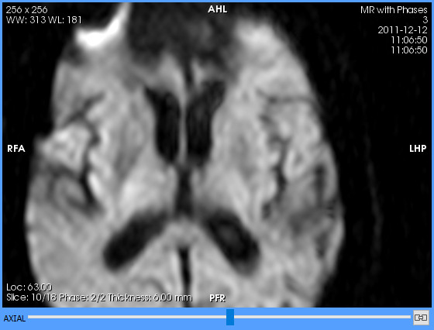Figure 2: Left: initial zoom level. Right: after zooming in.

Magnify

Function
It shows a small square window where the area of the image pointed out by the mouse is magnified.
Shortcut
Shift+Z
Mode of operation
Drag the mouse over the image of a viewer while holding down the left mouse button . A borderless square window appears displaying the magnified area. If the mouse is moved, the window is updated. When the left button  is released or the mouse exits the viewer, the window disappears.
The magnification level can be configured as explained in section 16.1 2D viewer.
Viewer where it is applied
The viewer where the mouse is moved while holding down the left button .
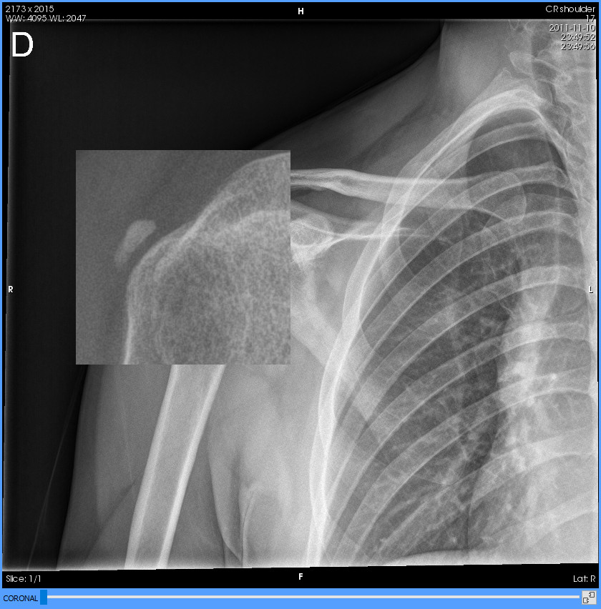
Example

Panning

Function
Moves the image within the viewer.
Mode of operation
Drag the mouse within a viewer while holding down the middle button or wheel ; the image will move in the same direction the same distance. The same tool can be assigned to the left mouse button  from the scrolling and phase change tool button menu. Panning with the middle button is always enabled.
Viewer where it is applied
The viewer where the dragging has started.
Example
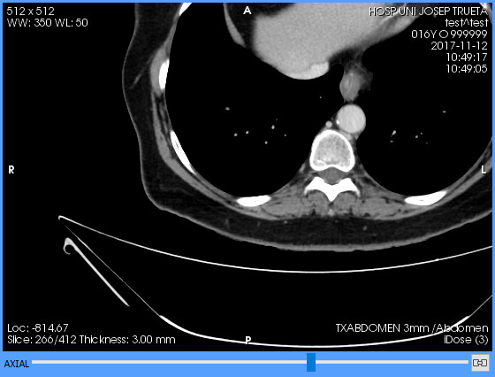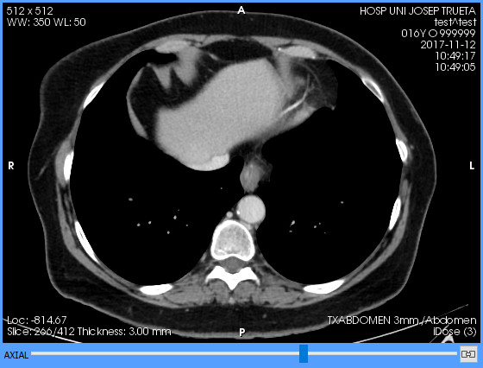Figure 3: Left: initial position. Right: after panning.

Windowing (WW/WL)

Function
It changes the greyscale of the viewer. See also the Selection of default windows (VOI LUT) tool.
Shortcut
W
Mode of operation
Drag the mouse within a viewer while holding down the right mouse button ; the horizontal movement changes the window width (increases or decreases the contrast) and the vertical one changes the level (increases or decreases the brightness). The same tool can be assigned to the left mouse button  from the scrolling and phase change tool button menu or with the shortcut. Windowing with the right button is always enabled in the 2D viewer.
The values of the current window are displayed in an annotation in the upper-left corner of each viewer: WW (window width) and WL (window level).
In PET or SPECT images, both window values (width and level) are bound because the window always has an end set to 0. This mode of operation is also known as «burning». In this case, an additional annotation, Threshold, is displayed, which indicates what percentage of the values contained in the series are within the width of the current window.
This tool also works with images that contain a VOI LUT. In this case, the tool scales and moves the function defined in the DICOM file but does not alter its shape. The name of the VOI LUT is displayed next to the annotation of the window values.
The default window of each image before using the tool is the one indicated in the DICOM file, which may be different for each image of the series. If the DICOM file does not provide a window, an automatic one is computed which allows seeing the full range of the series’ values. Once the tool has been used, all images of the series are displayed with the same window, regardless of what the DICOM file says.
Example
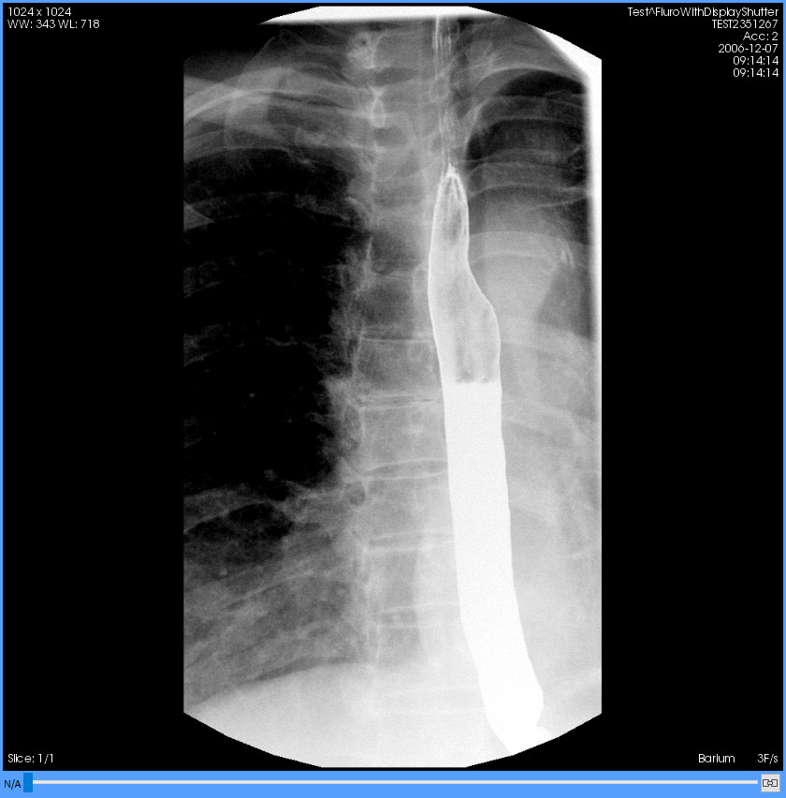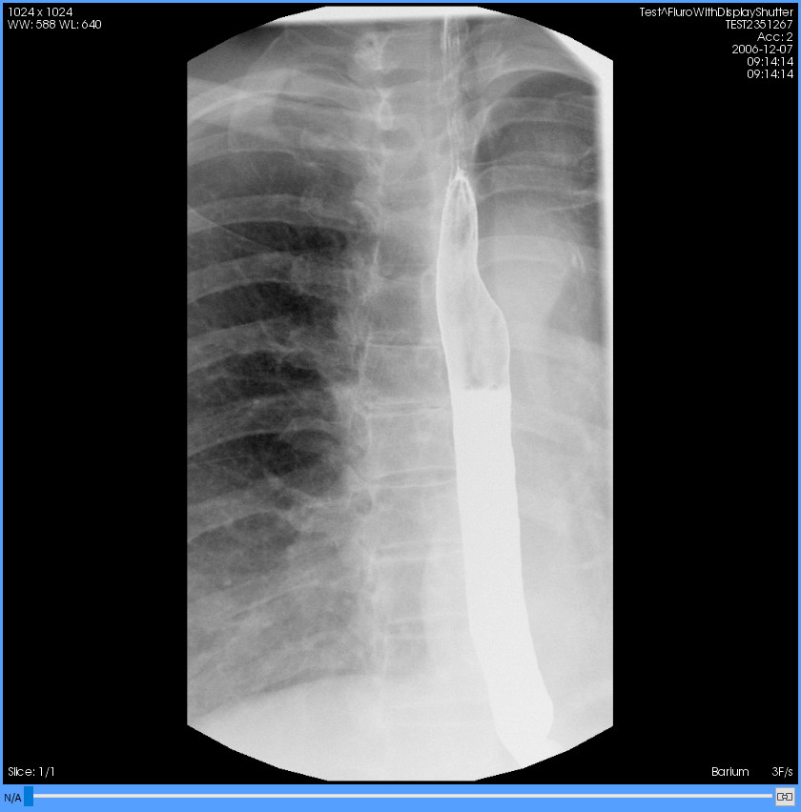Figure 4: Left: original DICOM window. Right: modified window.

Selection of default windows (VOI LUT)
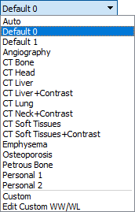
Function
It changes the greyscale of a viewer by applying a default window or a window previously defined by the user. There are four types of default windows:
Default window type | Description
Automatic | The first entry: Auto. It applies a window that includes the full range of series’ values.
DICOM defaults | The following entries, below the automatic one. These are the windows defined in the DICOM file, if any. Each DICOM file can define zero, one or more windows, and these may be different for each image of the series. The name displayed here is also the name stated in the DICOM file, and if no name is specified, they are called Default n, where n is a number greater than or equal to 0 to distinguish them.
Modality defaults | The entries below those of DICOM. These are default windows included in Starviewer designed to visualise studies of certain modalities such as CT. They have names to indicate the purpose: Angiography, CT Head, etc.
User defined | The entries below Starviewer defaults. These are the windows that the user has previously defined following the instructions in section 11.2.7 User defined windows.
Mode of operation
Select the viewer where the default window has to be applied, and then select a window from the drop-down menu or use one of the following shortcuts:
° It sequentially goes through the automatic window and all the DICOM defaults (Auto, Default 0, Default 1…)
1-9, 0 Starviewer default functions, from first to tenth
!, " Eleventh and twelfth Starviewer default functions
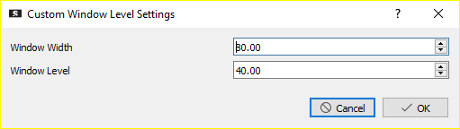
The Custom option (next to last in the drop-down menu) allows choosing the exact values of window width and level. When this option is selected, the following dialogue box appears to enter the values:
Finally, the last entry, Edit Custom WW/WL, allows the definition of user windows as explained in the next section.
Viewer where it is applied
The active viewer (with the blue frame).

User defined windows
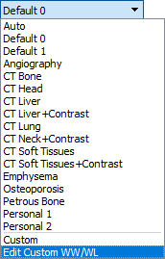
Function
It allows adding, editing and removing user windows that can later be chosen with the default window selection tool (see previous section). These windows are saved until the user removes them.
Mode of operation
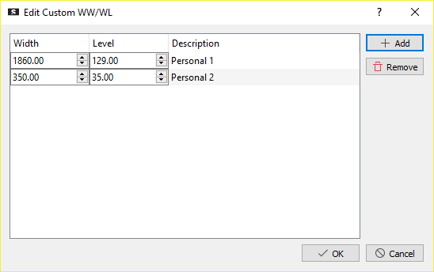
Select the Edit Custom WW/WL option from the default window selection drop-down menu. The following window will appear displaying the current custom windows:
To add a new window click on the Add button and edit the window Width and Level values and the Description. Width and level are initially filled with the current values of the active viewer. The name defined here is the one that will appear in the drop-down menu.
To edit the values of a window, simply change the values directly by deleting the current value and typing a new one, or by using the small arrows next to the text box. To edit the name, double-click  on it.
To remove one or more windows, select them in the Description column, and then click the Remove button. Removal must be confirmed. It is possible to select more than one entry by dragging the mouse while holding down the left button  to select a continuous range, or by clicking  on each one while holding down the Ctrl key.
To finish and save the changes, click  on the OK button. If there is an empty or repeated name, an error message appears reporting that the issue needs to be solved and changes cannot be saved until it is solved. To discard the changes, click  the Cancel button or close the window.
Viewer where it is applied
The new value will be available for all viewers.

Selection of colour functions (CLUT)
Function
It allows the application of one of the default colour functions to the selected viewer. Colour scales are especially indicated for visualising PET and SPECT studies, but they can be applied to any modality. The monochrome inverse colour function (Black & White Inverse) is applied to the PET-CT and SPECT series by default. In PET-CT or SPECT-CT fusion images, the PET Osirix colour function is applied to the PET or SPECT image by default.
Mode of operation
Select the viewer where the colour function has to be applied and select an element of the drop-down menu. The colour function is applied immediately. In the case of a merged visualisation, the function is applied to the secondary series.
Viewer where it is applied
The active viewer (with the blue frame).
Example
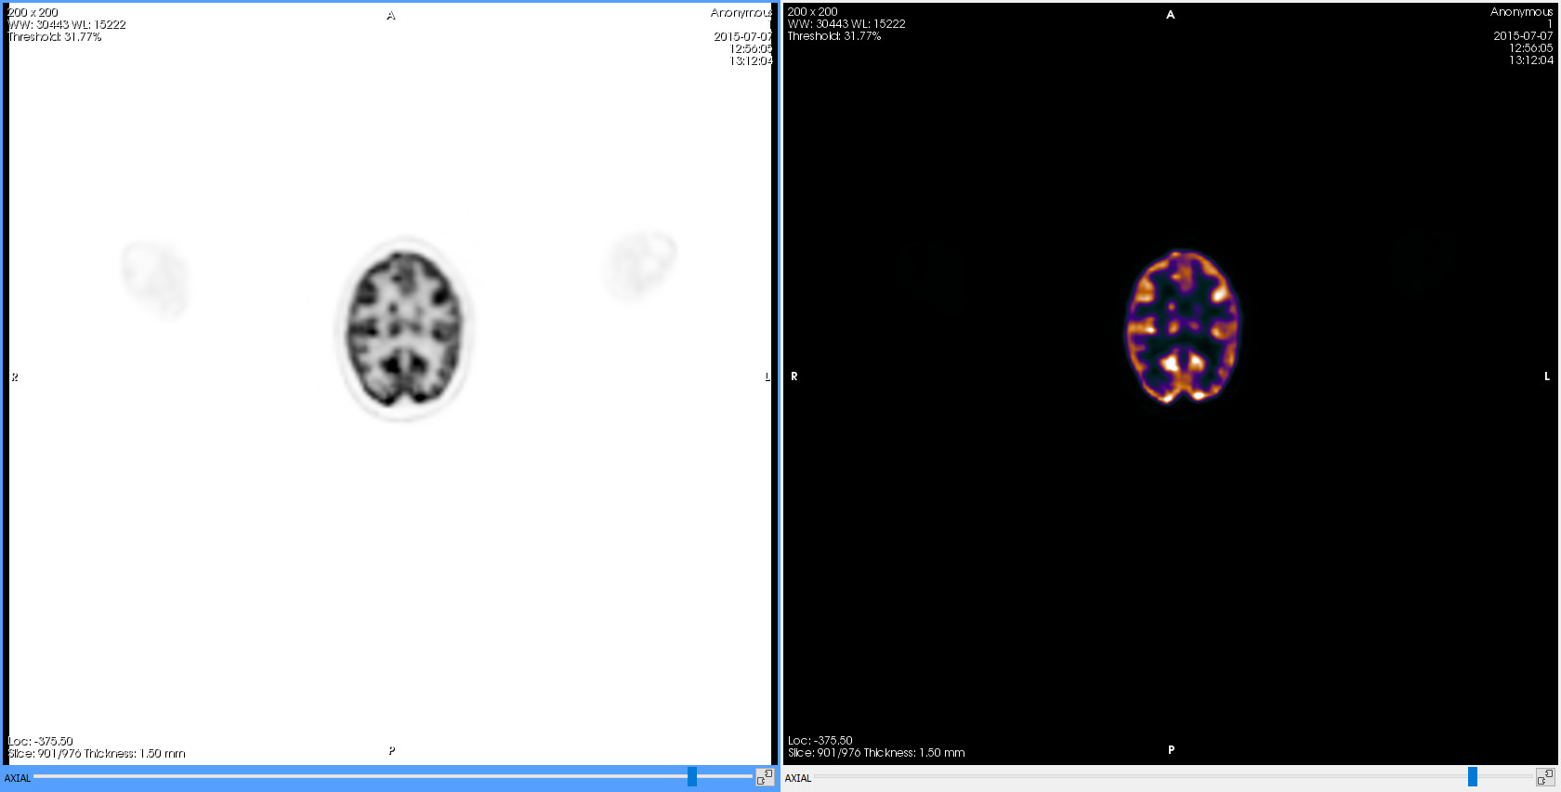Figure 5: Same PET series with different colour functions. Left: Black & White Inverse. Right: PET.

Window or colour inversion

Function
It inverts the grey or colour scale of the image, that is, the blacks turn white, the whites turn black, the yellows turn blue, the blues turn yellow, etc.
Shortcut
I
Mode of operation
Select the viewer where the colour inversion has to be applied and press the toolbar button or the shortcut.
Viewer where it is applied
The active viewer (with the blue frame).
Example
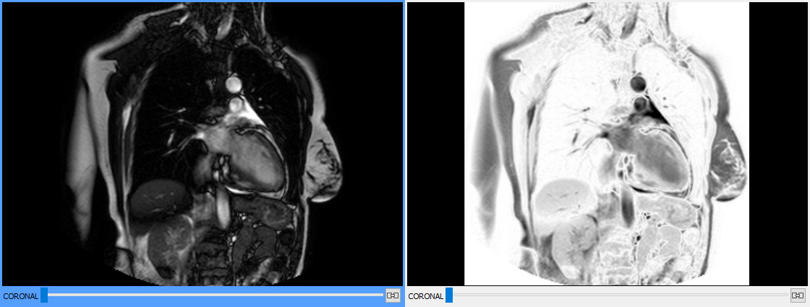Figure 6: Left: original image. Right: the same image with the colours inverted.

Horizontal and vertical flip

Function
They flip the image horizontally and vertically, respectively.
Shortcuts
H (horizontal) and J (vertical)
Mode of operation
Select the viewer where the transformation has to be applied and press the toolbar button or the corresponding shortcut.
Viewer where it is applied
The active viewer (with the blue frame).
Examples
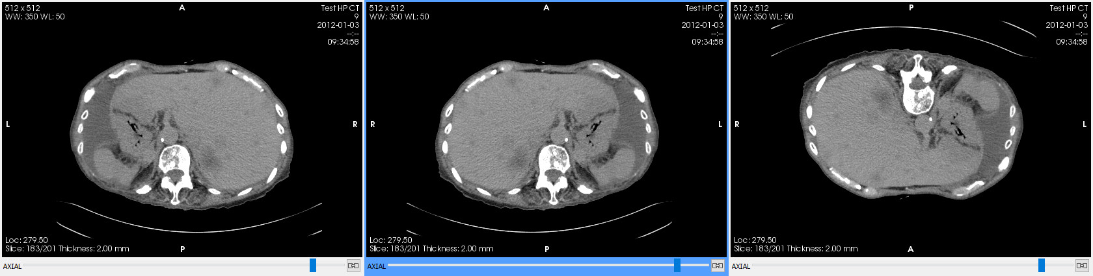Figure 7: Centre: original image. Left: horizontally flipped. Right: vertically flipped.

Rotation

Function
They apply 90° rotations anti-clockwise and clockwise, respectively.
Shortcuts
F (anti-clockwise) i G (clockwise)
Mode of operation
Select the viewer where the transformation has to be applied and press the toolbar button or the corresponding shortcut for each 90° turn to be applied.
Viewer where it is applied
The active viewer (with the blue frame).
Examples
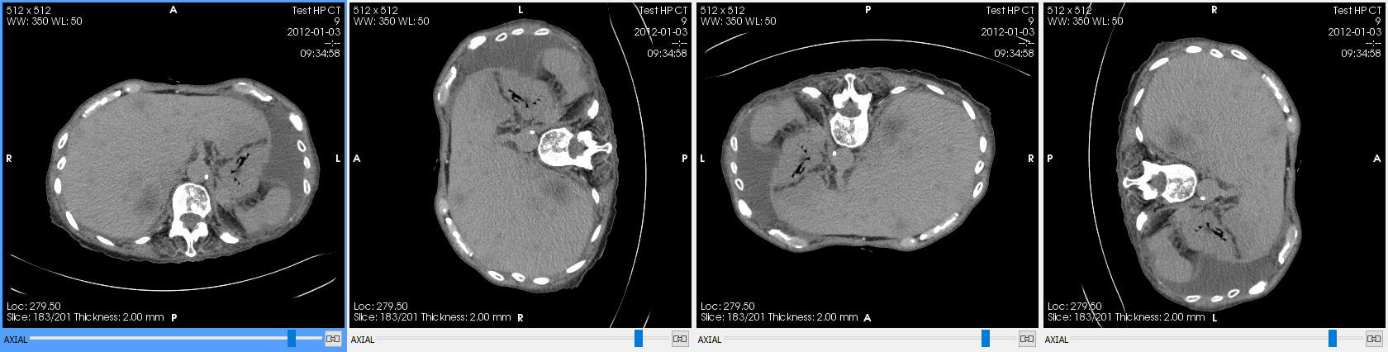Figure 8: An image with the four possible rotations.

Restore to initial state

Function
It returns the viewer to its initial state as if it was reloaded from the beginning, returning to the initial slice and phase, to the initial window, undoing rotations and zooms, erasing measurements, etc.
Shortcut
Ctrl+R
Mode of operation
Select the viewer that has to be restored and press the toolbar button or the shortcut.
Viewer where it is applied
The active viewer (with the blue frame).
Example
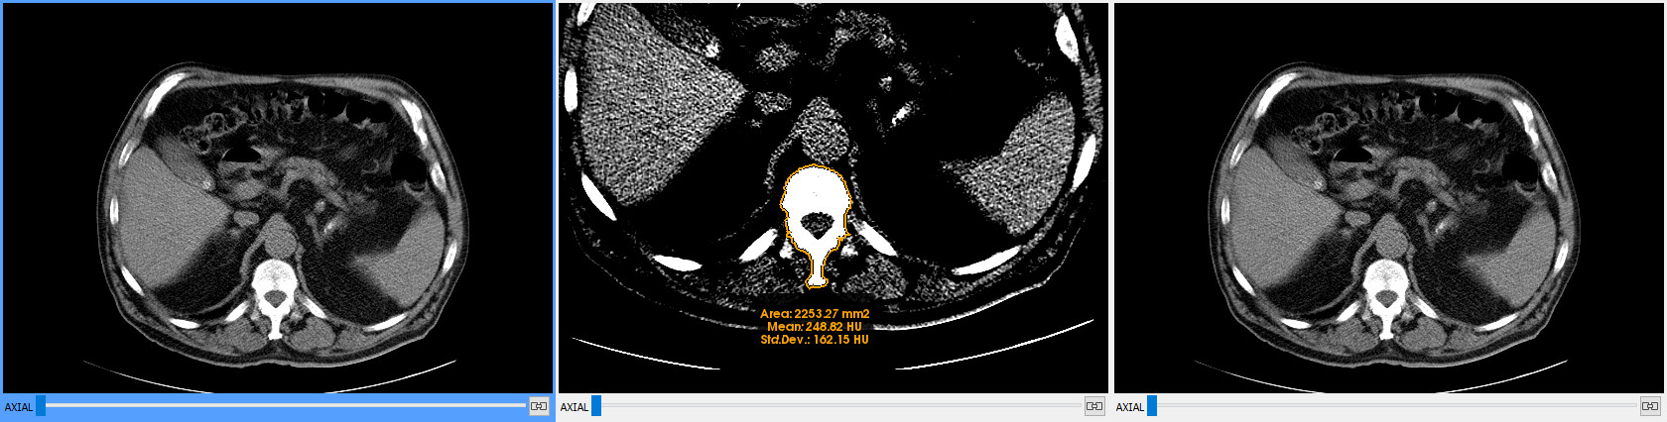Figure 9: Left: original image. Centre: same image after zooming and panning the image, changing the window and drawing a ROI. Right: result of restoring the central image to the initial state; it looks exactly the same as the one on the left.

Information layers management

Textual information

Function
It shows or hides the textual information within the viewers, including patient and study data, image data, image size, current window, slice, orientation, etc.
This feature is useful if one needs to create an image to present it without patient data.
Information printed on the image itself cannot be hidden, as is often the case with ultrasounds, amongst others.
You can configure what information is shown for each modality as explained in section 16.3 2D viewer annotations.
Shortcut
.
Mode of operation
Click  on the toolbar button to hide the information and click  on it another time to show the information again. Alternatively, the shortcut can be used. By default, textual information is visible unless otherwise stated in the settings.
Viewer where it is applied
All of them.
Example
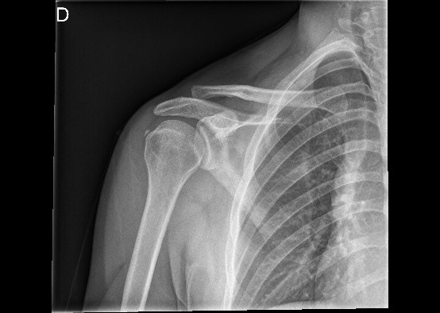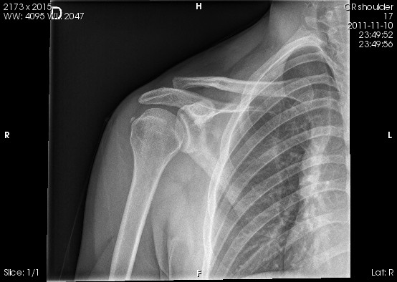Figure 10: Left: viewer with visible information. Right: same viewer with hidden information.

Overlays

This feature can be found in the menu of the button to manage the textual information.
Function
It shows or hides the overlays of the image. Overlays are information layers that contain annotations made to the image. It is a deprecated annotation format, but there are still modalities that use it and they may contain important information for the diagnosis.
Mode of operation
Click  on the menu to hide the overlays and click  on it another time to show them again. They are visible by default.
Viewer where it is applied
All of them.
Example
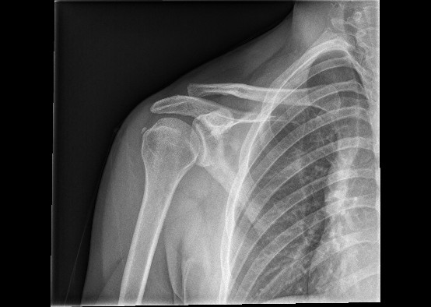Figure 11: Left: viewer with visible overlays (the upper-left D). Right: same viewer with hidden overlays.

Shutters

This feature can be found in the menu of the button to manage the textual information.
Function
It shows or hides the shutters of the image. Shutters are masks that crop out unimportant areas of the image to facilitate diagnosis. These are usually white areas that may be a nuisance for image visualisation. They are common in RF and plain X-ray modality images.
Mode of operation
Click  on the menu to hide the shutters and click  on it another time to show them again. They are visible by default.
Viewer where it is applied
All of them.
Example
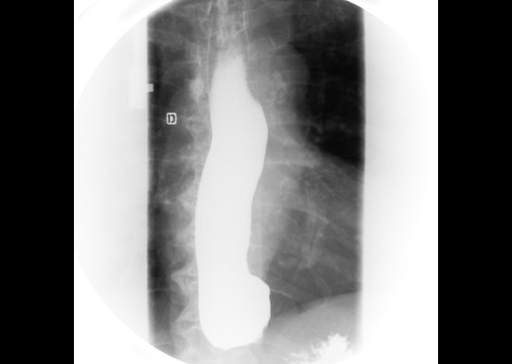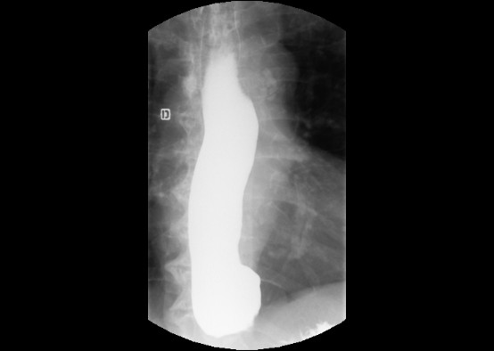Figure 12: Left: viewer with visible shutters. Right: same viewer with hidden shutters.

Screenshot

Function
It saves one or all of the images contained in the active viewer in non-DICOM image format anywhere on the computer or on an external device (USB, hard disk…). Export formats are standard formats: PNG, JPEG, BMP and TIFF.
Annotations, textual information, shutters and overlays also appear in the screenshot if they are visible.
Shortcuts
Ctrl+S (current image) i Ctrl+A (all images)
Mode of operation
Select the viewer from which the current image or all of the images have to be saved, and then click  on the toolbar button and choose the preferred option (Save current series image… o Save all images of the current series…) or press the corresponding shortcut. A dialogue box appears to choose the folder where to save the image and indicate the file name. In case of saving all of the images of the series, a file is created for each image with a numeric suffix; for this reason, it is recommended to save them in an empty folder.
Viewer where it is applied
The active viewer (with the blue frame).

Exporting DICOM images

Function
It generates a new DICOM series from a screenshot of the series that is currently displayed. This series is stored within the same study in the local database. Optionally, it can also be sent to one or several PACS.
Annotations, textual information, shutters and overlays also appear in the screenshot if they are visible.
Currently, this feature is the only way to save annotations.
Mode of operation
Select the viewer that contains the series to be exported and press the toolbar button. The window in Figure 13 is opened with different options:
- Series description: it is the name the new series will have.
- Images to export: it allows choosing the images that will be included in the new series. Only those options that make sense according to the displayed series will be shown. There are the following options:
  - Current image only: it only saves the image currently displayed.
  - All images of current phase: it saves all slices to the current phase.
  - All phases of current image: it saves images from all phases to the current slice.
  - All images of the series: it saves all images of the series including all slices and all phases.
- Preview: it shows a small preview of one of the images to be saved. Below, the total number of images to be saved is displayed.
- On the right, it is reported that images will be saved in the local database and in the selected PACS, and below, a list of the configured PACS is shown that allows choosing one or more.
The new series is always saved in the local database and is hence accessible from the machine where it has been generated. If the user selects one or more PACS, the new series is sent there after saving it to the database and allows it to be retrieved from another machine.
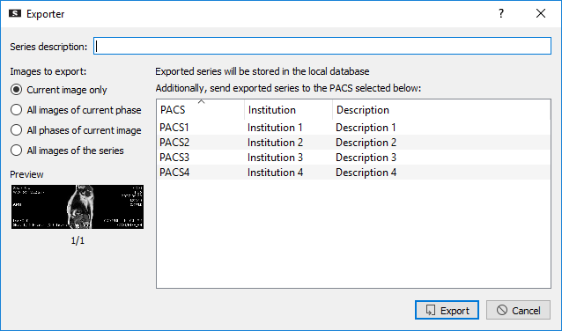Figure 13: DICOM images exporting window.
Viewer where it is applied
The active viewer (with the blue frame).

Example
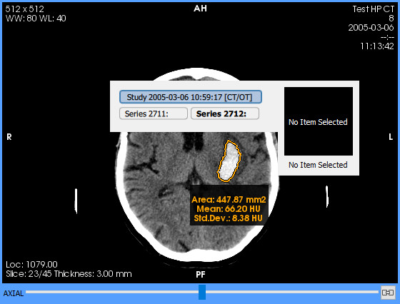
- We draw an area in one of the viewers to save it. By opening the series selection menu (right click ) we see that the study has two series.

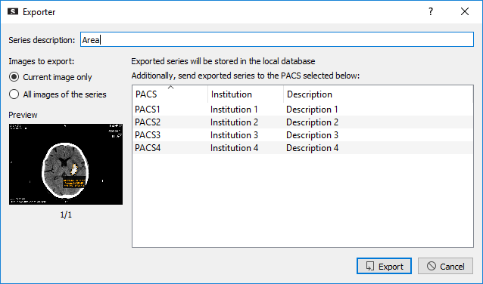
- We click on the toolbar button, and in the dialogue box we give a name to the new series and we choose to export only the current image and not send it to any PACS. We click on Export.

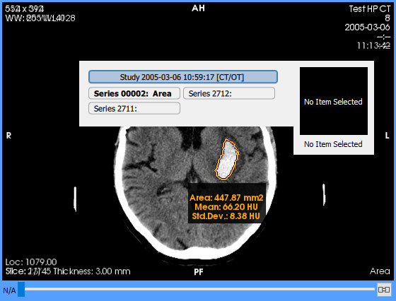
- By opening the series selection menu (right click ) we see that the new series has appeared and we can assign it to the viewer.

Measurement and drawing tools

Distance

Function
It allows computing the distance between two points.
Shortcut
D
Mode of operation
Click  on the starting point to begin the measurement and click  again on the ending point to finish it. After placing the second point, the measured distance appears next to it. A started distance can be cancelled by pressing the Esc key before setting the second point.
Viewer where it is applied
The viewer where the clicks  are made.
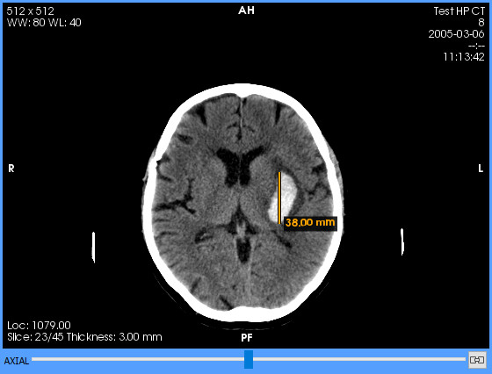
Example

TA-GT

Function
It allows performing a TA-GT measurement.
Mode of operation
Click  to set the starting point and click  again to set the second point; these two points define the reference line. Then two lines perpendicular to this one have to be created. With a third click , set the first of these perpendicular lines —with a specific length—, and with a fourth click , set the second one —of the same length as the previous one. Between the two perpendicular lines, and passing through the last point, a fourth line perpendicular to these ones and parallel to the reference line appears, which is the one that is measured and indicates the separation between the two perpendicular lines. A started TA-GT measurement can be cancelled at any time before setting the last point by pressing the Esc key.
Viewer where it is applied
The viewer where the clicks  are made.
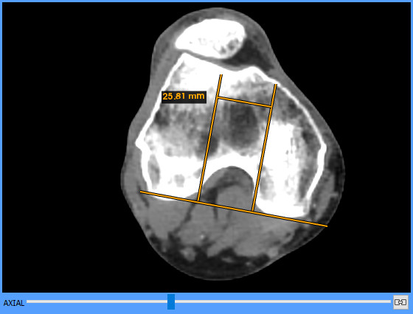
Example

Angle

Function
It allows measuring the angle formed by two lines that converge at a point.
Shortcut
A
Mode of operation
Click  to set the first point, click  again to set the second point —the vertex—, and click  a third time to set the last point. Once the three points are set, the measurement of the angle in degrees appears next to the angle’s vertex. The measured angle is the one formed by the two lines that intersect at the vertex. A started angle can be cancelled at any time before setting the third point by pressing the Esc key.
Viewer where it is applied
The viewer where the clicks  are made.
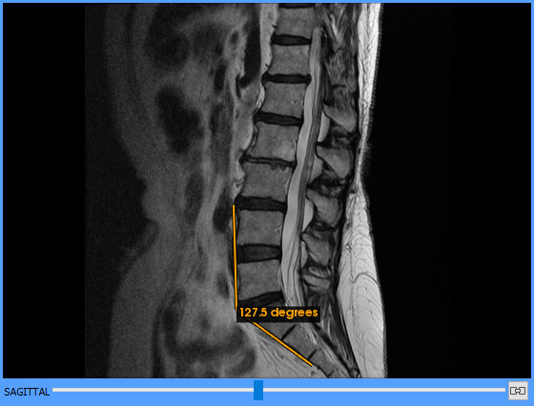
Example

Cobb angle

Function
It allows measuring the angle formed by two lines that converge at an undefined point, useful for example to measure scoliosis.
Shortcut
Shift+A
Mode of operation
Two lines must be drawn and then the angle between them is measured. Click  to start the first line and click  again to finish it; then click  to start the second line and click  again to finish it. Starviewer then calculates the convex angle formed by the two lines and displays it. Since the convex angle is always calculated, the relative order of the points within each line does not matter. A started measurement can be cancelled at any time before setting the last point by pressing the Esc key.
Viewer where it is applied
The viewer where the clicks  are made.
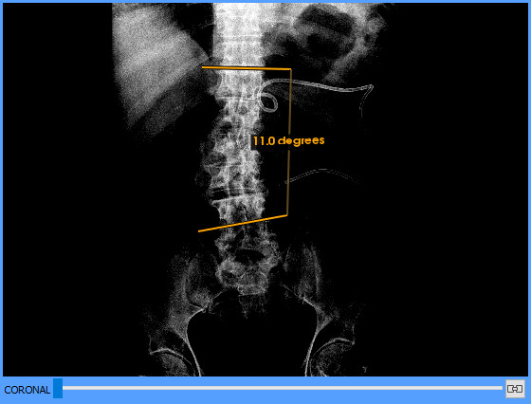
Example

Regions of interest (ROI)
Starviewer provides several tools for drawing regions of interest (ROI) with different shapes. A region of interest defines a region of an image on which geometric and statistical measurements are calculated. Starviewer calculates the area in mm² (in px² if the image has no spatial information) and the mean and standard deviation of the values of the pixels included in the ROI. For colour images (with more than one component), only the area is calculated. The mean and deviation are expressed in the corresponding units of the image, if this is the case (for example, HU (Hounsfield Units) are the units for CT). In PET images, the maximum and average SUV is also calculated, and in SPECT images the maximum, the sum of the counts within the ROI and the counts per mm². In merged images (PET-CT and SPECT-CT), the statistical data of both images are calculated. To find out about what the SUV is and how it is calculated, see section 12.12 Standardised Uptake Value (SUV).

Elliptical ROI

Function
It allows the creation of a region of interest with elliptical shape.
Shortcut
R
Mode of operation
Press and hold down the left mouse button  at a point to start the ROI; drag the mouse to adjust the size of the ellipse and, when it has the desired size, release the left button . The ellipse is drawn inside the imaginary rectangle defined by the two points. A started ROI can be cancelled by pressing the Esc key before releasing the left button .
Viewer where it is applied
The viewer where the dragging has started.
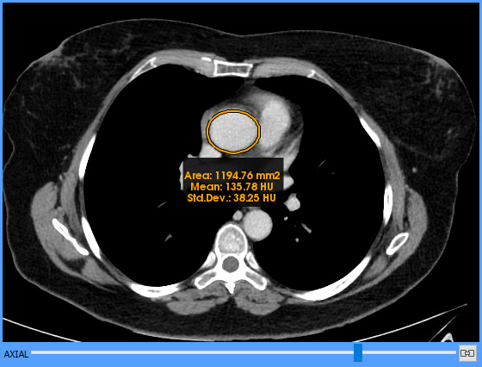
Example

Polyline ROI

Function
It allows the creation of a region of interest with a polygonal shape.
Shortcut
Shift+R
Mode of operation
Click  on the image to start the polygon, then keep on clicking  to add more points to the polygon. To set the last point, a double click  is needed, and with this the polygon is closed and the measurements are calculated. A started ROI can be cancelled at any moment before finishing it by pressing the Esc key.
Viewer where it is applied
The viewer where the clicks  are made.
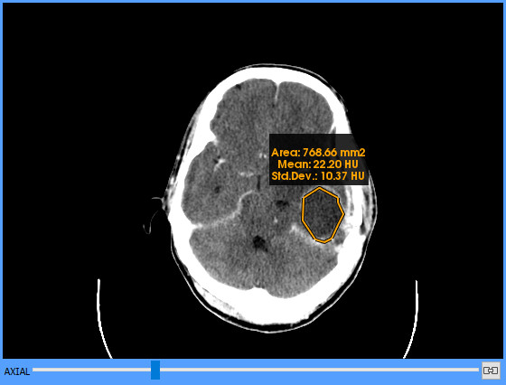
Example

Magical ROI

Function
It allows the creation of a region of interest that automatically expands to include neighbouring pixels with an intensity value similar to the initial point where the ROI has been started. The range of values that are considered to be similar is controlled with the tool itself.
Shortcut
M
Mode of operation
Press and hold down the left mouse button  at a point of the area that has to be included in the ROI. While holding down the left button , drag the mouse away from the point in any direction to expand the area included in the ROI, and near the starting point to reduce it. When the area is the desired one, release the left button . The ROI measurements are then calculated. A started ROI can be cancelled by pressing the Esc key before releasing the left button .
Viewer where it is applied
The viewer where the dragging has started.
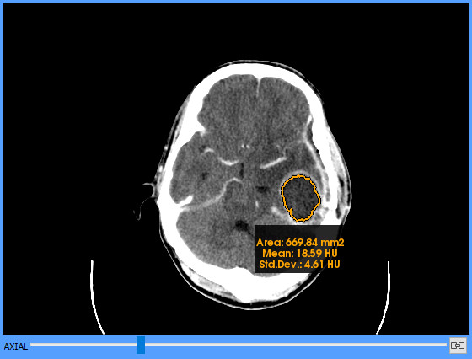
Example

Circle

Function
It allows the creation of a circular region and indicates its centre.
Mode of operation
Press and hold down the left mouse button  at a point on the edge of the circular region, drag the mouse and release the left button  at the opposite point on the edge of the circular region to finish the circle. The drawn circle passes through the two points and its diameter is the distance between them. Once the circle is finished, its centre is indicated by a cross hairs. A started circle can be cancelled by pressing the Esc key before releasing the left button .
Viewer where it is applied
The viewer where the dragging has started.
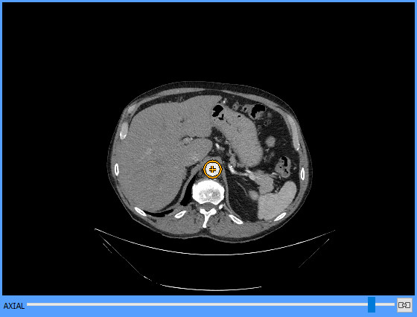
Example

Arrow

Function
It allows drawing an arrow.
Mode of operation
Click  on the starting point to begin drawing the arrow, and click  again on the ending point to finish it. The arrowhead is at the second point. A started arrow can be cancelled by pressing the Esc key before setting the second point.
Viewer where it is applied
The viewer where the clicks  are made.
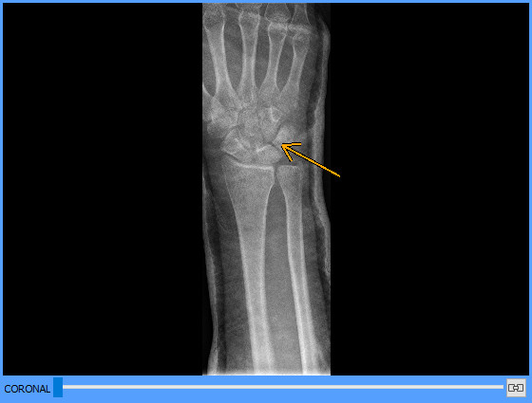
Example

Erase

Function
It allows erasing the measurements and drawings carried out with the other tools (distances, ROIs, angles, etc.). It is possible to erase objects one by one, those that lie within a rectangular area, or all those in a viewer.
Shortcuts
E (to enable the erasing tool) i Ctrl+E (to erase all measurements and drawings in the selected viewer)
Mode of operation
To erase a drawing or a measurement, click  on it. To erase the drawings and measurements that lie in a rectangular area, draw this area by dragging the mouse while holding down the left button . To erase all measurements and drawings in a viewer, select the viewer and click  the All of current viewer option in the Erase button menu or press the corresponding shortcuts.
Viewer where it is applied
The viewer where the clicks  or the dragging are made, or the active viewer (with the blue frame) when erasing all drawings.
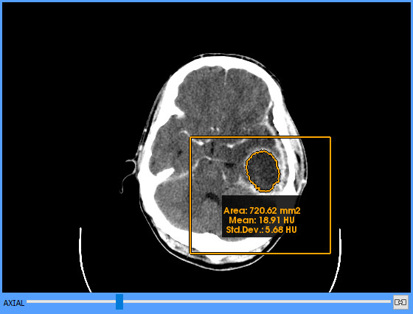
Example

Considerations on geometric measurements

Units and types of measurements
The units displayed in the geometric measurements, mainly distances and ROI, may vary depending on the presence of certain DICOM attributes. Additionally, depending on the image modality and according to the present attributes, the application may give one or more results for the same measurement, each one with its corresponding meaning. When needed, the type of measurement will be explicitly indicated to avoid confusion with the default measurement type.
The cases where each unit and each measurement type may be given are detailed below.
All geometric measurements are always displayed together with their corresponding unit, be they pixels (px) or millimetres (mm).

Measurements in pixels
The measurements are displayed in pixels (px) when it is not possible to determine the physical space between two consecutive pixels. This occurs in the absence of the following attributes in the image:
- Pixel Spacing (0028,0030)
- Imager Pixel Spacing (0018,1164)

Measurements in millimetres
For the measurements to be shown in millimetres, at least one of the following attributes must be present in the image:
- Pixel Spacing (0028,0030)
- Imager Pixel Spacing (0018,1164)
In this case, additionally, depending on the modality, the present attributes and the corresponding values, more than one value may be calculated in the same measurement where each value has a specific meaning. The different types of measurement values that may be given and their possible conditions are detailed below.

Physical measurements
Measurements are considered to be physical when the following conditions are met:
- The image modality is CT, MR, PT, SC, US or NM
- There is the Pixel Spacing (0028,0030) attribute and it has a valid value
The Pixel Spacing attribute determines the physical space between two consecutive pixels, so the measurement taken on the image corresponds to the actual physical measurement on the patient.

Measurements in projection radiography images
When dealing with projection radiography images (those of CR, DX, RF, MG, XA, XC, IO, OP or ES modality), their own nature implies that different spacing attributes may be provided which make it possible to calculate different types of measurements. The different scenarios that may occur are described below.
Measurement in detector
Measurements are considered relative to the detector’s plane when one of the following conditions is met:
- The Imager Pixel Spacing (0018,1164) attribute is the only spacing attribute present
- The image contains both Imager Pixel Spacing (0018,1164) and Pixel Spacing (0028,0030) attributes and they have the same value
In projection radiography images, if no type is explicitly indicated, the default measurement is relative to the detector.
Calibrated measurement
The calibrated measurements may be given when the following condition is met:
- The image contains both Imager Pixel Spacing (0018,1164) and Pixel Spacing (0028,0030) attributes and they have different values
In this case, Imager Pixel Spacing (0018,1164) indicates the spacing corresponding to the detector’s plane, and Pixel Spacing (0028,0030) a calibrated spacing that approximates the spacing to the image plane. This circumstance allows giving two measurements, that of the detector and the calibrated one.
If a calibrated measurement is displayed, it is always explicitly stated that it is calibrated, regardless of whether it is the only one displayed or whether there is also that of the detector.
Magnified measurement
This case is similar to that of calibrated measurements, but it is specific to MG modality images. Magnified measurements may be given when the following conditions are met:
- Image modality is MG
- The image contains the Imager Pixel Spacing (0018,1164) and Estimated Radiographic Magnification Factor (0018,1114) attributes
In this case, the calibration between the detector and the image plane is done by dividing the value of the Imager Pixel Spacing by the value of the Estimated Radiographic Magnification Factor. This circumstance also allows giving two measurements, that of the detector and the magnified one.
If the magnified one is displayed, whether or not together with the measurement from the detector, it will always be displayed together with a label that explicitly indicates that the value of the measurement corresponds to the magnified one.
If a magnified measurement is displayed, it is always explicitly stated that it is magnified, regardless of whether it is the only one displayed or whether there is also that of the detector.
Unknown meaning measurement
This scenario occurs when, according to the modality and the present attributes, the meaning of the measurement cannot be determined due to the lack of information. A measure is considered to be of unknown meaning when the following conditions are met:
- The image modality is a projection radiography modality (CR, DX, RF, XA, XC, MG, IO, OP or ES)
- The Pixel Spacing (0028,0030) attribute is the only spacing attribute present
If an unknown meaning measurement is displayed, it is always explicitly stated that it is of unknown meaning.
The fact that such a measurement is given is not normal and may indicate that there is an error or a problem in the generation of data of the acquired image. This problem should be reported to the modality’s technical team to correct it and properly generate the data.

Priority of measurements
As in some cases different types of measurements can be given, there must be clear criteria on what priorities are established between them according to each case.
- If the image is a projection radiography image:
  - If the measurement does not come with a label and it is displayed in mm, then it is a measurement relative to the detector’s spacing
  - If the measurement can be given calibrated or magnified, this value is given as a priority together with a label that explicitly states this condition
- If the image is not a projection radiography image, then it is a physical measurement (mm) and does not come with any label
- If the conditions for an unknown measurement are met, the measurement comes with a label that explicitly states this condition

Measurements verbosity
Given that Starviewer can sometimes calculate more than one result for the same measurement, users might want to have more or less information depending on their preferences. Starviewer allows choosing the verbosity of the measurements:
- Minimal: A single measurement is displayed (the one with highest priority if more than one can be calculated). The label for the measurements in the detector is not displayed. This is the default option.
- Minimal explicit: Only one measurement is displayed, as in the Minimal verbosity, but in this case the type of measurement is always indicated, also for the measurements in the detector.
- Verbose: All measurements that can be calculated according to the image are displayed. The label for the measurements in the detector is not displayed.
- Verbose explicit: All measurements that can be calculated according to the image are displayed, and the type of measurement is indicated also for the measurements in the detector.
The verbosity can be configured in the 2D viewer configuration options.

Accuracy and precision
In simple terms, accuracy measures how close the results are to the reality, while precision measures how much they vary when performing repeated measurements of the same thing.
In Starviewer, the precision of measurements is limited mainly by the precision of the user or the input device (the mouse) when trying to perform the same measurement, and also by the image resolution. On a lower degree, it is also limited by the precision of the DICOM Value Representation DS (Decimal String), the precision of the C++ double type,, and the precision of the FPU of the specific CPU.
On the other hand, accuracy depends on the calibration of the scanning device and the image resolution.
Accuracy has been verified with several measurement tests, including tests with reference images.
Numeric values in Starviewer are displayed with the following precisions:
- Distances, areas, statistical values and SUV are rounded to 2 decimal places
- Angles are rounded to 1 decimal place
- Window width and level are displayed with different rounding levels according to their magnitude in absolute value. Let x be the value of the window width or level:
  - If x ≥ 100, it is rounded to integer
  - If 1 ≤ x < 100, it is rounded to a maximum of 2 decimal places
  - If x < 1, it is rounded to 5 decimal places
- Pixel values are displayed with as many decimal places as needed (following the default C++ behaviour)

Advanced visualization

Reconstructions

Function
It changes the slice plane of the images.
Shortcuts
Ctrl+1 (axial), Ctrl+2 (sagittal), Ctrl+3 (coronal)
Mode of operation
Select the viewer where the reconstruction has to be changed and click  the corresponding icon. The image is immediately reconstructed with the selected plane.
Viewer where it is applied
The active viewer (with the blue frame).
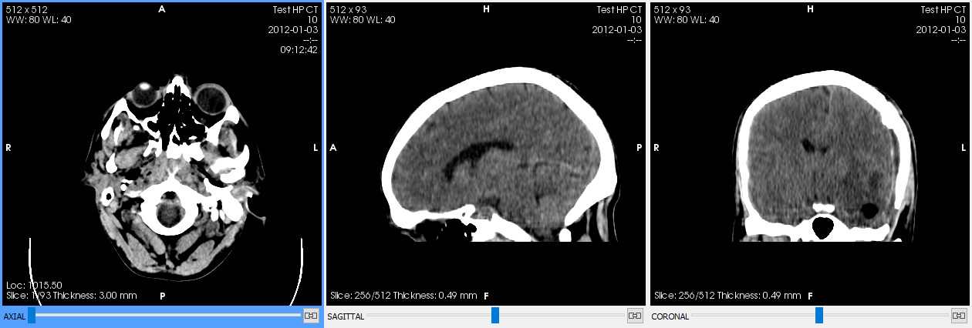
Examples

Change reconstruction in all viewers
Function
It changes the slice plane in all viewers.
Shortcuts
Ctrl+Shift+1 (axial), Ctrl+Shift+2 (sagittal), Ctrl+Shift+3 (coronal)
Mode of operation
Select any viewer and double click  or Shift+click  the corresponding icon. The image is immediately reconstructed with the selected plane in all viewers.
Viewer where it is applied
All.

Thick slab

Function
It assembles the information of a range of images in a single one. The available compositions are MIP (maximum intensity projection), MinIP (minimum intensity projection) and Average.
Mode of operation
Select the viewer where the thick slab has to be applied. Select the composition mode and the thickness next to the Thick Slab button; the Max. thickness option sets a thickness that includes all images with the current reconstruction. Finally, click  the Thick Slab button to enable it and click  again to disable it.
If the composition or thickness options are changed while the thick slab is enabled, changes are applied immediately.
Controls next to the button may initially be hidden if the Starviewer window is small; if so, they can be displayed by clicking  the little arrow next to the button or by directly enabling the thick slab.
Viewer where it is applied
The active viewer (with the blue frame).
Examples
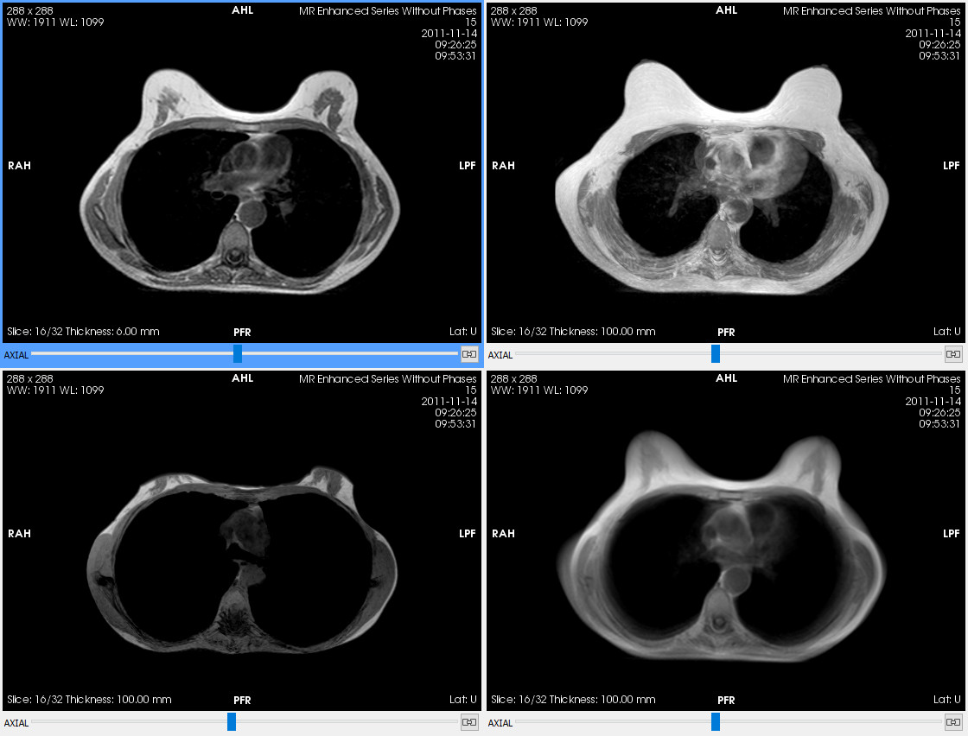Figure 14: Top left: a slice. Top right: MIP of 100 mm. Bottom left: MinIP of 100 mm. Bottom right: average of 100 mm.

Reference lines

Function
It allows visualising the intersection of the image plane of a viewer in all other viewers, helping to spatially locate the image.
Shortcut
L
Mode of operation
Click  on the toolbar button or press the shortcut to enable or disable the reference lines. While enabled, the image plane visible in the active viewer will be displayed in the form of two parallel lines in all the other viewers that meet the following conditions:
- That contains a series of the same study with the same Frame of Reference UID (0020,0052). This is usually the case if the patient has not moved between the series’ generation.
- That the angle between its image plane and that of the active viewer is between 45° and 135°. That is, if the active viewer is in axial, reference lines may be shown in sagittal and coronal viewers, but not in other axial ones.
Reference lines are usually displayed as two parallel lines to indicate the thickness of the image visible in the selected viewer. This thickness is the one defined by the DICOM data, or by the pixel spacing if it is a reconstruction, or the slice thickness if the thick slab tool is enabled. If it is an unreconstructed image and it does not have a defined thickness, a single line is displayed.
Viewer where it is applied
All those that meet the aforementioned conditions.
Example
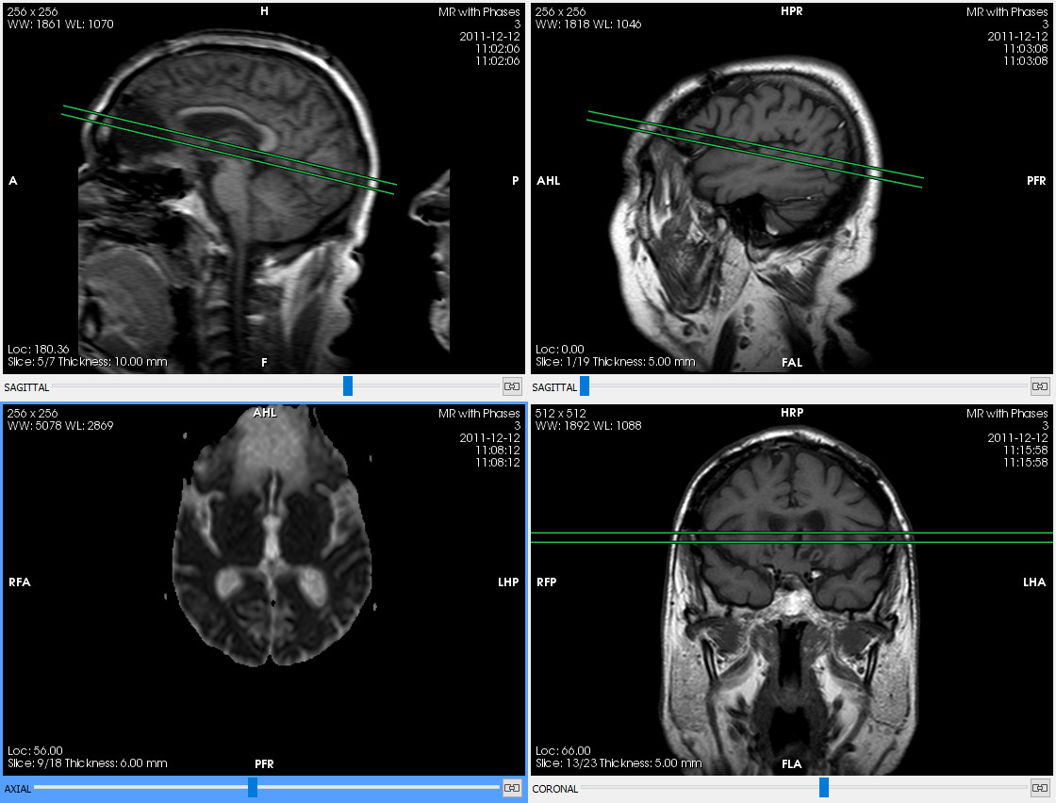Figure 15: The bottom-left viewer is selected and the plane of the current image, with a thickness of 6 mm, is projected on the other viewers.

3D cursor

Function
It allows marking a point of the image in a viewer and displaying the corresponding position in the other viewers.
Shortcut
C
Mode of operation
Click  on the toolbar button or press the shortcut to enable the 3D cursor. Then click  on a point in the image of a viewer and the same point will be marked with a cross hairs in all the other viewers that meet a condition, changing the displayed slice if needed. It is also possible to drag the mouse while holding down the left button  so that the other viewers are updated in real time. The condition for another viewer to be updated is that the series it displays is from the same study and has the same Frame of Reference UID (0020,0052) (this is usually the case if the patient has not moved between the series’ generation). To disable the 3D cursor, another tool has to be enabled.
Viewer where it is applied
All those that meet the aforementioned condition.
Example
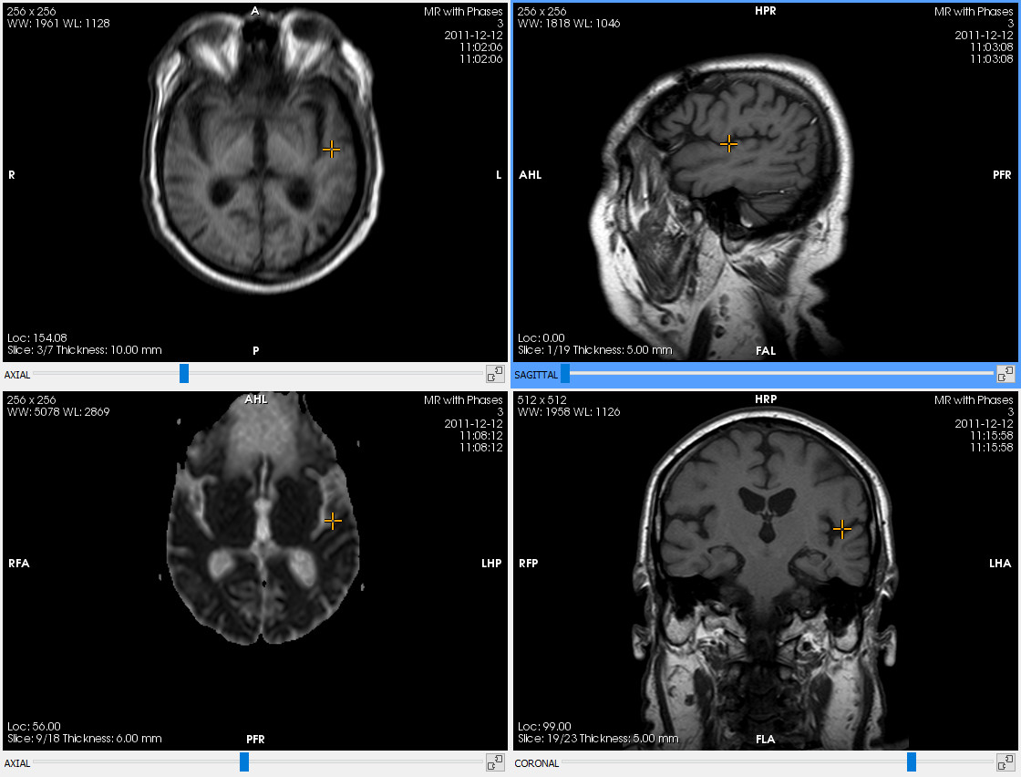Figure 16: A point has been marked in the top-right viewer, and the other viewers automatically indicate the same point of the space.

Cine

Function
It scrolls through the images automatically, as if it was a video. If the image has phases, it scrolls through the phases.
Mode of operation
Figure 17: Playback submenu.
Select the viewer where the images have to be automatically scrolled through and click  the toolbar button.
If the button’s submenu (Figure 17) is opened, different options that affect playback can be chosen:
- Scrolling speed
- Loop: if enabled, when it reaches the end it returns to the beginning and continues
- Boomerang: if enabled, it alternately scrolls through in one direction and in the other one by changing direction each time it reaches and end; it only works if the Loop is enabled at the same time.
Viewer where it is applied
The active viewer (with the blue frame). If the active viewer is changed while the tool is enabled, it affects the new active viewer.

Voxel information

Function
It shows the value or values of a specific point in the image (a voxel). As many values as voxel components are displayed (one value for greyscale images and 3 for colour images). For merged images, the values of both images are displayed. The value is displayed together with the corresponding units, if any (for example, HU (Hounsfield Units) in CT images). For PET images, the SUV is displayed.
Shortcut
V
Mode of operation
Click  on the toolbar button or press the shortcut to enable or disable the tool. With the tool enabled, hover the mouse over the image and the value of the voxel that is under the pointer at any given time will appear.
Viewer where it is applied
The viewer that is under the mouse pointer.
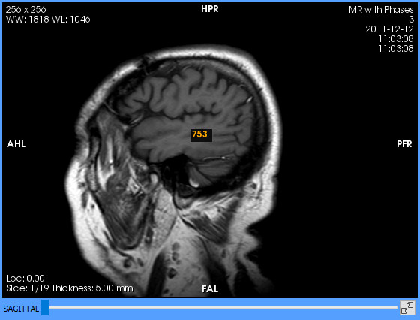
Example

DICOM information

Function
It opens a window that allows seeing all the information contained in the DICOM file of the image displayed in the selected viewer.
Mode of operation
Select the viewer and scroll to the image whose information has to be displayed. Click  on the toolbar button to open the window with the DICOM information. To see the information of another image, scroll to the other image and click  the toolbar button again to update the window’s information, no need to close it.
The window looks like this:
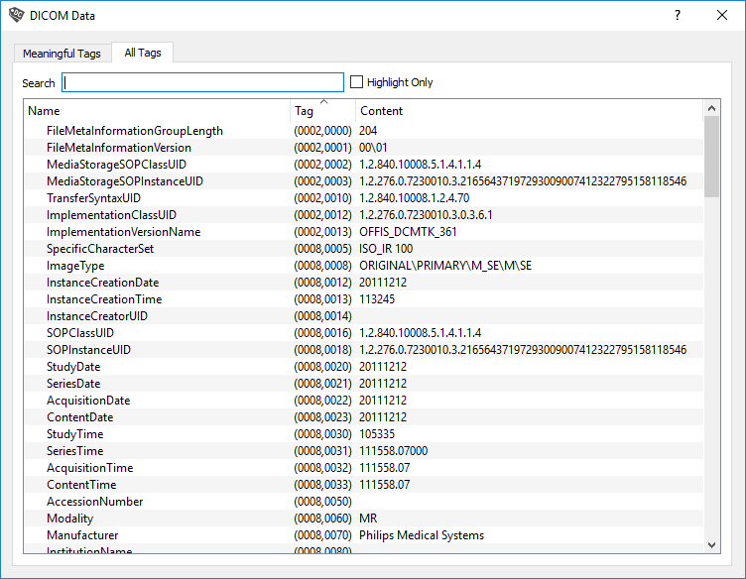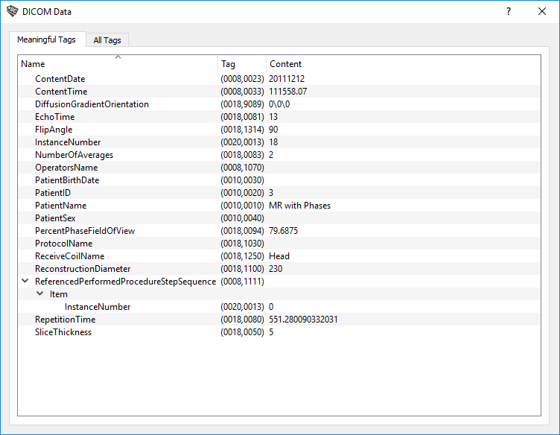Figure 18: DICOM information. Left: meaningful tags. Right: all tags.
The Meaningful tags tab displays a small subset of tags that are considered meaningful according to the modality. The All tags tab displays all the tags defined in the file and allows filtering them or highlighting some of them by using the Search box.
Viewer where it is applied
It displays the information related to the visible image in the active viewer (with the blue frame) when it is enabled.
Example
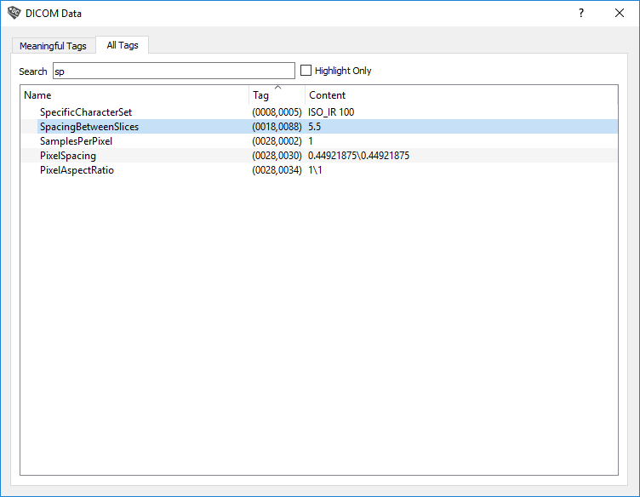Figure 19: DICOM information by filtering to find the Spacing Between Slices tag.

Manual synchronisation
Function
It synchronises a set of viewers so that when one of them changes the slice, the other synchronised viewers are moved the same distance (not the same number of slices). It is only applied to the synchronised viewers that have the same anatomical plane, that is, an axial can be synchronised with an axial, but not with a sagittal (the manual synchronisation in the latter case has no effect).
This tool synchronises the movement distance, not the number of slices.
When the manual synchronisation is enabled in a viewer, the automatic synchronisation is disabled.
Viewer where it is applied
All the viewers for which it has been enabled.
It can be enabled or disabled for each viewer individually or for all at once.

For each viewer

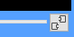
The button is placed in the bottom-right corner of each viewer:
Function
It enables or disables the manual synchronisation in a viewer.
Mode of operation
Click  the synchronisation button of the viewer to enable its synchronisation and click  on the button again to disable it.
The synchronisation button switches between the two icons to indicate whether a viewer is synchronised (closed chain) or not (open chain).
Viewer where it is applied
The viewer corresponding to the clicked  button.

For all viewers

Function
It enables or disables the manual synchronisation in all viewers at once.
Shortcuts
U (to enable it) and Shift+U (to disable it)
Mode of operation
Click  on the corresponding toolbar button or press the corresponding shortcut. The individual manual synchronisation buttons of each viewer are updated to reflect the new status.
Viewer where it is applied
All the viewers that have an image loaded.

Automatic synchronisation

Function
It synchronises all the viewers so that when one of them changes the slice, the other synchronised viewers are moved to the slice corresponding to the same position in the space. It is only applied to the synchronised viewers that have the same Frame of Reference UID (0020,0052) (this is usually the case if the patient has not moved between the series’ generation) and the same anatomical plane, that is, an axial can be synchronised with an axial, but not with a sagittal (the manual synchronisation in the latter case has no effect).
This tool synchronises the position in the space.
When the automatic synchronisation is enabled, the manual synchronisation is disabled in all viewers.
Shortcut
O
Mode of operation
Click  on the toolbar button or press the shortcut to enable or disable the automatic synchronisation. When enabled, each slice change in a viewer will be reproduced in those other ones that are compatible: same Frame of Reference UID (0020,0052) and same reconstruction.
Viewer where it is applied
All of them.

Propagation

Function
It propagates a set of visualisation properties from the active viewer to the other ones, so that these properties are reproduced in the other viewers following some criteria that vary for each visualisation property.
Shortcut
P
Mode of operation
Click  on the toolbar button or press the shortcut to enable or disable the propagation. When enabled, an initial propagation of the properties is carried out between all viewers giving priority to the active viewer at that time, so that the properties are synchronised from the beginning.
The toolbar button has a submenu that allows choosing what properties are propagated (by default they are all propagated):
- Image orientation: image orientation (rotation and horizontal or vertical flip) is propagated.
Synchronised viewers: those that have the same anatomical plane and the same modality as the active viewer, or between the PET-CT and SPECT-CT modality pairs.
- Pan: image position within the viewer is propagated between viewers that share the same coordinate system (the same Frame of Reference UID (0020,0052)); if the coordinate system is different, it cannot be guaranteed that the same position is seen between viewers, and hence panning is not propagated.
Synchronised viewers: those that have the same anatomical plane and the same Frame of Reference UID (0020,0052) as the active viewer.
- Phase: the phase is propagated.
Synchronised viewers: those whose secondary series (see 12.11 Fusion) is the main series of the active viewer.
- Thick slab: the composition mode and the thickness of the thick slab are propagated.
Synchronised viewers: those whose secondary series (see 12.11 Fusion) is the main series of the active viewer.
- VOI LUT: the window is propagated. If a default window is applied to the active viewer, the equivalent window is applied to the other ones (the automatic window of the active viewer corresponds to the automatic window of the other ones, the first DICOM window of one corresponds to the first DICOM window of the other, etc.); if it is a custom window, the absolute values of the window width and level are propagated.
Synchronised viewers: those that contain the same series as the active viewer. For merged visualisations, it is only applied to the matching series.
- Zoom: the absolute value of the zoom is propagated.
Synchronised viewers: those that have the same anatomical plane and the same modality as the active viewer, or between the PET-CT and SPECT-CT modality pairs.
One can configure propagation to be enabled by default for certain modalities, as explained in section 16.1 2D viewer. With the default settings it is enabled for CT, MR and PET modalities.
Examples
Propagation of window:
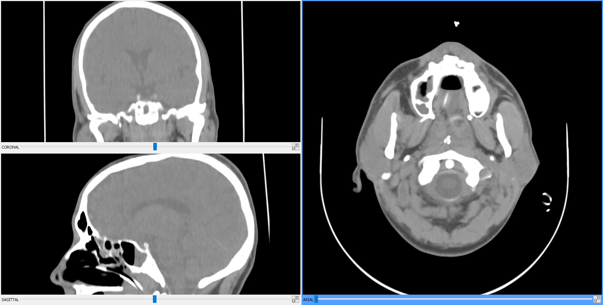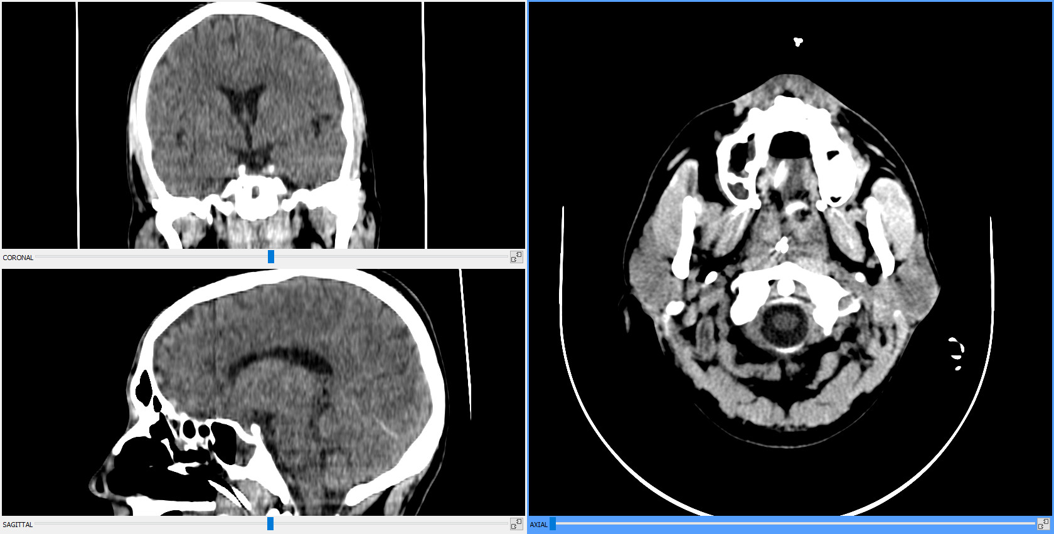Figure 20: Left: initial window. Right: window changed in the axial viewer and propagated to the other ones.
Propagation of zoom, pan and orientation:
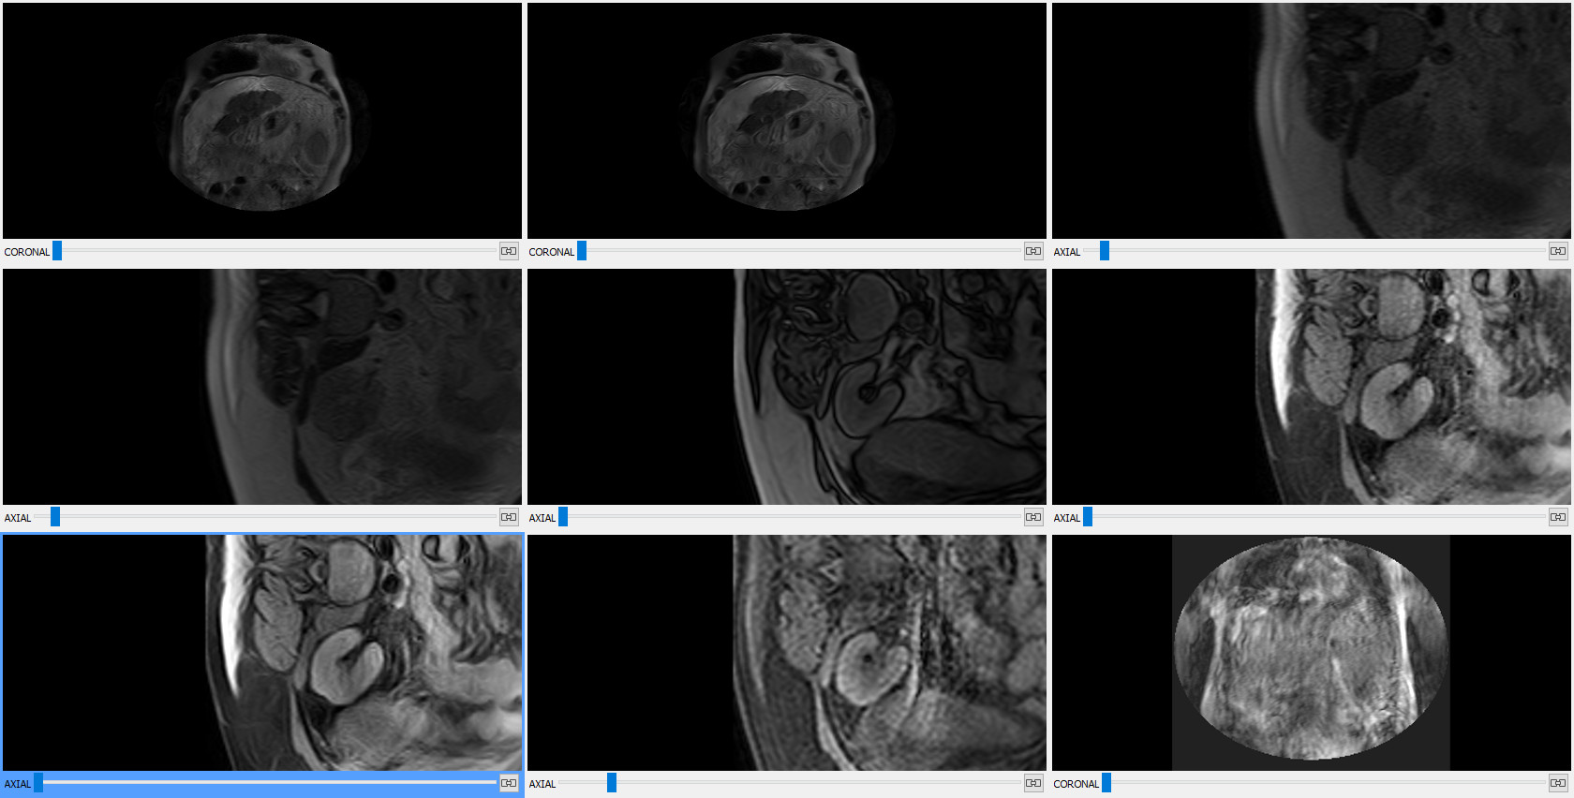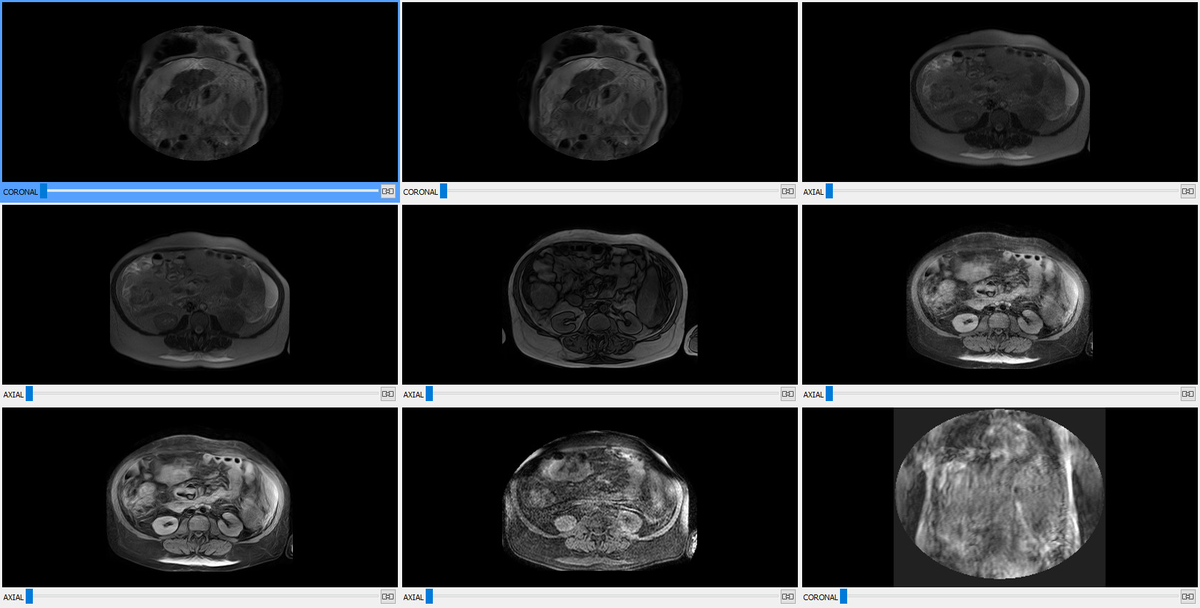Figure 21: Left: initial state. Right: zoom, pan and orientation changed in the bottom-left viewer and propagated to those with the same anatomical plane.

Propagation of thick slab:
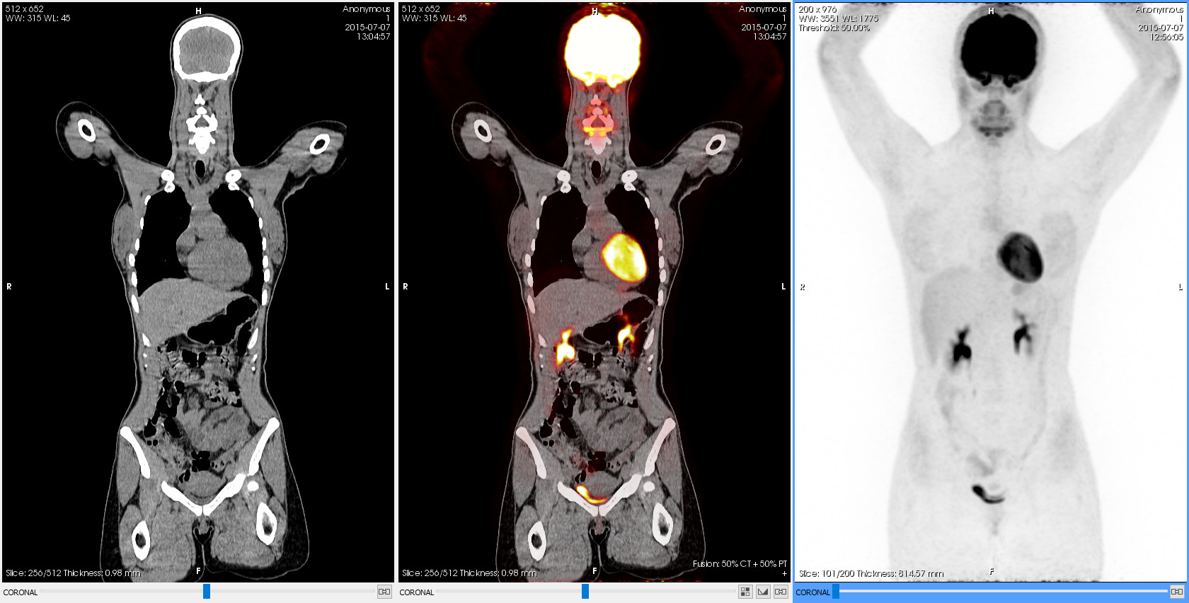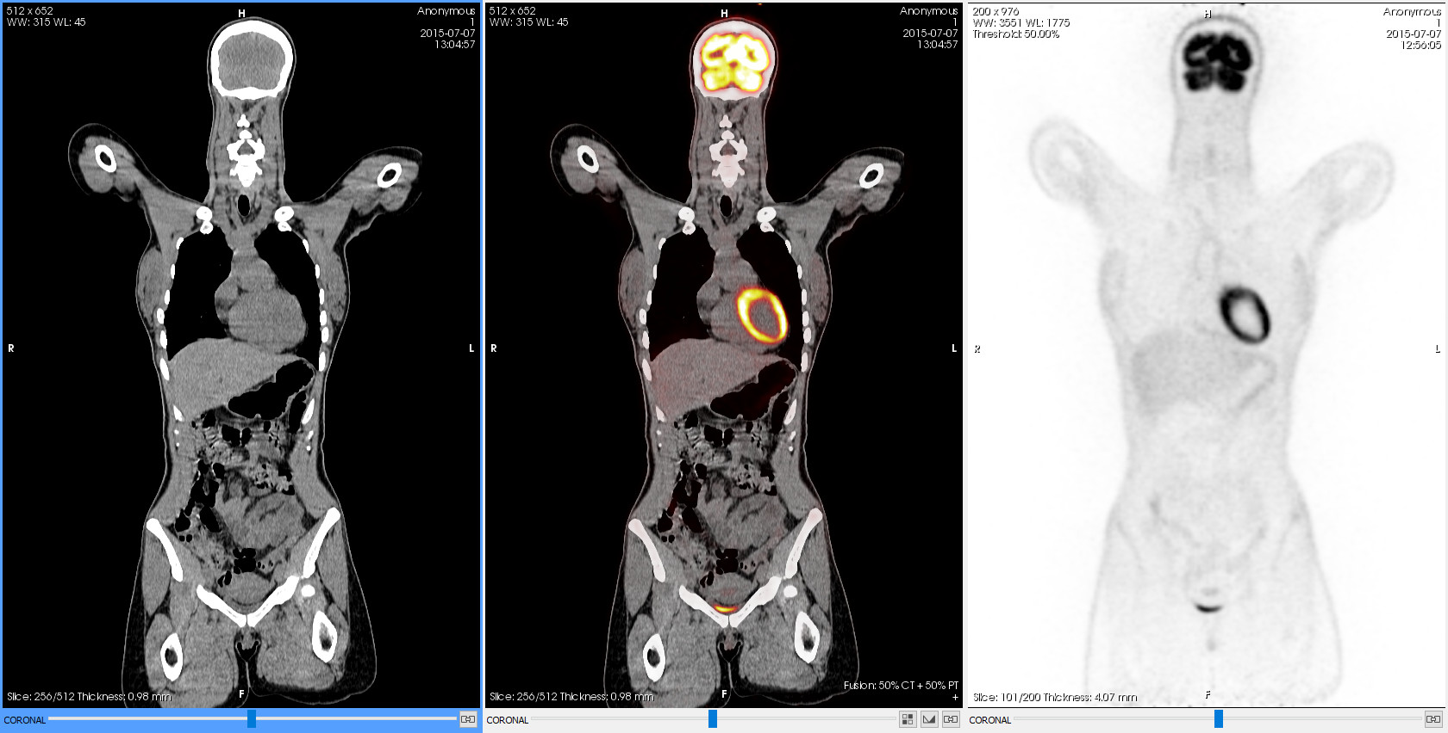Figure 22: Left: without thick slab. Right: Maximum thickness MIP applied to PET and propagated to the secondary series (PET) of the fusion.

Fusion
The fusion function allows displaying a combined visualisation of PET-CT or SPECT-CT. A fusion can be loaded from the same series selection menu, where all the available fusion combinations are shown after the individual series. For a CT series to be fused with a PET or SPECT one, the following conditions must be met:
- Both series have to share the same spatial identifier (Frame of Reference UID (0020,0052)), that is, that they are acquired in the same coordinate system.
- The CT series has to be contained in the space occupied by the PET or SPECT series, or vice versa.
There is also the option to apply a fusion hanging protocol. In this case, the above restrictions do not apply and any pair of images that meet the restrictions of the hanging protocol itself can be combined. Starviewer does not currently have any fusion hanging protocol as standard, but the user or a technician can create custom ones.
In a PET-CT or SPECT-CT fusion, the CT series is seen as the main series over which the PET or SPECT series is superimposed as the secondary one, partially transparent and with a colour function. Both series are permanently synchronised to show the same region of the space. If an area only available in the CT is explored, the PET or SPECT secondary series is not displayed.
The contribution of each series to the final fusion image is, by default, 50% of each series, but it can be adjusted with the fusion balance tool, which is displayed at the bottom of the viewer, next to the manual synchronisation button. The current balance can be seen at all times in the bottom-right corner of the viewer.
When a PET-CT or SPECT-CT fusion is displayed, some tools behave differently than when a single series is displayed:
- The selection of a colour function changes the colour of the PET or SPECT series instead of that of the main series.
- The voxel information tool displays two values, one from each series. For the PET image, the SUV is displayed whenever possible.
- The ROI tools, besides the corresponding ROI values of the CT image, show the maximum and average SUV for PET-CT, and the total and per mm² counts for SPECT-CT.
On the other hand, there are certain functionalities and tools that are not synchronised between the CT and PET or SPECT fused images, and they must be applied separately. When acting on the combined viewer, windowing, phase change and thick slab are only applied to the main series, that is, the CT one. To act on the secondary series, the PET or SPECT one, the propagation through a secondary viewer is needed. The PET or SPECT series has to be loaded in another viewer; then, through this viewer and with the propagation enabled, it is possible to synchronise and change the phase, the window or the thick slab of the fused PET or SPECT series. The exception is the window change of the secondary series, the «burning», which can be performed directly on the combined visualisation using the windowing tool by holding down the Shift key.
These differences are summarised in the following table:
Action | How to apply it to the primary image (CT) | How to apply it to the secondary image (PET or SPECT)
Windowing | Apply the action to the combined viewer | Apply the action to the combined viewer while holding down the Shift key; alternatively, apply the action to another viewer with the same PET or SPECT series with the propagation enabled.
Phase change  Thick slab | Apply the action to the combined viewer | Apply the action to another viewer with the same PET or SPECT series whith the propagation enabled
Colour function | Not applicable | Select the colour function on the combined viewer
The rest of functionalities and tools do not depend on the content of the image, so they behave exactly the same as with a simple visualisation.
The «burning» of the fusion (i.e. the window of the PET or SPECT image) can be adjusted by using the windowing tool on the combined viewer while holding down the Shift key.
Example
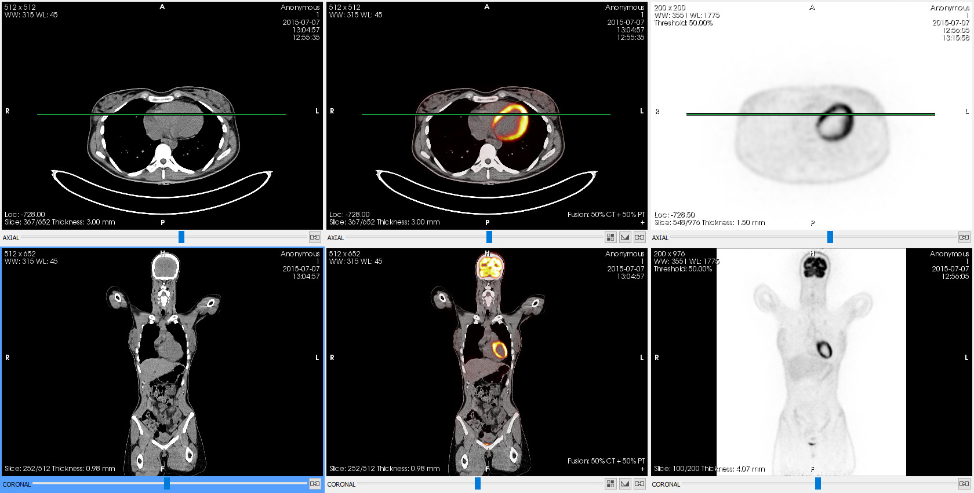Figure 23: PET-CT fusion with different views. In the columns, from left to right: CT, fusion, PET. In the rows, from top to bottom: axial and coronal.

Fusion layout

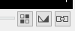
The button is placed at the bottom-right corner of the viewers that display a fusion:
Function
It allows the application of a default fusion layout that includes different viewers with the fusion, the individual series and different reconstructions.
Mode of operation
Click  on the button and then click  on one of the provided layouts. The selected layout replaces the current window layout.
The following layouts are available:
- 2×1 CT: one viewer with the CT and one with the fusion, with the reconstruction of the original combined viewer
- 2×1 PT/NM: one viewer with the fusion and one with the PET or SPECT, with the reconstruction of the original combined viewer
- 3×1: one viewer with the CT, one with the fusion and one with the PET or SPECT, with the reconstruction of the original combined viewer
- 2×3 CT: one column with the CT and one with the fusion, and one row for each reconstruction (axial, coronal, sagittal)
- 2×3 PT/NM: one column with the fusion and one with the PET or SPECT, and one row for each reconstruction (axial, coronal, sagittal)
- 3×3: one column with the CT, one with the fusion and one with the PET or SPECT, and one row for each reconstruction (axial, coronal, sagittal)
- MPR R: the three reconstructions (axial, coronal, sagittal) with the fusion, with the axial one covering the right half of the window
Viewer where it is applied
All of them: the selected layout replaces the current window layout.
Example
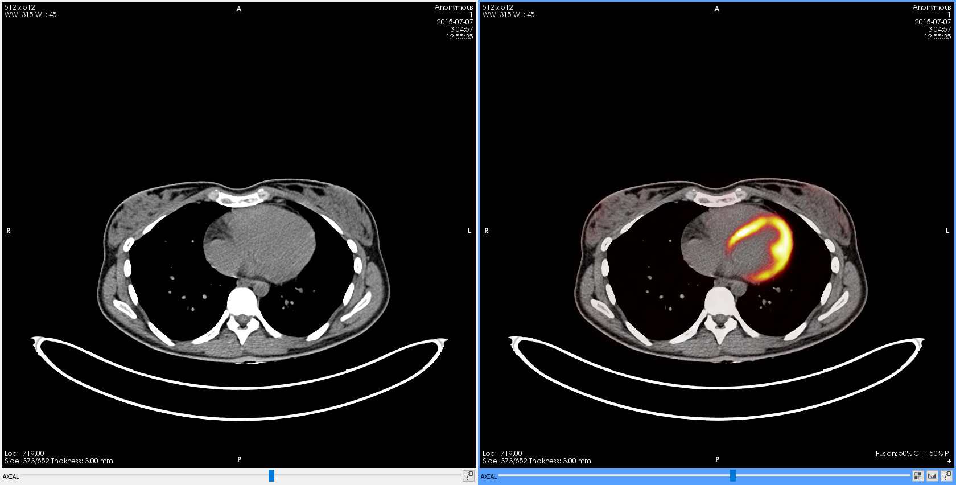
- Load a fusion in a viewer:

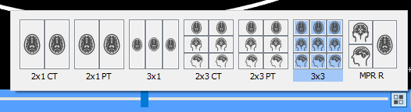
- Apply a fusion layout:
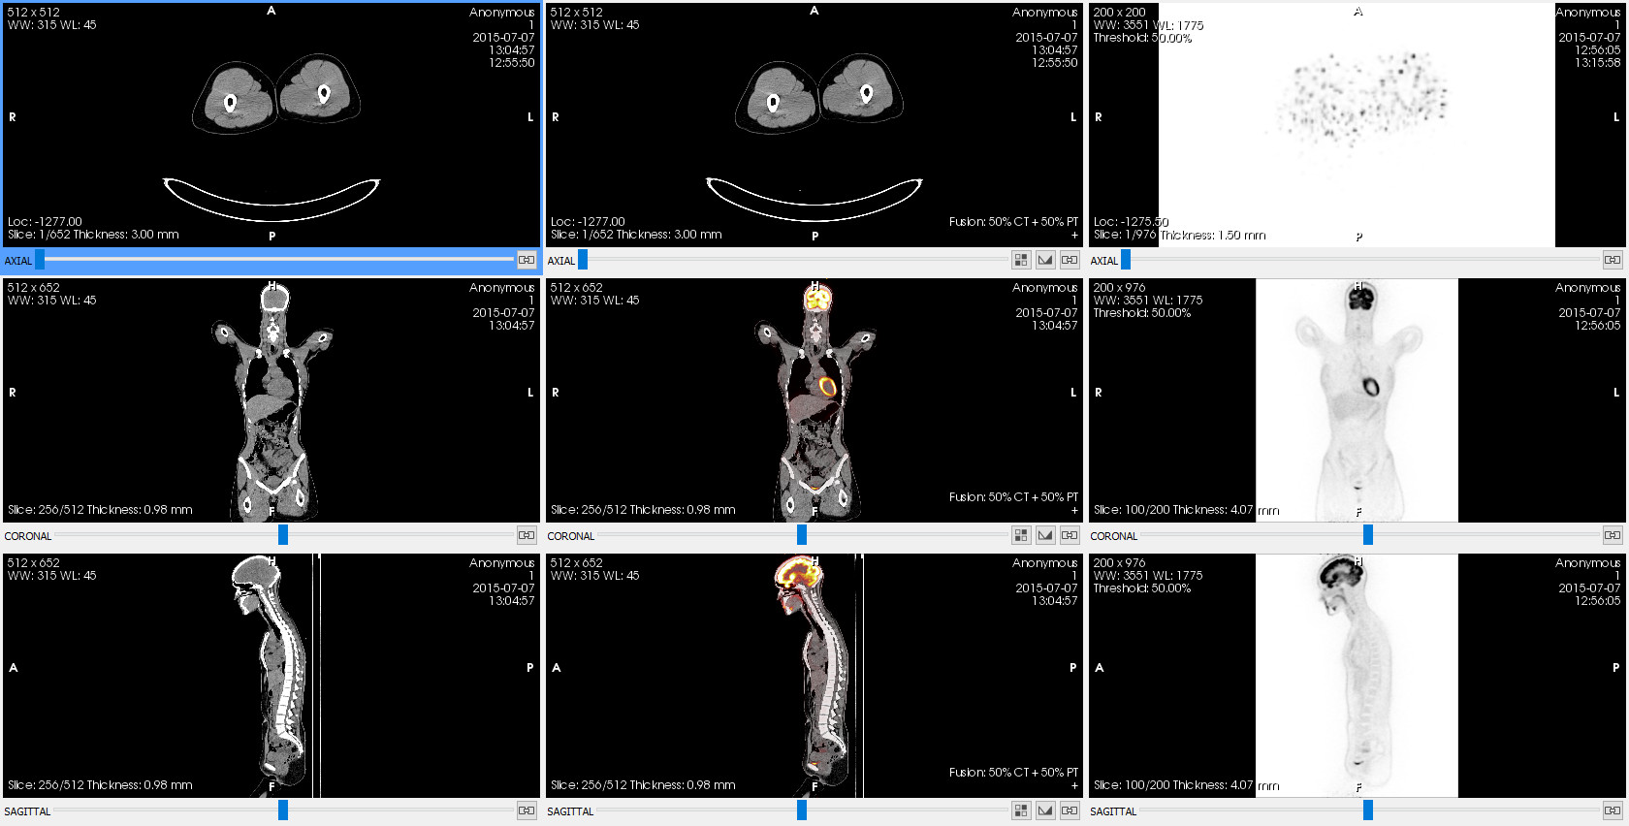
- Result:

Fusion balance

The button is placed at the bottom-right corner of the viewers that display a fusion:
Function
It controls the contribution of each individual image to the final fused image. This allows seeing only the primary image (balance 100%–0%), only the secondary (balance 0%–100%), or any combination in between that makes one of the images contribute more to the final result than the other one. The initial balance is always 50%–50%, so that both images have the same contribution to the final result.
Mode of operation
Click  on the button in a combined viewer; a slider will appear with which the balance can be adjusted to one side o to the other one.
Viewer where it is applied
The viewer whose button has been clicked .
Example
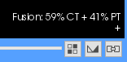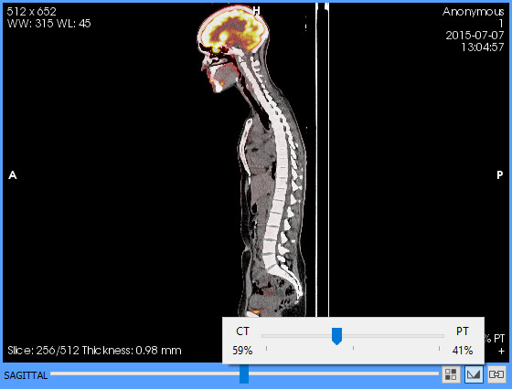Figure 24: Left: slider to control the fusion balance. Right: annotation to indicate the current fusion balance.

Standardised Uptake Value (SUV)
The SUV is a value commonly used in the PET modality image analysis. It is commonly defined as the ratio of the radioactive concentration C of the tissue [Bq/ml] at time t and the injected radioactivity, multiplied by a normalisation factor such as the body weight.
The SUV is computed when a ROI is drawn or the voxel information tool is used on a PET image or a PET-CT fusion. In the case of the ROI, the maximum and average SUV of the region is computed.
There are three normalisation methods available:
- Body weight
- Lean body mass
- Body surface area
The user can select the normalisation method in the 2D viewer configuration options. Body weight is used by default.
The normalisation method applied is indicated in the annotation that displays the SUV as follows:
- bw: body weight
- lbm: lean body mass
- bsa: body surface area
Each measurement is also displayed together with the corresponding units, which depend on the normalisation method:
- g/ml: for body weight and lean body mass
- cm²/ml: for body surface area

Formulae

SUV

Parameter | Description | Unit
C(t) | Radioactive concentration | Bq/ml
Dᵢ | Injected radioactive dose | Bq
d | Decay correction factor
N | Normalisation factor selected (body weight, lean body mass or body surface area) | g (body weight and lean body mass)  cm² (body surface area)

Decay correction factor
The injected dose Dᵢ to calculate the SUV is corrected by the radioactive decay factor that exists between the injection time and the beginning of the acquisition through the formula

Where:
- T_{1/2} is the half-life in seconds
- The calculation of Δt is given according to the value of the Decay Correction (0054,1102) DICOM attribute:
  - If it is START: Δt is the time interval between the administration of the dose and the acquisition of the image, in seconds
  - If it is ADMIN: Δt is 0
The calculation of the time interval is preferably done with the Series Date (0008,0021), Series Time (0008,0031) and Radiopharmaceutical Start Date Time (0018,1078) attributes.
If they are not available, it is done with the Series Time (0008,0031) and Radiopharmaceutical Start Time (0018,1072) attributes, assuming that the administration of the dose and the acquisition of the images have been done the same day.
If any of these attributes is also missing, the calculation of the SUV cannot be carried out.

Lean body mass
The lean body mass is calculated with two formulae, Morgan’s or James’, depending on the patient’s sex:
- Males (Morgan):
- Females (James):
Where:
- W is the weight of the patient in kg
- H is the height of the patient in cm

Body surface area
To obtain this value, the Du Bois’ formula is used:

Where:
- W is the weight of the patient in kg
- H is the height of the patient in cm

Required data
The following table indicates the DICOM attributes required for the SUV calculation. The lack of any of these attributes may make it impossible to calculate the SUV or some of the normalisation types.
Attribute | Description | Required for
(0010,1030) | Patient’s weight | All normalisations (bw, lbm, bsa)
(0010,1020) | Patient’s height | lbm and bsa
(0010,0040) | Patient’s sex | lbm
(0008,0021) | Series date | Decay correction factor
(0008,0031) | Series time | Decay correction factor
(0018,1078) | Dose administration date and time | Decay correction factor
(0018,1072) | Dose administration time | Decay correction factor
(0018,1075) | Half-life | Decay correction factor
(0018,1074) | Radioactive dose administered to the patient at the administration time | Injected radioactive dose
(0054,1001) | Units of pixel values | SUV: units determine whether it can be calculated or not

Manufacturer exclusive attributes
Depending on the manufacturer of the modality, some private attributes are needed to calculate the SUV.
Manufacturer | Attribute | Description | Required for
Philips | (7053,1009) | Pixel conversion factor | Converting pixel values to Bq/ml

MPR 2D viewer
The MPR 2D viewer allows performing reconstructions of a series in any cutting plane, even if it is not orthogonal. It allows manipulating two additional cutting planes that form the resulting images, thus being able to see images in planes different from the acquisition one.
The cutting planes can be moved as follows:
Movement | Operation
Rotation | Hover the pointer over one of the lines and drag the mouse in the desired direction while holding down the left button .
Positioning | Hover the pointer over one of the lines and drag the mouse in the desired direction while holding down the left button  and the Ctrl key.
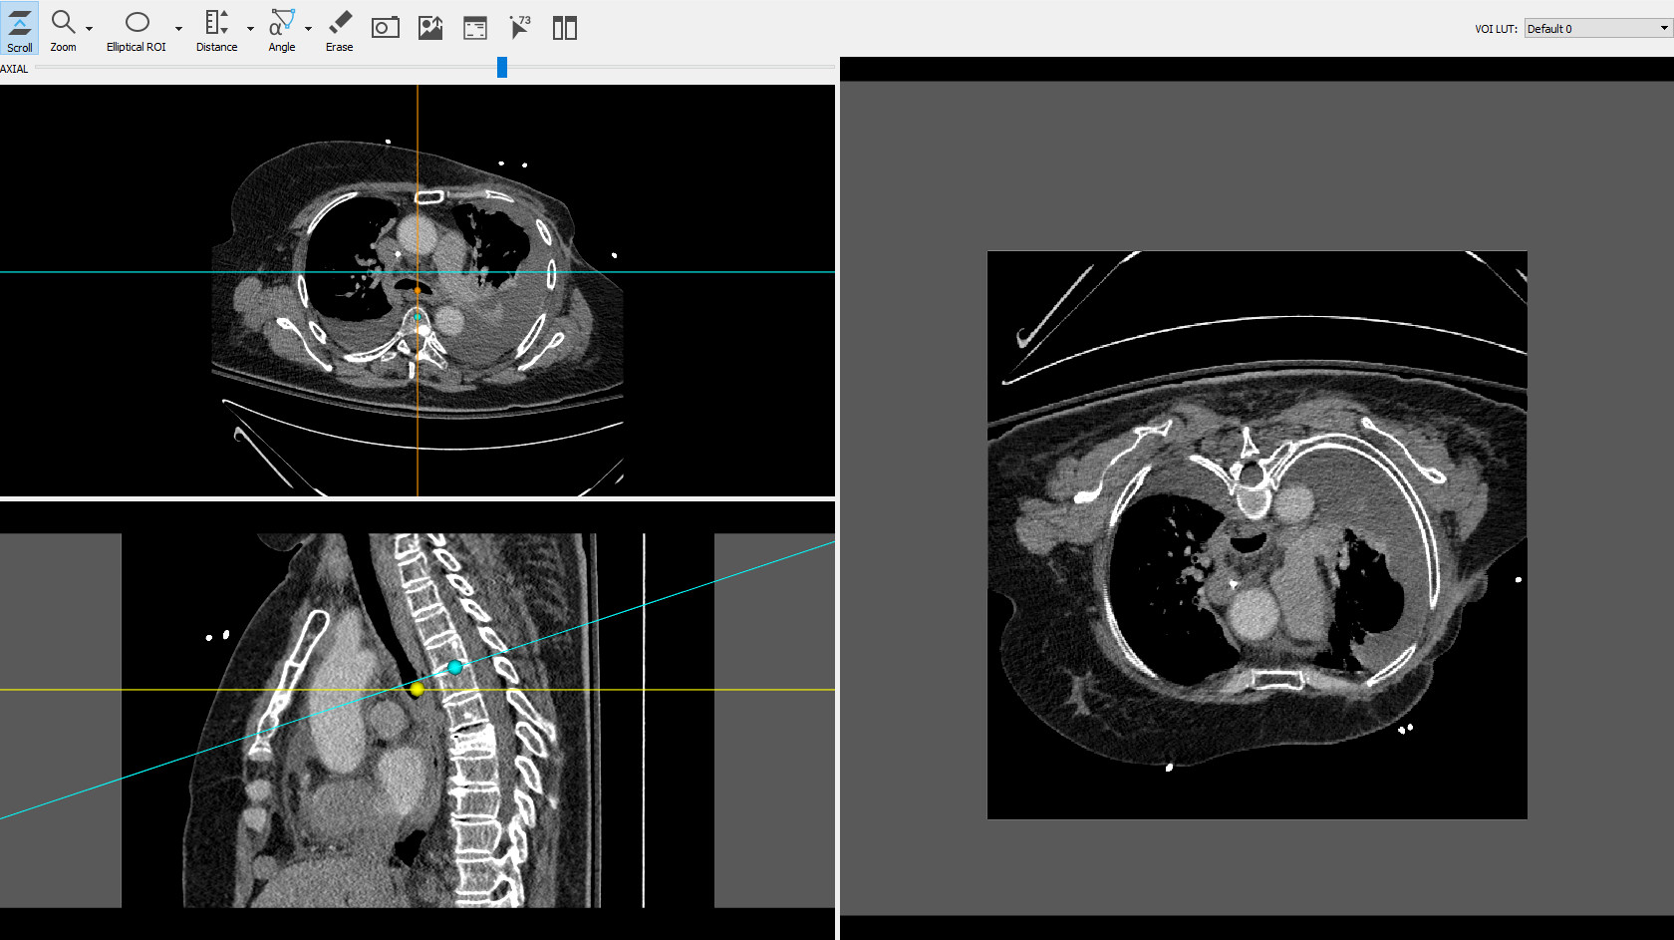
The spheres located on the lines indicate the rotation centre of the cutting planes.
The MPR 2D viewer also has different calculation tools:
- Distances, TA-GT
- Angles, Cobb angles
- Elliptical, polyline, magical ROIs (regions of interest)
- Circle
- Arrow
- Erase
And also general tools:
- Scroll
- Zoom
- Magnify
- Export a screenshot to an image format (.jpg, .png, .bmp, .tiff)
- Exporting to PACS
- Hide the patient's information of the viewer
- Visualise voxel information

3D viewer
It visualises all the information of a series in 3D by means of volume rendering, with tools that allow the application of different colour functions or clipping a part of the volume.
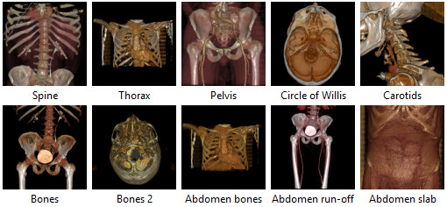
There are several default rendering styles that combine a transfer function (colour and opacity scale) with a set of parameters that affect the 3D rendering (mainly lighting parameters). The available default rendering styles are the following ones:
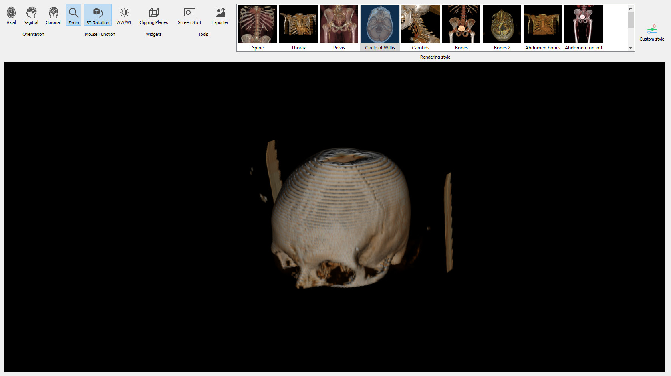
To apply one of these styles, double-click  on the corresponding image.
The 3D viewer has different tools:
- Switching views (axial, sagittal, coronal)
- Zoom
- 3D rotation
- WW/WL
- Pan
- Clipping planes (to clip the volume)
- Screenshot
- Sending image to PACS

Clipping planes

Function
It allows clipping a volume within a 3D viewer to remove areas of the volume that users do not want to visualise. These areas are hidden from the visualisation, but the information is not deleted, so that they can be visualised again by changing the clipping planes.
Shortcut
B
Mode of operation
When the tool is enabled, a box containing the volume appears. The part of the volume inside the box is visible, and the part that lies outside becomes invisible. The size, shape, orientation and position of the box can be interactively altered with different mouse actions and the volume rendering is updated at all times.

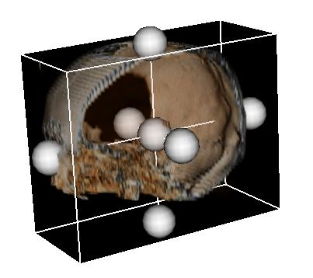
The box has six faces, and at the centre of each face there is a ball that allows modifying it. There is also a ball at the centre of the box that allows modifying the whole box.
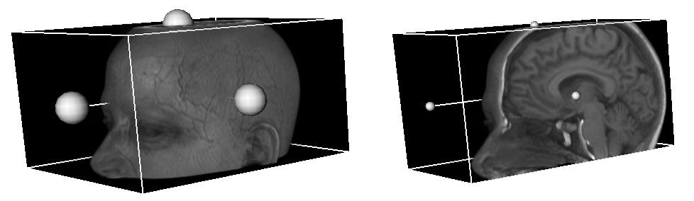
To clip on one face, click and hold down the left mouse button  on the ball of the corresponding face and drag it. This allows moving the plane along its normal.

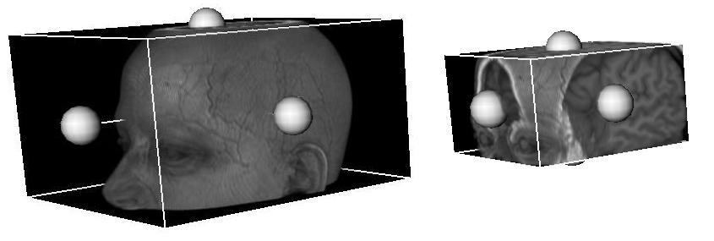
To scale the box, click and hold down the right mouse button  on the box or one of the balls, and drag up to expand the box or down to reduce it.
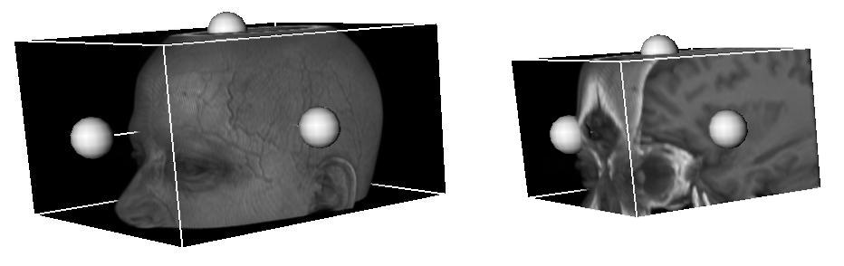
To move the box, click and hold down the middle mouse button or the wheel  on the box or one of the balls, and drag it in the desired direction.
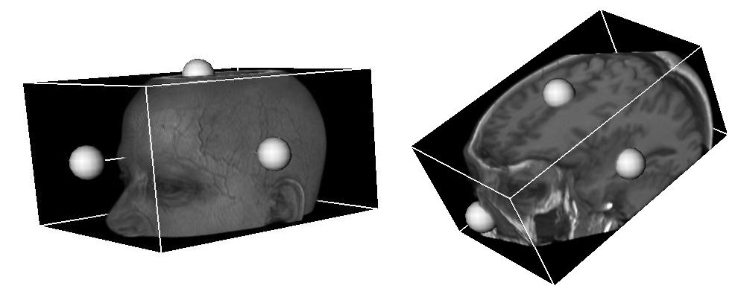
To rotate the box, click and hold down the left mouse button  on the box (not a ball) and drag in the direction of rotation.
If the clipping planes tool is disabled, the volume is kept clipped. If the tool is enabled again, a new box appears that can be manipulated to show other parts of the volume or show it in its entirety again.
Viewer where it is applied
The 3D viewer.
Example
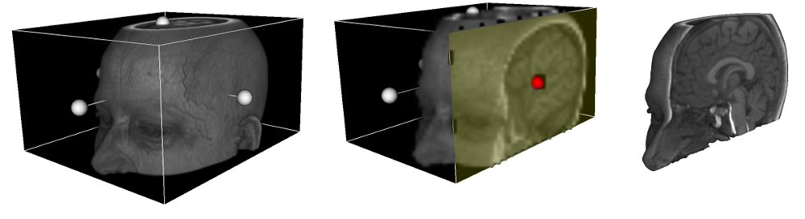Figure 25: Clipping planes in action. Left: initial state after enabling the tool; the balls at the centres of the planes can be seen. Centre: moving a face (the one with a different colour and the red ball) to clip the volume. Right: final state after clipping and disabling the clipping planes tool to hide the box.

3D rotation

Function
It allows rotating a volume within a 3D viewer.
Shortcut
Q
Mode of operation
Drag the mouse while holding down the right button  to rotate the volume in the direction of the movement. If the Ctrl key is held down while dragging, a rotation is made around the axis perpendicular to the screen.
Viewer where it is applied
The 3D viewer.
Example
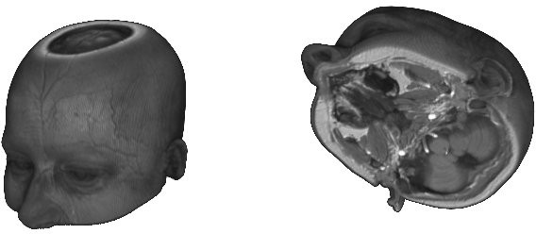Figure 26: Left: initial state. Right: after rotating the volume.

External applications
If external applications have been defined in the Starviewer configuration, these will be displayed in the Tools > External applications menu. To learn how to configure them, check section 16.8 External application.
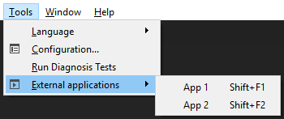
When clicking  on one of the menu’s elements, certain information (as configured) will be transmitted from the active viewer to the corresponding application. This allows the external application to know the current working context and act properly (for example, by showing the same study that is opened in Starviewer).

PDF
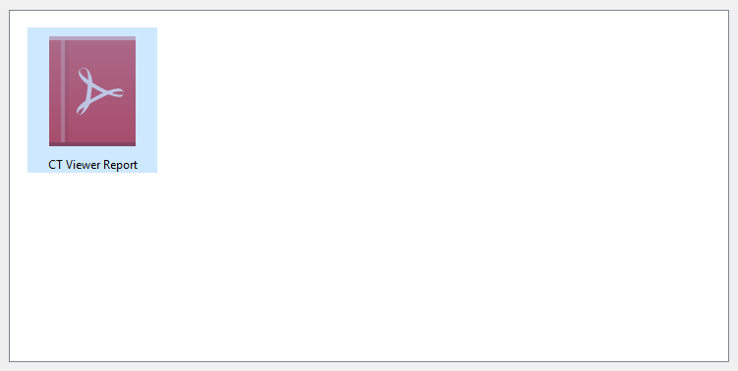
If one opens a study containing one or more series with encapsulated PDF, the PDF extension will be opened. It contains a list of icons representing the different encapsulated PDF contained in the study.
By double-clicking  on one of the icons, the corresponding PDF is de-encapsulated and opened with the system’s default PDF viewer.

Diagnosis tests
Diagnosis tests allow to check if Starviewer and its environment are properly configured and the hardware meets the minimum requirements.
To access the diagnosis tests, go to the Tools > Run diagnosis tests menu. Its functionality is to verify a series of system parameters and run a set of tests that allow evaluating whether the system is well configured and meets the recommended requirements, and diagnosing errors and possible problems.
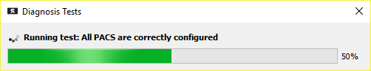
When selecting the menu, a window is opened informing that the tests are running and displaying a progress indicator.
Once the tests are completed, a window appears with the results. If no test has failed, users are informed that the tests have been completed successfully and they are offered the option to view the details of the results. If there are errors or warnings, a short message is displayed for each of them as well as another one to see the system information. By clicking  on each message, it can be expanded to see the details. At the bottom of the window there is a button to save the results and another one to close the window.
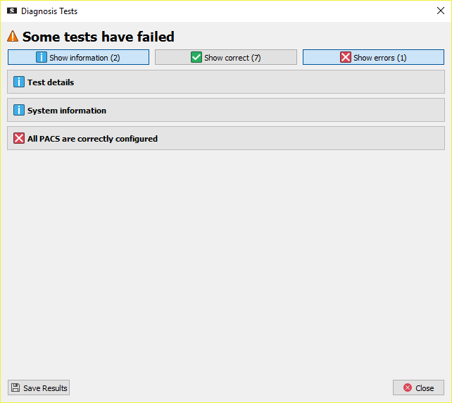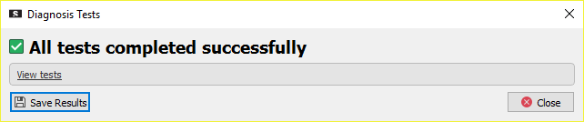Figure 27: Results of the diagnosis tests. Left: everything correct. Right: with errors.
Results are classified into three groups: the correct ones, the warnings and the errors. For each group there is a corresponding button to show or hide the results; by default, only the warnings and the errors are displayed, if any. The system information can always be viewed.
Correct results indicate that it has been possible to run the test and that the expected result has been obtained.
Warnings indicate that something is not properly configured, or that the application may not work as expected but can still be used. However, it is recommended not to have warnings.
When there is an error, the test may not have been run, or its result may not be correct.
With the details of warnings and errors, a hint is sometimes provided about how to solve them.
The Save results button allows saving the results of the tests to a file. This is useful to email them to the support address support@starviewer.udg.edu to help the developers diagnose a problem.

DICOM Print
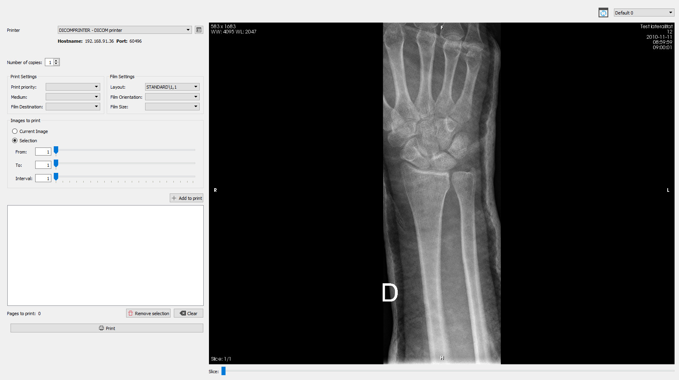
This extension allows printing images in DICOM format in DICOM printers. It can be accessed from the Visualization > DICOM Print menu.
In this window, the printing preferences are displayed on the left, and the image to be printed on the right. The viewer allows changing the image, the series and the patient study by using the patient menu (right button ). It also allows changing the window of the images by using the windowing tool or the selection of default windows tool. Finally, the image can be restored to the initial state with the restore tool, accessible through the toolbar button and the shortcut (Ctrl+R).
The left panel allows choosing different parameters such as:
- Printer (see 14.2 Add a printer)
- Number of copies
- Film size
- Film type
- Orientation
- Printing grid size
- Images to print: current or a range of images (see 14.1 Selection of images to print)

Selection of images to print
The printing tool allows printing one or several images, even from different series, on the same film. One or more images can be added for printing with the following steps:
- Select the series that contains the images in the viewer on the right.
- Select the images to print using the options in the Images to print box.
Images can be selected in different ways:
  - Current image: it adds only the current displayed image to the list of images to print.
  - Selection: it adds a subset of images from the series according to the following criteria:
    - From: initial image of the range.
    - To: final image of the range.
    - Interval: leap between images, that is, after how many images one is taken.
- Click  on the Add to print button.
The steps can be repeated as many times as needed until all the desired images have been added. Images can be removed from the printing list by selecting them in the list and clicking  the Remove selection button, or by clicking the Clear button to empty the list. To print the images, click  on the Print button.
Example
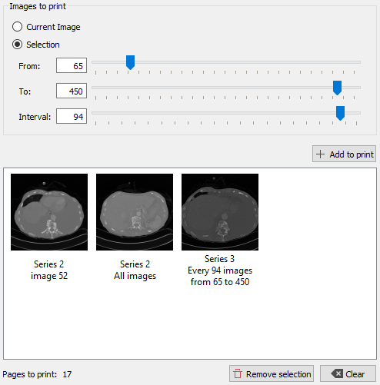Figure 28: Example of selection of images to print. Image 52 from series 2 has been selected to print, then all images from series 2, and finally those images from series 3 between 65 and 450 with an interval of 94, thus including images 65, 159, 253, 347 and 441. As indicated at the bottom left, 17 films will be printed, according to the print settings and format.

Add a printer
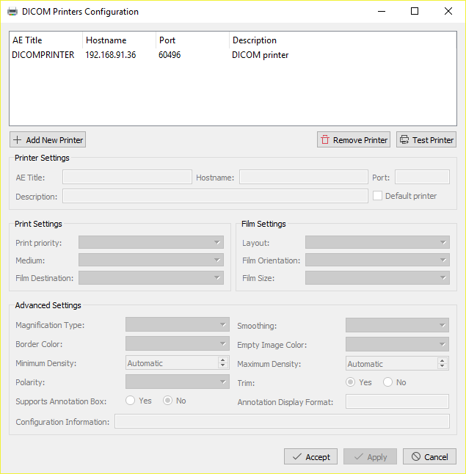
To add a printer, click  the button next to the printer selection drop-down menu ( icon). The following window appears:
The main actions in this window are:
- Add new printer: it opens a small window (Figure 29) that allows defining the main printer settings:
  - AE Title: name of the printer according to its DICOM configuration.
  - Hostname: IP address of the printer.
  - Port: printer listening port.
  - Description: short text to help users distinguish the printer.
  - Default printer: if the checkbox is checked, the printer will be set as the default printer, the one initially selected when the DICOM Print extension is opened (only one can be set as the default).
- Remove printer: it removes the selected printer from the list.
- Test printer: it checks the connection with the printer. If the test fails, it may be that the printer is not available or that some of the settings, such as the AE Title and the port, are incorrect.
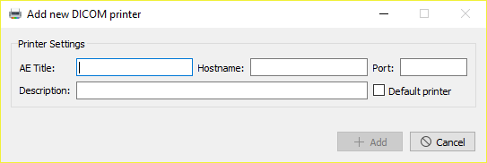Figure 29: Dialogue box to add a new printer.
After adding a printer or selecting one from the list, the other settings that appear in the window can be configured.
For advanced printer settings, check the application’s administrator guide.

Menus
In the menu bar the following elements are found:
- File
- Visualisation
- Tools
- Window
- Help

File
From this menu, it is possible to manage the data sources to be consulted and carry out a basic management of the application.
- New window: it opens a new Starviewer empty window. Shortcut: Ctrl+N.
- Local database studies: it opens the local database window to view and open studies previously retrieved. Shortcut: Ctrl+L.
- PACS: it opens the PACS query window to query and retrieve studies. Shortcut: Ctrl+P.
- Open DICOMDIR: it opens a window that allows opening a DICOMDIR stored on the computer, or an external drive, or a CD, etc. Shortcut: Ctrl+D.
- Open files: it allows opening local files in DICOM format (*.dcm) or other formats supported by Starviewer such as MetaImage (*.mhd). Shortcut: Ctrl+O.
- Open files from a directory: it allows opening all files in any supported format that are within a selected folder and its subfolders. Shortcut: Ctrl+Shift+D.
- Close: it closes the current window tab (extension). Shortcut: Ctrl+W.
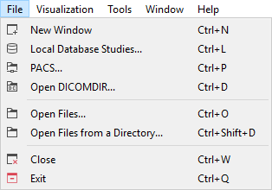
- Exit: it closes Starviewer. Shortcut: Ctrl+Q.

Visualisation
Once a study has been opened, users can choose between different viewer types or extensions that provide different functionalities:
- DICOM Print
- MPR 2D
- PDF (it is opened by default when a study containing encapsulated PDF is opened)
- 2D viewer (it is opened by default when a study is opened, unless it only contains encapsulated PDF)
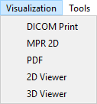
- 3D viewer
For each viewer or extension opened from this menu, a new tab appears. If the selected element is already opened, the corresponding tab is activated; a new one is not opened.

Tools
This menu includes several functionalities not related to opening or visualising images.
- Language: it allows changing the language of the application. After changing the language it is necessary to close and reopen Starviewer to implement the change.
- Configuration: it opens the configuration window.
- Run diagnosis tests: see section 13 Diagnosis tests.
- External applications: it allows running the external applications.
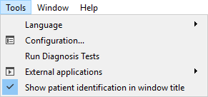
- Show patient identification in window title: it allows enabling or disabling the option of displaying the name and identifier of the patient in the title bar of the current Starviewer window. It is independent for each window and enabled by default.

Window
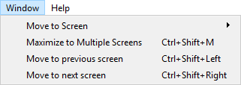
This menu allows moving the window to another screen or maximising it to take up multiple screens.

Move to screen
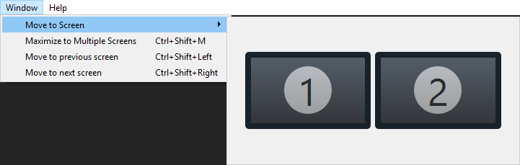
It moves the Starviewer window to a specific screen. The menu shows the current screen configuration. By clicking  one of the displayed screens, the window is sent to the corresponding screen.

Maximise to multiple screens
Shortcut: Ctrl+Shift+M.
Drawing 1: Example of maximisation to multiple screens. On the left the window is displayed in black and the screen layout in blue, in the initial state. On the right the result of maximising to multiple screens; the window has expanded taking up four screens horizontally.
This feature adjusts the size of the Starviewer window so that it takes up the maximum number of screens as long as they together form a rectangular space. Horizontal expansion is first considered, and then the vertical one.
Drawing 2: Another example of maximisation to multiple screens. On the left the window is displayed in black and the screen layout in blue, in the initial state. On the right the result of maximising to multiple screens; the window has expanded taking up six screens, two wide and three high.
Keep in mind that for the expansion to work, the screens must have exactly the same number of pixels at the edges that touch each other. Otherwise, a rectangular shape is not detected.

Move to previous screen
Shortcut: Ctrl+Shift+←
This function moves the window to the previous screen following a circular sequence as in Drawing 3.

Move to next screen
Shortcut: Ctrl+Shift+→
This function moves the window to the next screen following a circular sequence as in Drawing 3.
Drawing 3: Window movement sequence.

Help
This menu provides access to the guides, the log and information concerning Starviewer.
- User guide: it opens this user guide in PDF.
- Quick start guide: it opens the quick start guide in PDF, which explains the basic steps to get started with the program.
- Shortcuts guide: it opens a PDF document that indicates all the keyboard shortcuts in the application. The same information can be found in section 17 Keyboard shortcuts.
- Information about use as medical device: it shows a window with indications to ensure a proper use of Starviewer when used as a medical device for diagnosis in human patients.
- Show log file: it shows a window with the content of the log file that Starviewer generates with its use. The information it contains is often useful for developers to diagnose application problems.
- Release notes: it shows a window with the news, improvements and corrections of the last version of the program as well as of the previous ones.
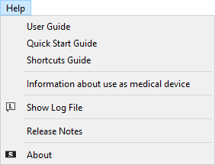
- About: it shows a window with information about Starviewer, including its version, support contact address, web, etc. The Licence information button shows information about Starviewer’s own and third-party licences.

Configurations
The configuration window, accessible from the Tools > Configuration menu, allows configuring various elements to fit the user’s preferences. Parameters are grouped into different sections which can be selected from the left panel of the window:
- 2D viewer
- 2D viewer layout
- PACS
- Local database
- RIS listener
- DICOMDIR
- External application
- Magnification
The options within each section are described below.

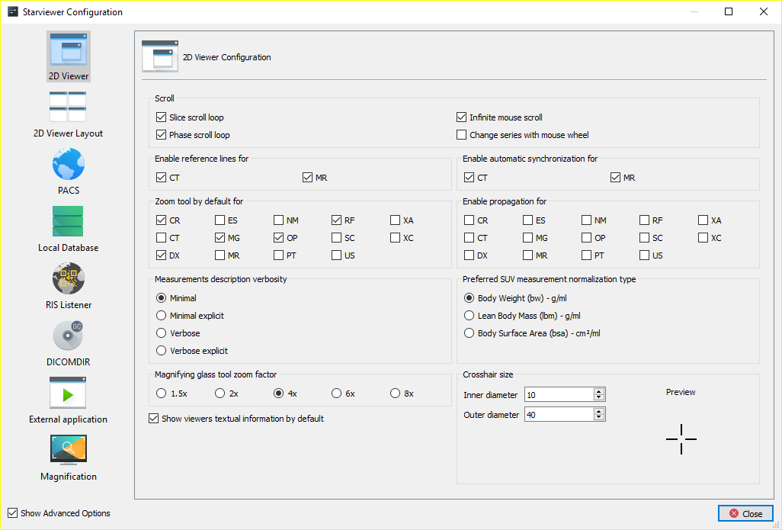
2D viewer
Options | Description | Default value
Slice scroll loop | It changes the behaviour of the image scrolling tool by doing a loop when it reaches an end, that is, the first comes after the last, and vice versa. | Disabled
Phase scroll loop | It changes the behaviour of the phase change tool by doing a loop when it reaches an end, that is, the first comes after the last, and vice versa. | Disabled
Infinite mouse scroll | It causes the mouse to teleport itself to the opposite end when it reaches an end of the viewer where it is acting, thus allowing a constant scrolling. | Enabled
Change series with mouse wheel | It causes the wheel to be used for navigating the series of a study in the same way as scrolling with the + and - keys. | Disabled
Enable reference lines for | It causes the reference lines to be automatically enabled when a study with one of the selected modalities is opened. | Enabled for MR
Enable automatic synchronisation for | It causes the automatic synchronisation to be automatically enabled when a study with one of the selected modalities is opened. | Enabled for MR and CT
Zoom tool by default for | When a study with one of the selected modalities is opened, the default tool is zoom instead of scrolling and phase change. | Enabled for CR, DX, MG, MR, OP and RF
Enable propagation for | It causes the propagation to be automatically enabled when a study with one of the selected modalities is opened. | Enabled for CT, MR and PT
Measurements description verbosity | It allows choosing the verbosity for measurements that may give more than one result depending on the existing image attributes. | Minimal
Preferred SUV measurement normalisation type | It allows choosing the normalisation factor used in SUV measurements. | Body weight
Magnifying glass tool zoom factor | It configures the zoom factor of the magnifying tool. | 4x
Cross hairs size | It allows setting the cross hairs size for the circle and 3D cursor tools. | 10, 30

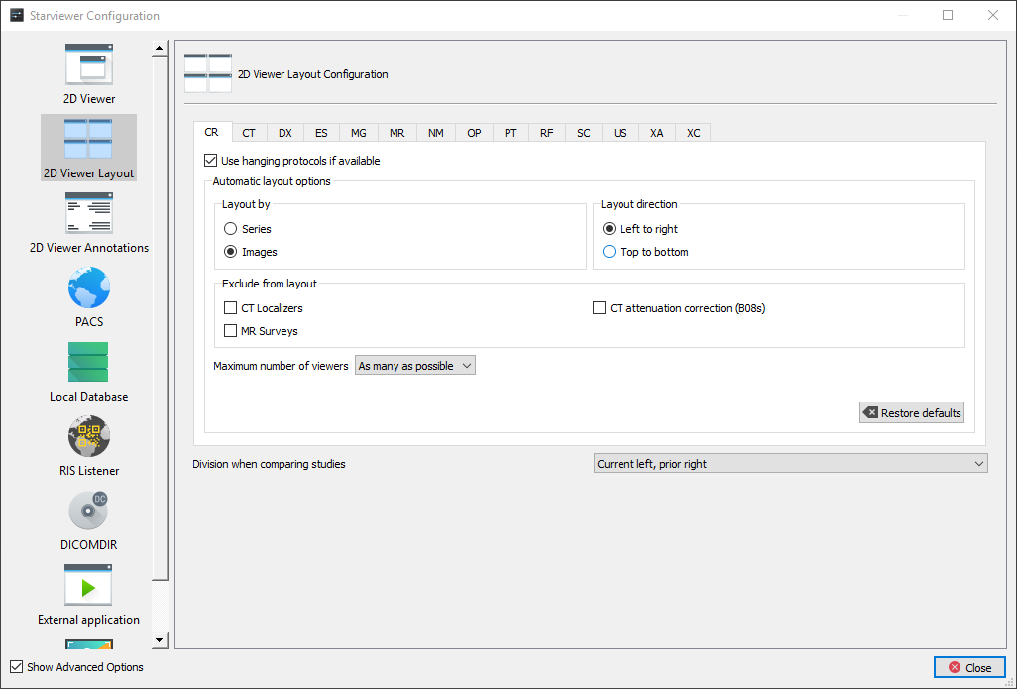
2D viewer layout
This section allows configuring how the 2D viewer images are laid out when a study is opened depending on the modality. There is a tab for each modality.
Options | Description | Default value
Use hanging protocols if available | If it is enabled and a study of the modality is opened, priority will be given to applying the best applicable hanging protocol. If it is disabled or there is no applicable hanging protocol, an automatic regular layout will be applied according to the parameters described in the following points. | Enabled for CR, CT, MG, MR and US
Layout by | If the layout is by series, each viewer is assigned a different series, sorted by series number. If the layout is by images, each viewer is assigned a different image, regardless of the series, sorted by series number and image number within the series. | Series for CT, MR, NM, PT, SC and XA; images for the rest.
Layout direction | It decides in which order the viewers of the grid are filled: by rows (left to right) or by columns (top to bottom). Always starting with the top-left viewer. | Left to right
Exclude from layout | It allows excluding some types of images from the regular layout that are considered little relevant. | CT localisers and CT attenuation correction (B08s) enabled for CT, and MR surveys enabled for MR
Maximum number of viewers | Maximum number of viewers that will be created with the automatic layout when the study is opened. No more viewers will be created even if there are series or images left to view. More viewers than necessary will also never be created if there are few series or images. | As many as possible (equivalent to 48)
Restore defaults | It restores the default values of the selected modality.
The last option, independent of modality, is Division when comparing studies and allows to choose how the window is divided in two halves when the Comparison of studies is activated. There are the following options:
- Current left, prior right (default)
- Current right, prior left
- Current top, prior bottom
- Current bottom, prior top

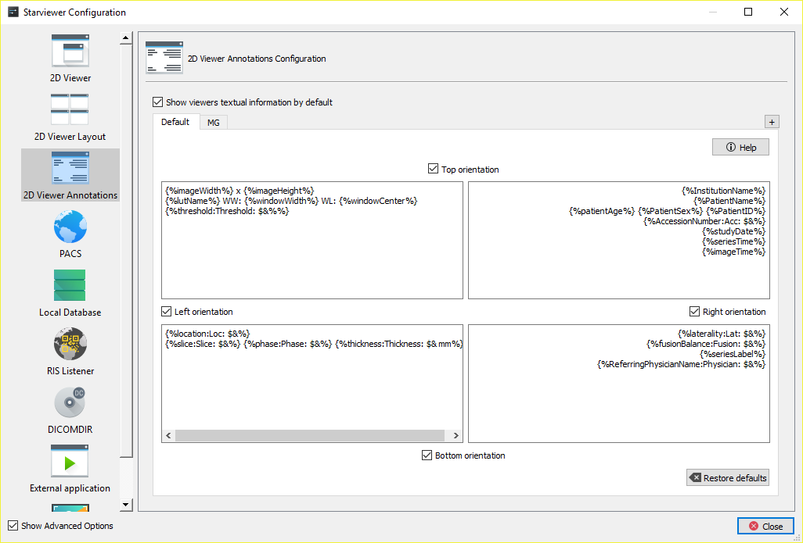
2D viewer annotations
This section allows to configure what textual information is shown in viewer depending on series modality.
The checkbox Show viewers textual information by default allows to choose whether textual information in viewers is shown by default when opening a study; by default it is checked.
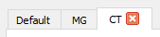
In the main section there are several tabs to configure annotations according to the modality of the visualised series. The first tab, Default, applies to all modalities that do not have a specific configuration. The second one, MG, is always present and applies to mammographies. With the + button new tabs for other modalities can be added, and they can be removed with the cross in each tab.
Each tab has the following elements:
- Text box to edit the Modality (except in Default, and not editable in MG).
- ​Help button: opens a help window with an explanation of how everything works and the list of recognised elements (variables and DICOM tags). Clicking  an element selects it to enable copying it. It can also be dragged and dropped to the desired position.
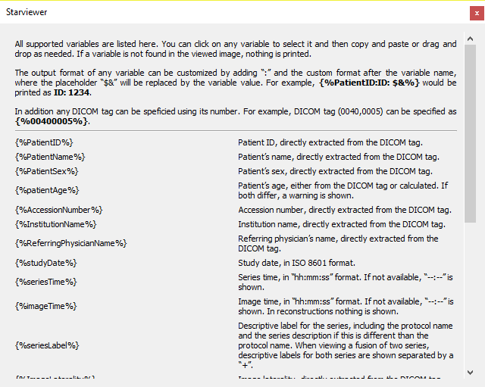
- Four checkboxes to show or hide each orientation annotation.
- Four text boxes to configure textual annotations in each corner.
- Checkbox Invert sides to avoid covering MG image (only in MG): in the case of mammographies this checkbox can be checked to switch the left and right annotations in order to avoid covering the image; in this case the default position is considered the left and thus the side inversion is applied when the image is right aligned. For the same reason this modality only has annotations in the right side by default. This option is enabled by default.
- ​Restore defaults button: restores the default values for the active tab.

PACS
This section allows configuring remote PACS servers and the parameters of the local node.

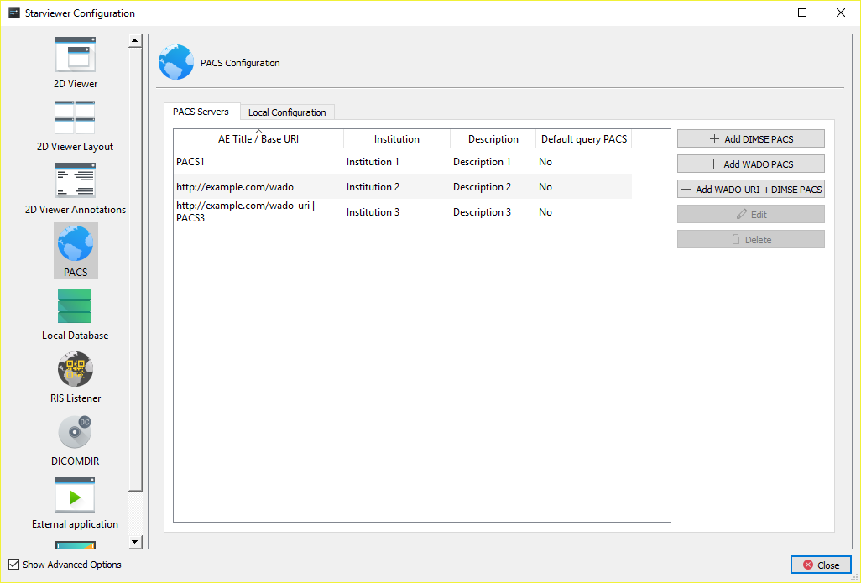
PACS servers
In this tab there is a list of the configured PACS servers, and to the right several buttons to add, modify or delete them.
Three types of servers can be added with the three corresponding buttons:
- DIMSE: to connect with a PACS using the DIMSE-C family of protocols from DICOM (C-FIND, C-MOVE, C-STORE), the oldest and most widely extended ones.
- WADO: to connect with a PACS using the WADO RESTful family of protocols from DICOM (QIDO-RS, WADO-RS, STOW-RS), the newest ones, based on HTTP and easier to configure, but less extended.
- WADO-URI + DIMSE: also called hybrid PACS, in this case the WADO-URI protocol is used for the searches and DIMSE-C (C-MOVE, C-STORE) to transfer the files.
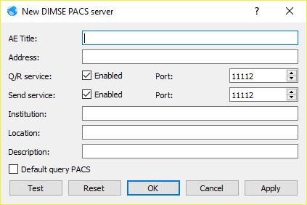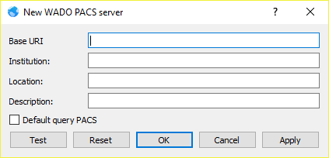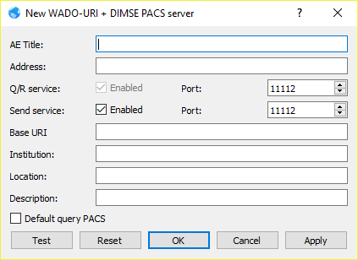Figure 30: Different variants of the dialogue to add a new PACS. Left: DIMSE PACS. Centre: WADO PACS. Right: hybrid PACS.
The Test button in the dialogue to add or edit a PACS allows testing whether a server is responding taking into account the current field settings.

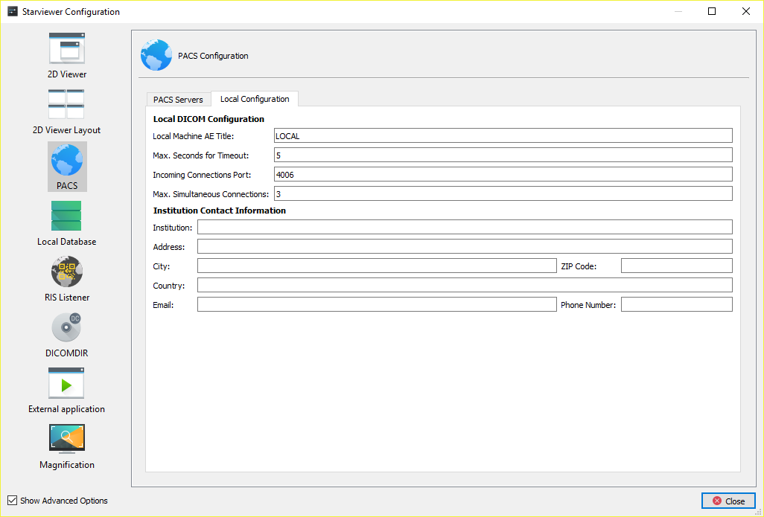
Local configuration
This tab allows configuring the connection settings of the local machine with the PACS servers.
Options | Description | Default value
Local machine AE Title | The DICOM identifier of this machine that is sent to the PACS. | The hostname of the machine
Incoming connections port | The port where Starviewer will be listened to retrieve studies from the PACS. | 4006
Maximum seconds for timeout | How many seconds to wait for a response from the PACS before giving up. | 20
Maximum simultaneous connections | Maximum number of connections that can be active at the same time, at any time, including queries and uploads; downloads are always carried out one by one. | 3
Institution contact information | It allows adding information about the institution. This information will appear in the readme.txt file in the DICOMDIR that are created.

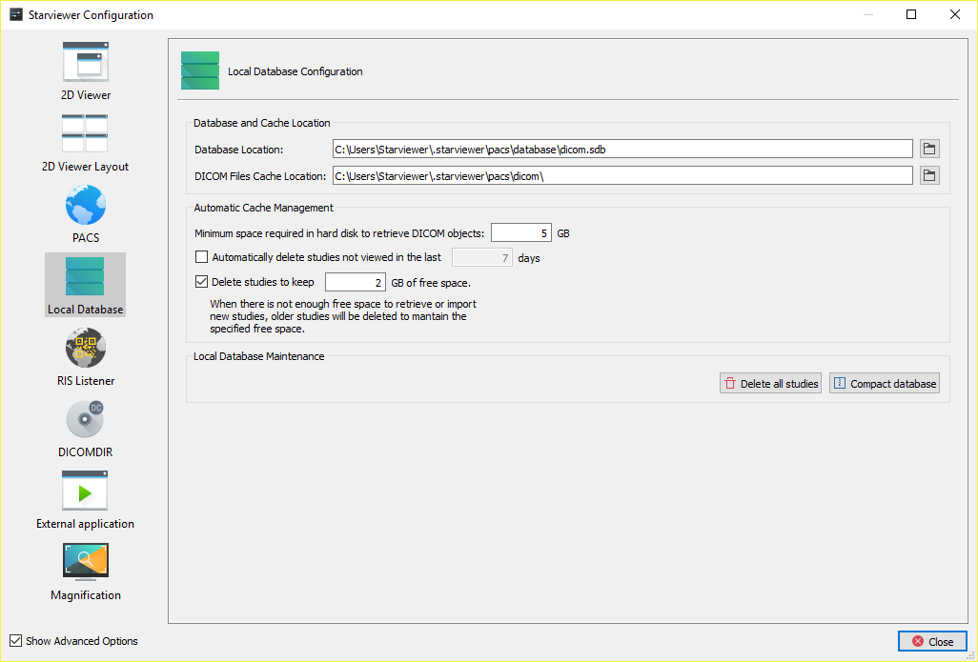
Local database
Options | Description | Default value
Database location | File where the local database is stored. | Windows: %USERPROFILE%\.starviewer\pacs\database\dicom.sdb  Linux: ~/.starviewer/pacs/database/dicom.sdb
DICOM files cache location | Directory where the retrieved studies are stored. | Windows: %USERPROFILE%\.starviewer\pacs\dicom\  Linux: ~/.starviewer/pacs/dicom/
Minimum space required in hard disk to retrieve DICOM objects | It allows defining the minimum disk space in GB required to retrieve or import studies. | 5
Automatically delete studies not viewed in the last X days | If enabled, when Starviewer is opened it deletes all the studies that have not been opened in the time indicated. This allows freeing up space automatically. | Enabled, 7
Delete studies to keep X GB of free space | If it is enabled, an attempt is made to retrieve or download a study, and there is less free space than the minimum one indicated in the other parameter, the application deletes the studies that have not been viewed for the longest time to free up space until the minimum space indicated in the other parameter plus the space indicated here is reached. | Enabled, 2
Delete all studies | It deletes all retrieved studies.
Compact database | It reduces the database size and makes local study queries faster.
When old studies are deleted in order to free up space to retrieve a new one, the space attempted to be freed up is the bare minimum plus an extra space so that this process does not have to be done so often. Both values are controlled by the two parameters described above.
If, after deleting all studies, the bare minimum cannot be reached, it is not allowed to retrieve more studies. In this case, disk space should be freed up by using another tool or by changing the cache location to a disk with more space.

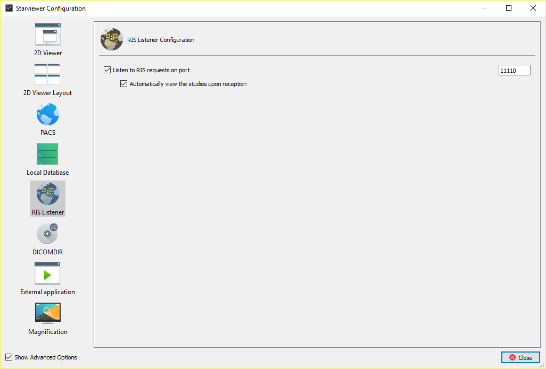
RIS listener
Options | Description | Default value
Listen to RIS requests on port | If enabled, Starviewer listens on the indicated port waiting for a RIS request. It also affects integration with SAP. | Enabled, 11110
Automatically view the studies upon reception | If enabled, studies requested by RIS or SAP are automatically retrieved and opened. Otherwise they are just retrieved. | Enabled

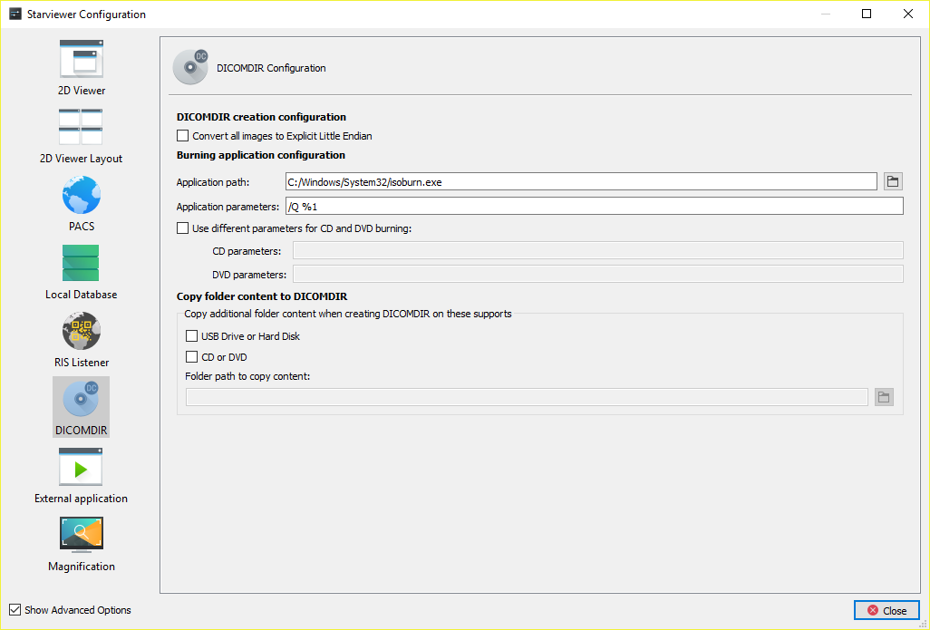
DICOMDIR
Options | Description | Default value
Convert all images to Explicit Little Endian | If enabled, all images are converted to Explicit Little Endian when creating the DICOMDIR. This may improve compatibility with other viewers. | Disabled
Application path | Path to the program executable to burn optical discs. | Windows: %ProgramFiles%\ImgBurn\ImgBurn.exe  Linux: /usr/bin/k3b
Application parameters | The arguments that the optical disc burning program should receive. | Windows: /MODE write /SRC %1 /EJECT YES /VERIFY NO /CLOSESUCCESS /START  Linux: --nosplash %1
Use different parameters for CD and DVD burning | It allows defining different arguments depending on whether a CD or a DVD is burnt. | Windows: disabled  Linux: enabled. CD parameters: --nosplash --cdimage %1. DVD parameters: --nosplash --dvdimage %1
Copy folder content to DICOMDIR | These options allow the content of the specified folder to be copied to the DICOMDIR whenever one is created. Whether the copy is carried out or not can be discriminated depending on whether a DICOMDIR is created on an optical medium or on a hard disk or USB drive. It may be useful to include a DICOM viewer with the DICOMDIR. | All disabled

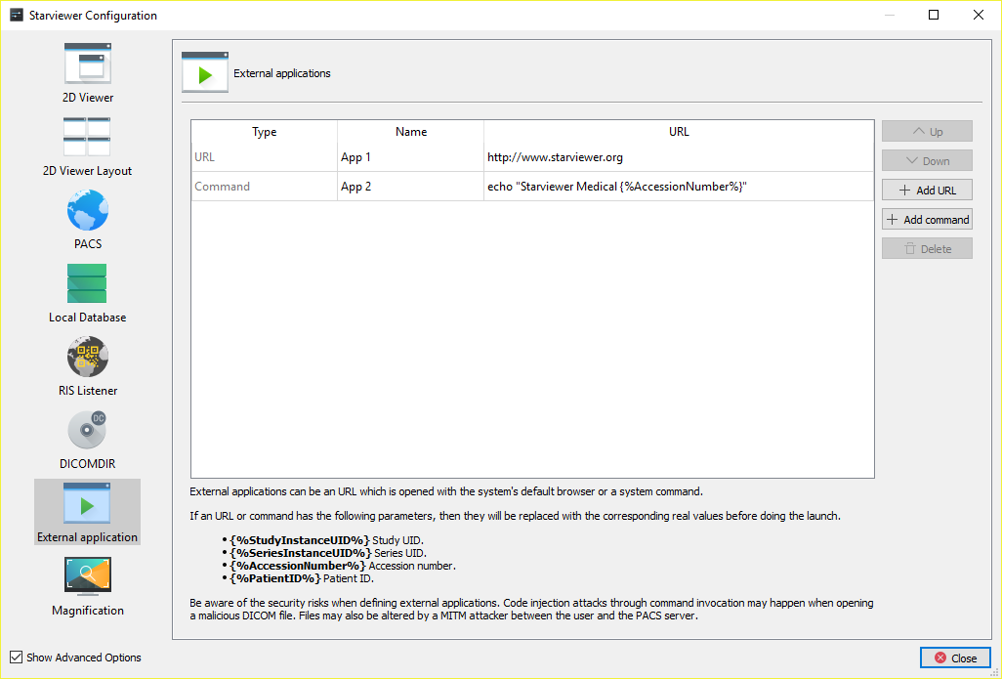
External application

External applications consist in a URL that can be opened in the browser or executed as a system command. New ones can be added with the Add URL or Add command buttons. If a URL or command has one of the parameters described below, then this parameter will be replaced by the value of the corresponding DICOM attribute. If it is opened with the browser, then the special characters will be encoded with the percentage method (also known as «URL encoding»).
- {%StudyInstanceUID%} (0020,000D)
- {%SeriesInstanceUID%} (0020,000E)
- {%AccessionNumber%} (0008,0050)
- {%PatientID%} (0010,0020)
Be aware of the risks when defining external applications. Code injection attacks through command invocation may happen when opening a malicious DICOM file. Files may also be altered by MITM attacks between Starviewer and the PACS server.
The order of external applications is taken into account when generating the menu and the keyboard shortcut mapping. It can be altered by selecting a table row and using the Up and Down buttons.

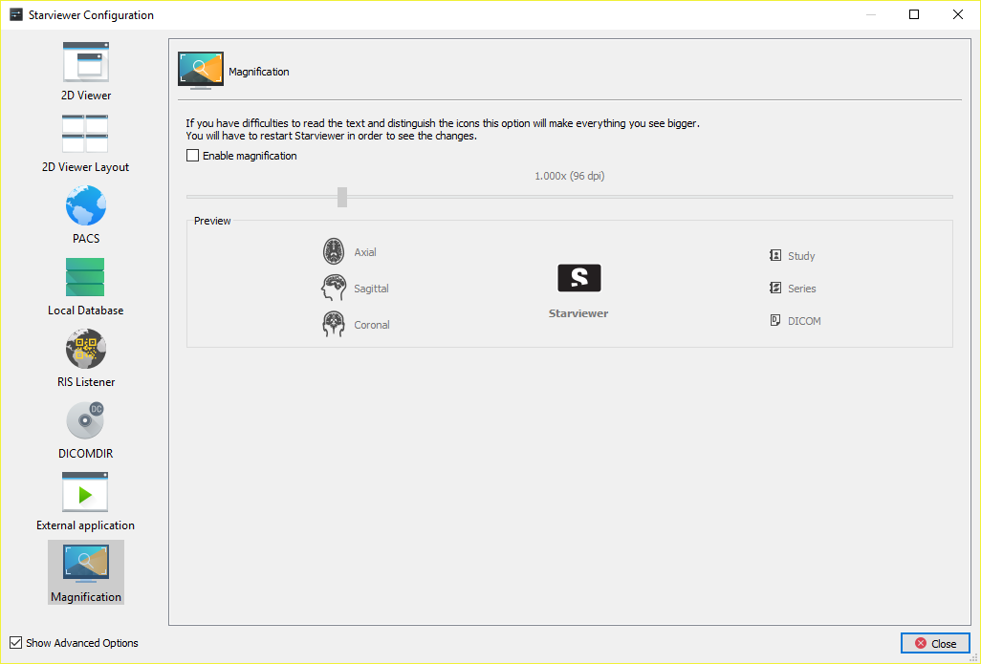
Magnification
This section of the configuration allows enabling an option to enlarge application text and icons. A preview of how they will look like depending on the magnification level is shown. To apply the changes, Starviewer must be restarted.
Magnification is useful when Starviewer is used on very large screens such as those of mammography.

Keyboard shortcuts

Main shortcuts

Other shortcuts
Icon | Function | Shortcut | Icon | Function | Shortcut
 | Axial view (current viewer)  (all viewers) | Ctrl+1  Ctrl+Shift+1 |  | New window | Ctrl+N
 | Sagittal view (current viewer)  (all viewers) | Ctrl+2  Ctrl+Shift+2 |  | Close tab | Ctrl+W
 | Coronal view (current viewer)  (all viewers) | Ctrl+3  Ctrl+Shift+3 |  | Exit | Ctrl+Q
 | Capture current image | Ctrl+S |  | Local database studies | Ctrl+L
 | Capture all of current series | Ctrl+A |  | PACS | Ctrl+P
 | Erase all annotations | Ctrl+E |  | Open DICOMDIR | Ctrl+D
 | Restore viewer to the initial state | Ctrl+R |  | Open files | Ctrl+O
 | Cobb angle | Shift+A |  | Open files from a directory | Ctrl+Shift+D
 | Polyline ROI | Shift+R |  | Maximise to multiple screens | Ctrl+Shift+M
 | Magnify | Shift+Z |  | Move to previous screen | Ctrl+Shift+←
 | Desynchronise all viewers | Shift+U |  | Move to next screen | Ctrl+Shift+→
 | External applications | Shift+F1…F12

Glossary
AE Title: The AE Title (from Association Entity Title) is the identifier used by the DICOM protocol to recognise the parts implied in communication and image transfer operations. Therefore, each PACS and workstation has its own AE Title associated to a TCP/IP address with which the communications between them are negotiated.
DICOM: DICOM (from Digital Imaging and Communications in Medicine) is a standard for manipulating, storing and transmitting medical imaging information. The standard includes a definition of the DICOM file format and the communication protocols, based on TCP/IP, which allow the exchange of information between two entities that have the ability to send and receive information in DICOM format. DICOM was developed to allow the integration and communication of scanners, radiographic devices, servers, workstations and a variety of hardware from different vendors.
PACS: PACS (from Picture Archiving and Communication System) is a system formed by the combination of hardware and software dedicated to the storage, retrieval, administration, distribution and presentation of medical images. The universal format for the storage and transfer of images is DICOM.
Query/Retrieve: It is a DICOM service that allows a workstation to search for and retrieve images from a PACS.
Store: It is a DICOM service used for sending images or other persistent objects to a PACS or to a workstation.
Table of figures
Figure 1: Left: initial slice and phase. Centre: scrolling. Right: phase change. 48
Figure 2: Left: initial zoom level. Right: after zooming in. 49
Figure 3: Left: initial position. Right: after panning. 51
Figure 4: Left: original DICOM window. Right: modified window. 52
Figure 5: Same PET series with different colour functions. Left: Black & White Inverse. Right: PET. 56
Figure 6: Left: original image. Right: the same image with the colours inverted. 57
Figure 7: Centre: original image. Left: horizontally flipped. Right: vertically flipped. 58
Figure 8: An image with the four possible rotations. 59
Figure 9: Left: original image. Centre: same image after zooming and panning the image, changing the window and drawing a ROI. Right: result of restoring the central image to the initial state; it looks exactly the same as the one on the left. 59
Figure 10: Left: viewer with visible information. Right: same viewer with hidden information. 61
Figure 11: Left: viewer with visible overlays (the upper-left D). Right: same viewer with hidden overlays. 62
Figure 12: Left: viewer with visible shutters. Right: same viewer with hidden shutters. 63
Figure 13: DICOM images exporting window. 64
Figure 14: Top left: a slice. Top right: MIP of 100 mm. Bottom left: MinIP of 100 mm. Bottom right: average of 100 mm. 86
Figure 15: The bottom-left viewer is selected and the plane of the current image, with a thickness of 6 mm, is projected on the other viewers. 88
Figure 16: A point has been marked in the top-right viewer, and the other viewers automatically indicate the same point of the space. 89
Figure 17: Playback submenu. 90
Figure 18: DICOM information. Left: meaningful tags. Right: all tags. 92
Figure 19: DICOM information by filtering to find the Spacing Between Slices tag. 92
Figure 20: Left: initial window. Right: window changed in the axial viewer and propagated to the other ones. 96
Figure 21: Left: initial state. Right: zoom, pan and orientation changed in the bottom-left viewer and propagated to those with the same anatomical plane. 96
Figure 22: Left: without thick slab. Right: Maximum thickness MIP applied to PET and propagated to the secondary series (PET) of the fusion. 97
Figure 23: PET-CT fusion with different views. In the columns, from left to right: CT, fusion, PET. In the rows, from top to bottom: axial and coronal. 99
Figure 24: Left: slider to control the fusion balance. Right: annotation to indicate the current fusion balance. 102
Figure 25: Clipping planes in action. Left: initial state after enabling the tool; the balls at the centres of the planes can be seen. Centre: moving a face (the one with a different colour and the red ball) to clip the volume. Right: final state after clipping and disabling the clipping planes tool to hide the box. 111
Figure 26: Left: initial state. Right: after rotating the volume. 112
Figure 27: Results of the diagnosis tests. Left: everything correct. Right: with errors. 114
Figure 28: Example of selection of images to print. Image 52 from series 2 has been selected to print, then all images from series 2, and finally those images from series 3 between 65 and 450 with an interval of 94, thus including images 65, 159, 253, 347 and 441. As indicated at the bottom left, 17 films will be printed, according to the print settings and format. 118
Figure 29: Dialogue box to add a new printer. 119
Figure 30: Different variants of the dialogue to add a new PACS. Left: DIMSE PACS. Centre: WADO PACS. Right: hybrid PACS. 132

https://en.wikipedia.org/wiki/DisplayPort#Display_Stream_Compression. «Display Stream Compression (DSC) is a VESA-developed low-latency compression algorithm to overcome the limitations posed by sending high-resolution video over physical media of limited bandwidth. It is a lossy low-latency algorithm based on delta PCM coding and YCGCO-R color space; it allows increased resolutions and color depths and reduced power consumption.»
Operating system not officially supported.
For example, if it is a series without phases, the phase-related options will not be displayed.
https://en.wikipedia.org/wiki/Accuracy_and_precision
http://dicom.nema.org/medical/dicom/current/output/chtml/part05/sect_6.2.html
https://en.cppreference.com/w/cpp/language/types#Floating_point_types
https://en.wikipedia.org/wiki/IEEE_754
https://en.wikipedia.org/wiki/Floating-point_unit
http://www.dclunie.com/
https://en.wikipedia.org/wiki/Exponential_decay#Half-life
Denis J. Morgan, Kelly M. Bray. Lean body mass as a predictor of drug dosage. Implications for drug therapy. Clinical Pharmacokinetics. 1994, Vol. 26, 4, pp. 292–307. https://doi.org/10.2165/00003088-199426040-00005
W. Philip T. James. Research on obesity. London: Her Majesty’s Stationery Office, 1976. ISBN 0114500347.
Delafield Du Bois, Eugene F. Du Bois. A formula to estimate the approximate surface area if height and weight be known. Archives of Internal Medicine. 1916, Vol. 17, 6-2, pp. 863–871.

